

Faculty of Computing and Information Technology

Assignment 2020/2021

AACS1084 Programming Concepts & Design II

Programme : Diploma in Computer Science

Tutorial Group : DCS 3

Tutor : MR CHAN ZHEN HUI

|  |  |
| --- | --- |
| **Student Name** | **Module Handled** |
| Choo Wei Sern Vincent | Visitor Information Module |
| Tan Yan Pin | Venue Information Module |
| Cheng Ling Ern | Administrative Staff Module |
| Tan Jenny | Visits and Exits Module |
| Cheng Cai Yuan | Sanitization Records Module |

**DECLARATION OF ORIGINALITY**

|  |  |
| --- | --- |
| I declare that this assignment is free from all forms of plagiarism  and for all intents and purposes is my own work. I understand that  I will be penalized if I have not complied with TAR UC’s  Plagiarism policy.  Signature : Choo  Date :2/4/2021  ID : 20PMD04930 | Name: Choo Wei Sern Vincent |

|  |  |
| --- | --- |
| I declare that this assignment is free from all forms of plagiarism  and for all intents and purposes is my own work. I understand that  I will be penalized if I have not complied with TAR UC’s  Plagiarism policy.  Signature : David  Date : 2/4/2021  ID : 20PMD04219 | Name: Tan Yan Pin |

|  |  |
| --- | --- |
| I declare that this assignment is free from all forms of plagiarism  and for all intents and purposes is my own work. I understand that  I will be penalized if I have not complied with TAR UC’s  Plagiarism policy.  Signature : Ern  Date : 2/4/2021  ID : 20PMD03776 | Name: Cheng Ling Ern |

|  |  |
| --- | --- |
| I declare that this assignment is free from all forms of plagiarism  and for all intents and purposes is my own work. I understand that  I will be penalized if I have not complied with TAR UC’s  Plagiarism policy.  Signature : Jenny  Date : 2/4/2021  ID : 20PMD04706 | Name: Tan Jenny |

|  |  |
| --- | --- |
| I declare that this assignment is free from all forms of plagiarism  and for all intents and purposes is my own work. I understand that  I will be penalized if I have not complied with TAR UC’s  Plagiarism policy.  Signature : Yuan  Date : 2/4/2021  ID : 20PMD04044 | Name: Cheng Cai Yuan |

**Assignment Evaluation Form**



**Table of Contents**

**1.0 Introduction** 1

**2.0 Overall System – Module Structure Chart** 2

**3.0 Main Screen Design** 7

**4.0 System modules** 8

**4.1 Visitor Information Module by < Choo Wei Sern Vincent>** 8

4.1.1 Brief Description. 8

4.1.2 Output and File Contents 8

**4.2 Venue information module by < Tan Yan Pin >** 34

4.2.1 brief description 34

4.2.2 Outputs & Files Contents 34

**4.3 Administrative Staff Module by <Cheng Ling Ern>** 47

4.3.1 Brief Description 47

4.3.2 Outputs & File Contents 47

**4.4 Visit And Exit by < Tan Jenny >** 68

4.4.1 Brief Description 68

4.4.2 Outputs & File Contents 69

**4.5 Sanitization Module by < Cheng Cai Yuan >** 95

4.5.1 Brief Description 95

4.5.2 Outputs and File Contents 95

**References** 118

# **1.0 Introduction**

Taruc contact-tracking system is a system that is used extensively throughout Taruc college to ensure the safety of the students as well as staff. This system is a part of the Government’s law as everyone must check-in and check-out when they visit a place. The covid-19 situation is serious day by day and this system used to be tracked the movement of students when they contact the covid-19 patients. It is utmost importance in areas where there is a high risk of contact status. This system requires students to provide information about themselves such as address, email, phone number so it can be contacted if needed during the pandemic .Everyone who is visiting the venue must supply their information such as purpose , check-in venue, temperature and current status. Besides, this system is categorized as an auto-save data system so that students or staff are unnecessary to manual key in their details when they want to check-in or check-out. Hence, the contact data that will be collected by the system will only be accessed by the admin, others are not allowed to access. Admin is fully accessed to the system such as add, update or modify ,delete records. This system completely preserves students or staff privacy and also their personal information .

# **2.0 Overall System – Module Structure Chart**

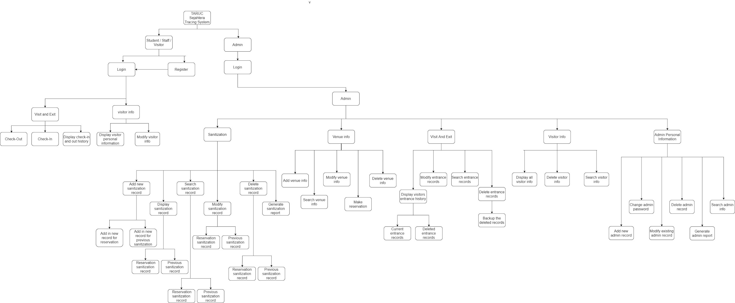

*Figure 2.1 Show overall structure chart*

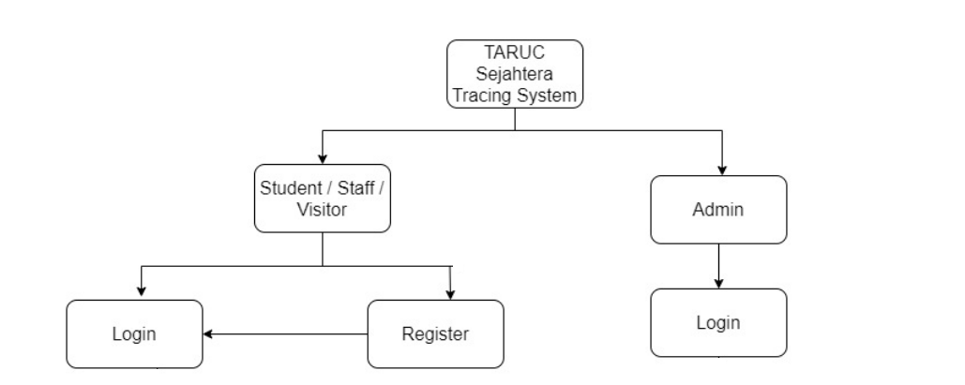

*Figure 2.2 Show login part of student/staff/visitor or admin in structure chart*

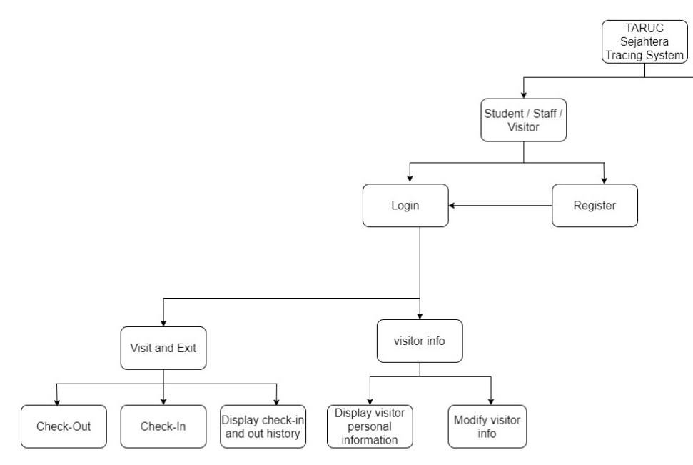

*Figure 2.3 Show login part of student/visitor/staff in structure chart*

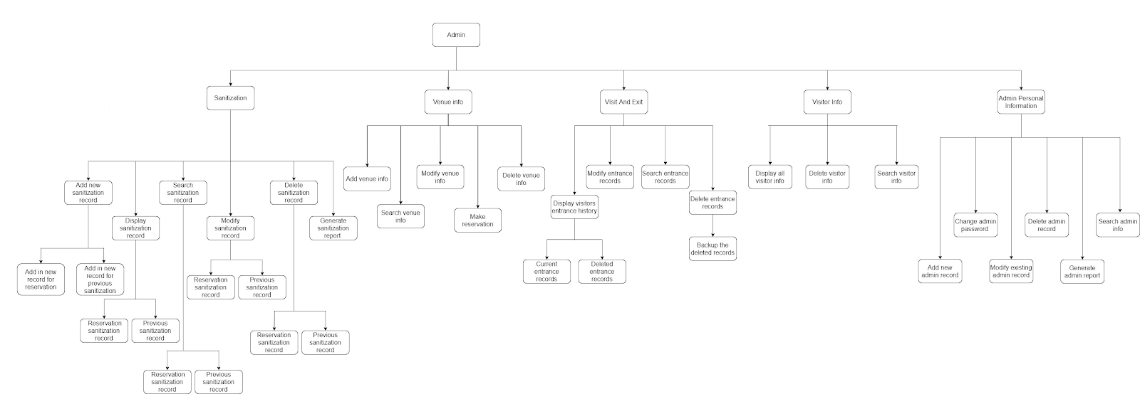

*Figure 2.4 Show login part of admin function in structure chart*

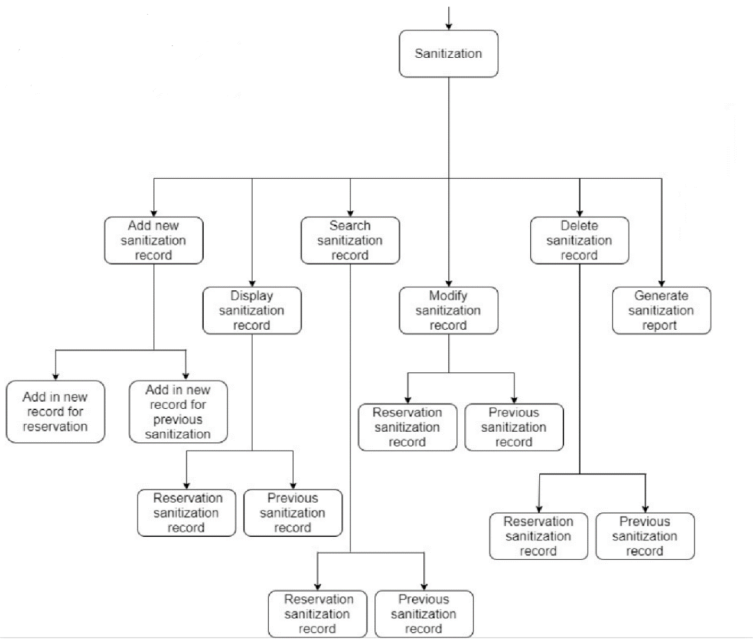

*Figure 2.4.1 Show sanitization module of admin function in structure chart*

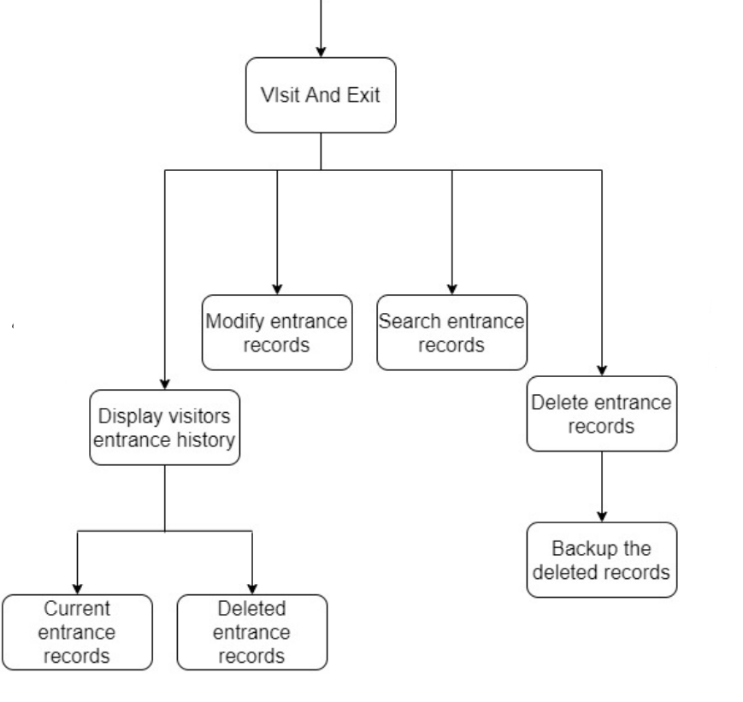

*Figure 2.4.2 Show visit and exit module of admin function in structure chart*

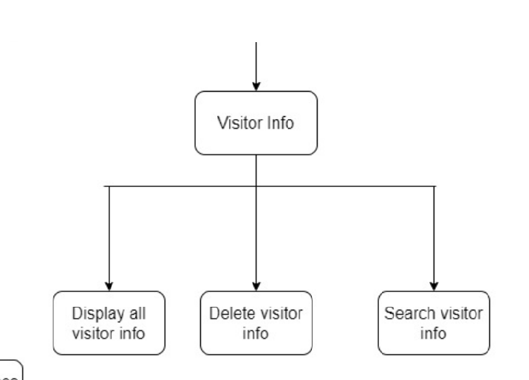

*Figure 2.4.3 Show visitor module of admin function in structure chart*

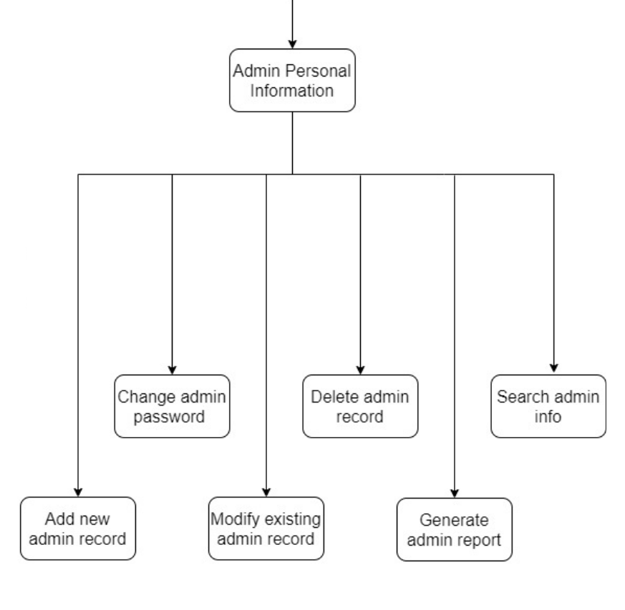

*Figure 2.4.4 Show admin personal information module of admin function in structure chart*

# **3.0 Main Screen Design**

The screenshot shown is the home page of the Taruc contact-tracing system. The design is using the people to stand with each other on a specific distance in order to remind each other of social distancing to safeguard everyone's safety .

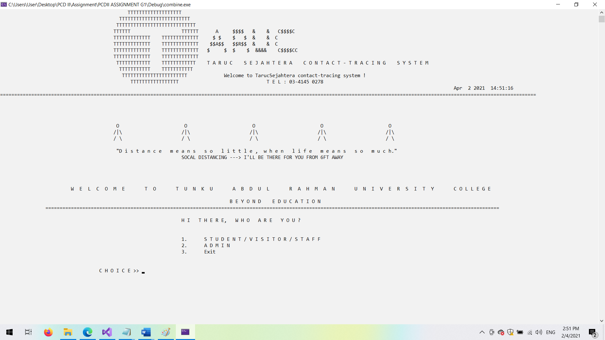

*Figure 2.3.1 Show screenshot of homepage*

# **4.0 System modules**

# **4.1 Visitor Information Module by < Choo Wei Sern Vincent>**

## 4.1.1 Brief Description.

* The visitor information module is the module that stores all data and information of existing visitor accounts into the system. Furthermore, it also allows new users to sign up for a new account to enjoy the benefits of the system. The visitor information is divided into 5 modules. As a normal visitor, he or she can only access the display user module, modify module and as an administrator, they can access the display all module, search module and delete module.

## 4.1.2 Output and File Contents

**Main menu**

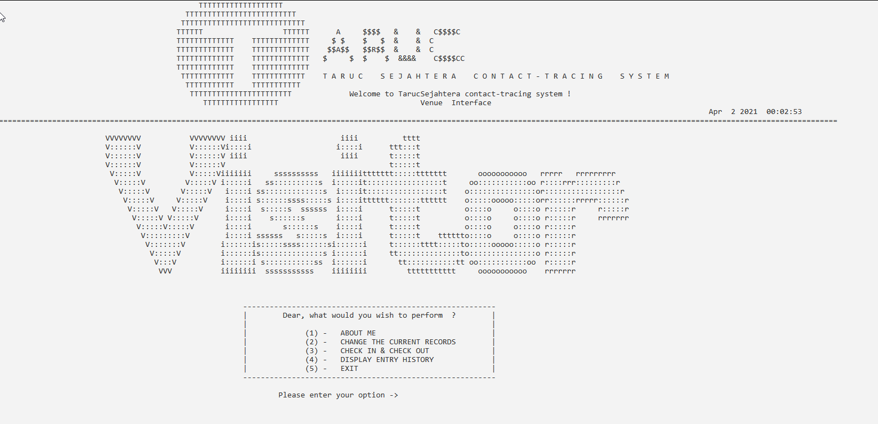

1. **Register Function**

* When a user enters the program, the user will be greeted with the following interface with 3 options, which are Login, Register and Exit. Upon choosing the Register option, the new user will be directed to the register interface. The new user is prompted to enter the required personal information such as identification card number, full name, gender, date of birth, personal email address, contact number and home address. If the new user is a foreigner, the new user would be prompted to enter their passport number instead of identification card number.

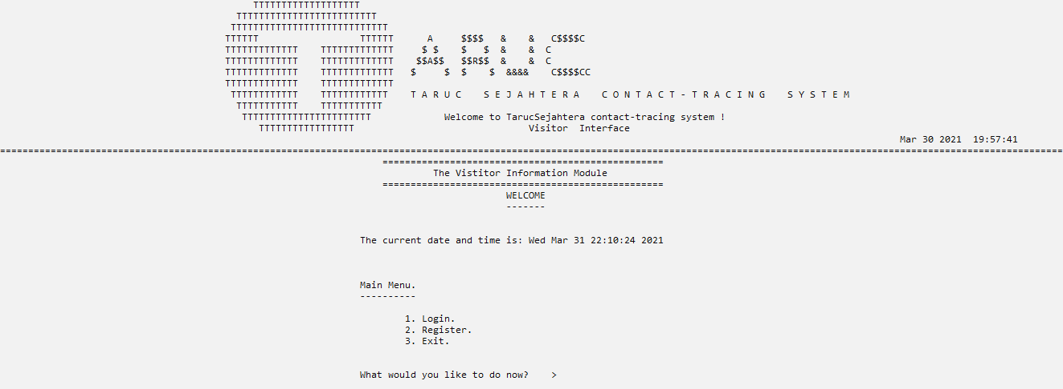

*Figure 4.1.1 shows the main menu interface for student, visitor and staff.*

* After filling up the required fields, the user is required to insert a password and a confirmation to create a new account. The system will display the generated visitor user ID to the user.

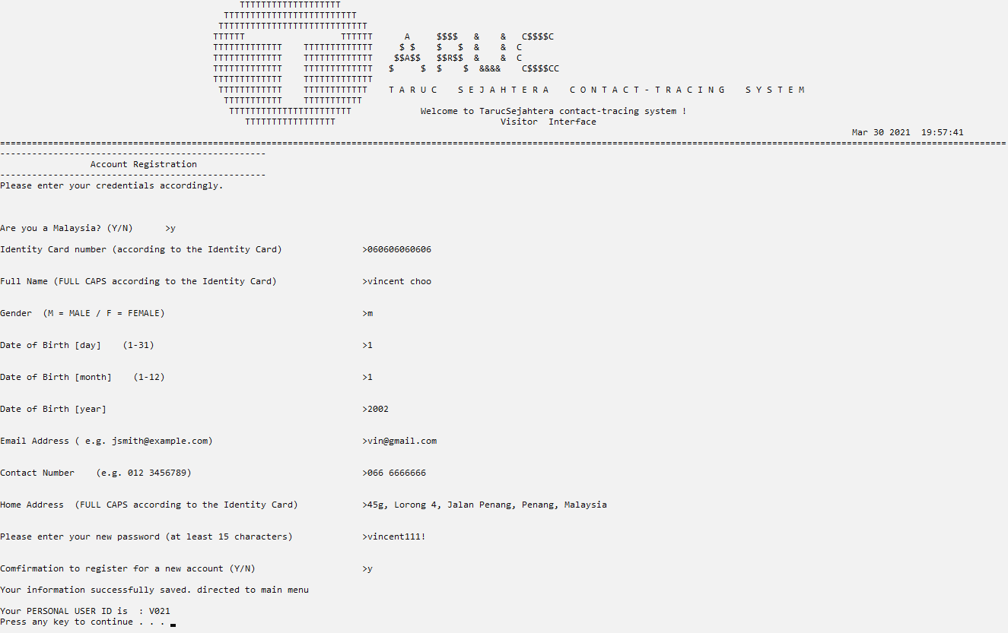

*Figure 4.1.2 shows the registration interface of the system.*

Registration Validaiton

* Validation Check 1

When the new user did not choose the available option of nationality in the registration interface, the system will prompt the user to enter again

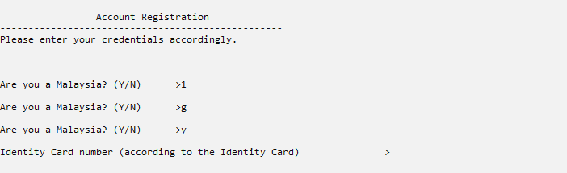

*Figure 4.1.3 shows the invalid input validation of nationality.*

* Validation Check 2

When the new user enters an invalid identity card number,the system will display the error message and prompt the user to enter a valid input. The criteria of a valid

Identity number is [ 12 digit characters ].

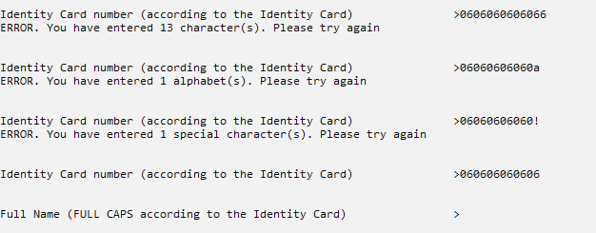

*Figure 4.1.4 shows the invalid input validation identity card number.*

* Validation Check 3

When the user enters an invalid name, the system will prompt an error indicating the invalid characters in the name and prompt the user to enter a valid name. The criteria of a valid name is [ 85 maximum alphabetical character ]

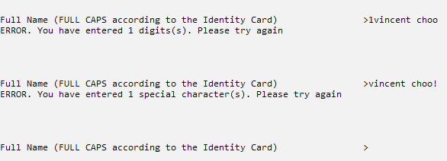

*Figure 4.1.5 shows the invalid input validation full name.*

* Validation Check 4

When the user enters an invalid gender, the system will prompt an error indicating the invalid characters of gender and prompt the user to enter a valid name. The criteria of a valid name is either [M = male or F = female]

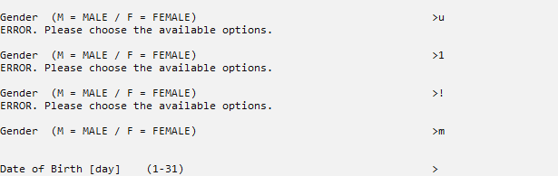

*Figure 4.1.6 shows the invalid input of gender.*

* Validation Check 5

When the user enters an invalid day of birth, the system will prompt an error indicating the invalid digit and prompt the user to enter a valid name. The criteria of a valid name is [between 1 - 31]

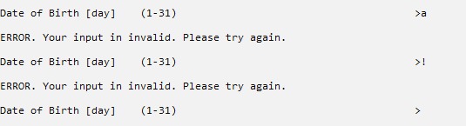

*Figure 4.1.7 shows the invalid input of day of birth.*

* Validation Check 6

When the user enters an invalid month of birth, the system will prompt an error indicating the invalid digit and prompt the user to enter a valid digit. The criteria of a valid name is [between 1 - 12].

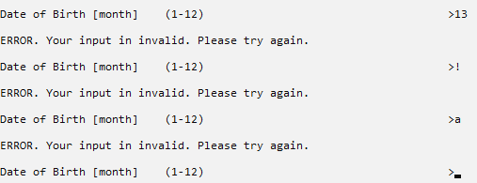

*Figure 4.1.8 shows the invalid input of month of birth.*

* Validation Check 7

When the user enters an invalid year of birth, the system will prompt an error indicating the invalid digit and prompt the user to enter a valid digit. The criteria of a valid name is [between 1900 - 2021].

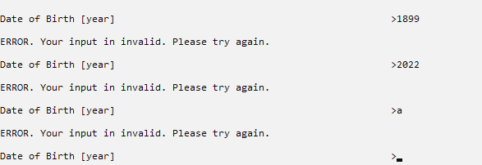

*Figure 4.1.9 shows the invalid input of year of birth.*

* Validation Check 7

When the user enters an invalid email address, the system will prompt an error indicating the invalid character and prompt the user to enter a valid email. The criteria of a valid name is [must have ‘@’ and ‘.’ AND ‘@’ must come before ‘.’].

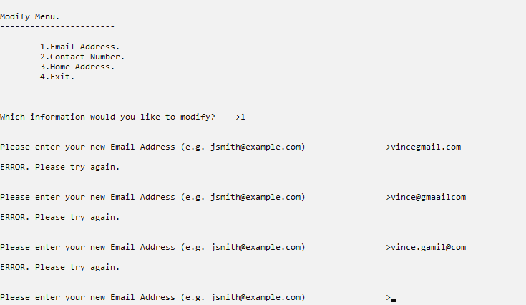

*Figure 4.1.10 shows the invalid input of email address.*

* Validation Check 8

When the user enters an invalid contact number, the system will prompt an error indicating the invalid character and prompt the user to enter a valid contact number. The criteria of a valid name is [max 13 numerical character with one [SPACE] ].

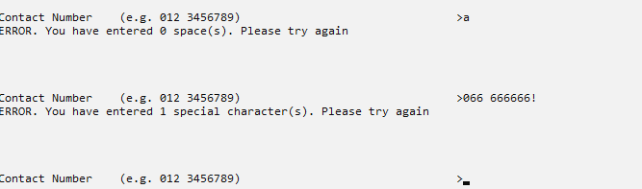

*Figure 4.1.11 shows the invalid input of contact number.*

1. **Login Interface**

* As an existing user account, the system will display the splash screen menu. The user is required to choose option one which is for student, visitor and staff.
* The user is then directed to the login screen interface. The system will prompt the user to enter the 2 required fields which are the User ID number and the password.

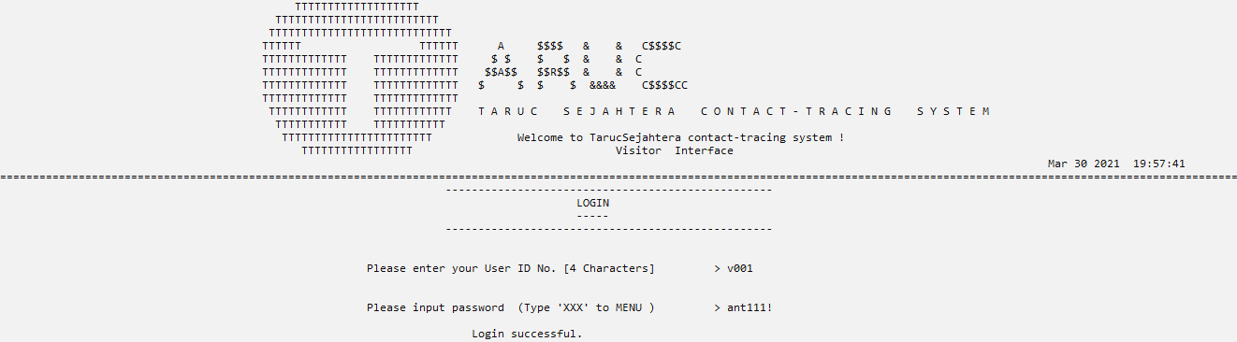

*Figure 4.1.12 shows the login interface of the system.*

**Login Validations**

* **Validation Check 1**
* If the User ID entered does not have any matching account in the system, the following screen will be displayed, providing three options to the user, which are the register account, retry and exit options.

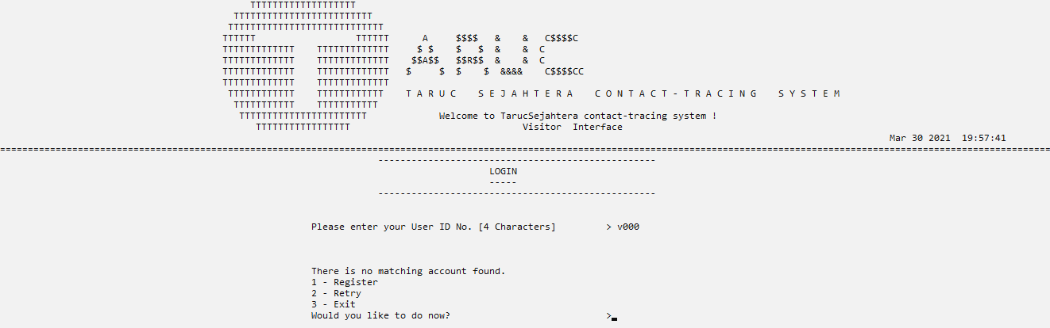

*Figure 4.1.13 shows the display if the user ID is inexistent.*

* **Validation check 2.**

After the user has entered an existing User ID, if the user entered an incorrect password, the system will display the following interface in Figure 4.1.5. The interface indicates to the user that the password does not match with the registered account and prompt the user to retry again. If the user wishes to exit the system, they can type ‘XXX’ to proceed.

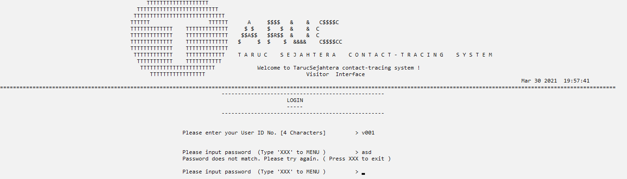

*Figure 4.1.14 shows the display if the user ID is invalid.*

* **Validation Check 3**

When the user enters an invalid user ID, the system will prompt an error indicating the invalid character and prompt the user to enter a valid User ID. The criteria of a valid name is [4 characters consisting of 1 alphabet and 3 digits].

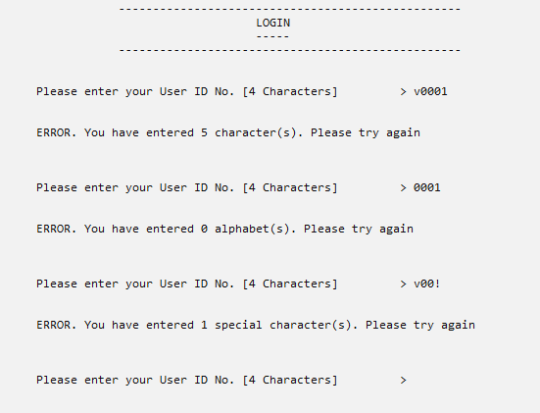

*Figure 4.1.15 shows the display if the user ID is invalid.*

**3.Display User Information Interface (About Me)**

* After login into the system, the system will display the profile menu options as shown. To display the profile information, the user needs to choose the first option, About Me, to check the profile credentials.

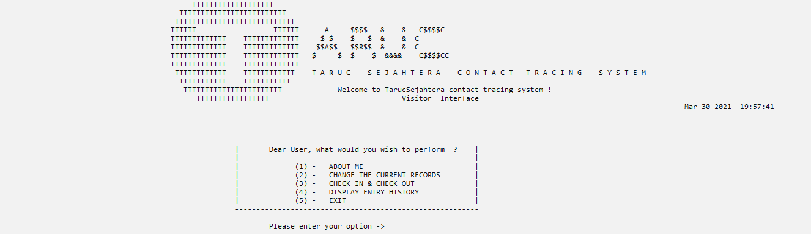

*Figure 4.1.16 shows the profile main menu.*

* In the About Me interface, the system displays the user’s details in each dedicated field. The user can then choose to either remain in the About Me interface or return to the profile menu.

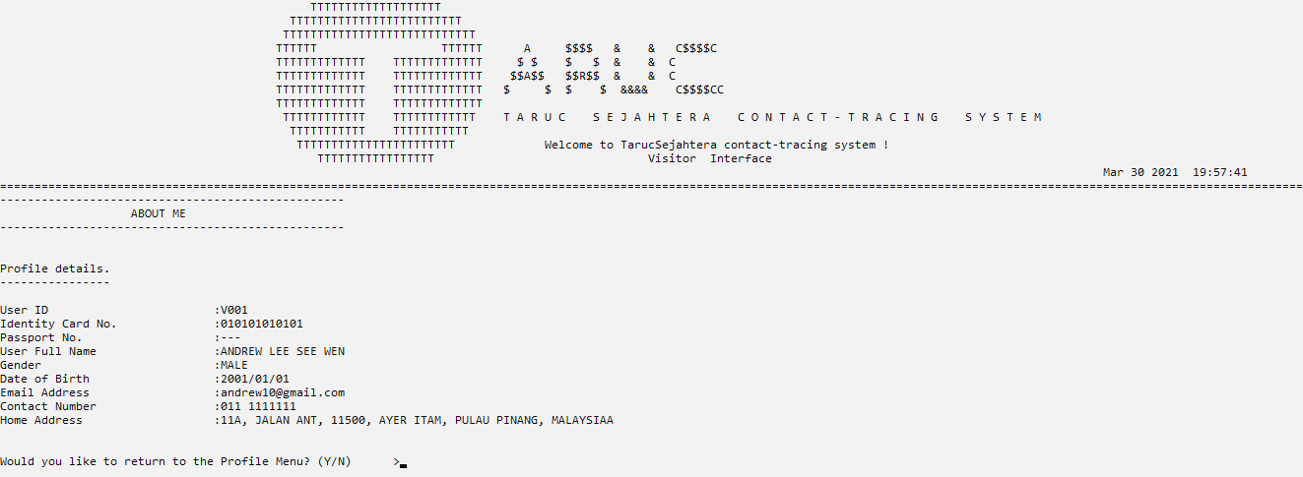

*Figure 4.1.17 shows the About Me interface.*

**Display Validation**

* Validation Check 1

When the user enters an invalid response, the system will prompt an error indicating the invalid character and prompt the user to enter a valid response.

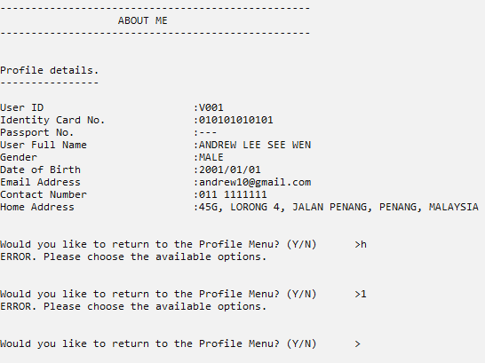

*Figure 4.1.18 shows the display if the user input an invalid respond to exit display module*

**4.Modify User Information Interface (Change The Current Records)**

* After login in and choosing the Change The Current Records option, the system will display the interface shown. The upper section shows the current saved profile details of the user in the system. Due to privacy and security restrictions, users are only permitted to modify three details in their profile settings , which are email address, contact number and the home address.

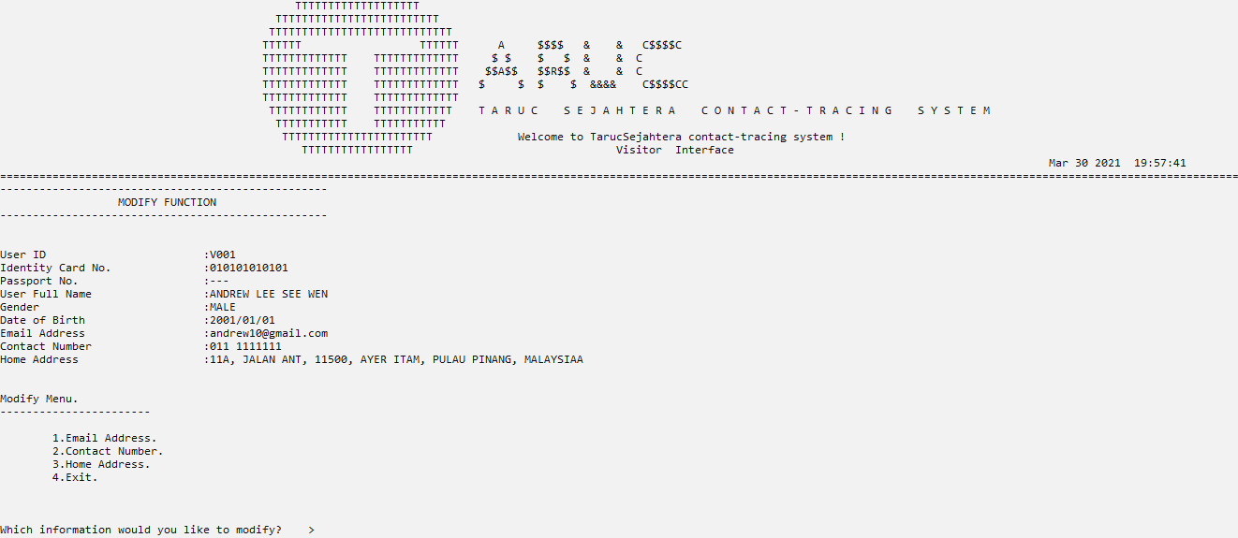

*Figure 4.1.19 shows the Modify Function interface.*

* After the modification, the system will prompt the user to Continue Modify or to Exit to the profile menu. If the user chose Continue Modify, the system will refresh the interface, and the profile details will be updated with the new profile details.



*Figure 4.1.20 shows the options after the modification..*

Modify Validation

* Validation Check 1

When the user enters an invalid email address, the system will prompt an error indicating the invalid character and prompt the user to enter a valid email. The criteria of a valid name is [must have ‘@’ and ‘.’ AND ‘@’ must come before ‘.’].



*Figure 4.1.21 shows the display if the user input a new invalid email address.*

* Validation Check 2

When the user enters an invalid contact number, the system will prompt an error indicating the invalid character and prompt the user to enter a valid contact number. The criteria of a valid name is [max 13 numerical character with one [SPACE] ].



*Figure 4.1.22 shows the invalid input of contact number.*

**5.Delete Visitor Account Interface**

* The delete visitor account interface can only be accessed by a registered administrator of the system. Upon login in the system as an admin, the system will prompt the administration menu with seven options shown below.

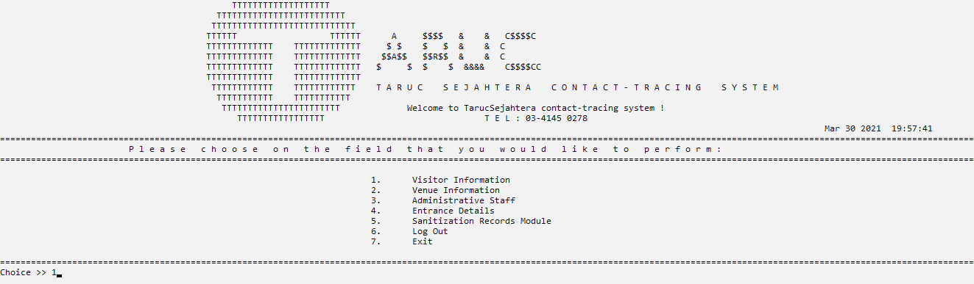

*Figure 4.1.23 shows the administration main menu.*

* After clicking on the Visitor information from the administration menu, the system will show the options related to the visitor information which is delete visitor account, display all visitor records and search user information.

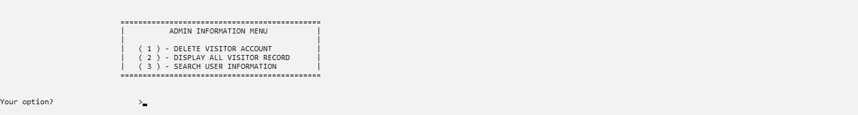

*Figure 4.1.24 shows the administration option regarding the visitor information.*

* Upon choosing the delete visitor account, the system will display the following interface. The administrator is prompted to input the intended User ID to delete. After verifying the User ID, the system will show the profile details of the User ID before prompting the confirmation to delete the existing user account. If the administrator proceeds the deletion, the system will prompt delete successful message and direct the administrator back to the profile menu, or else if the admin cancels the deletion, the administrator will just be directed back to the administration menu.

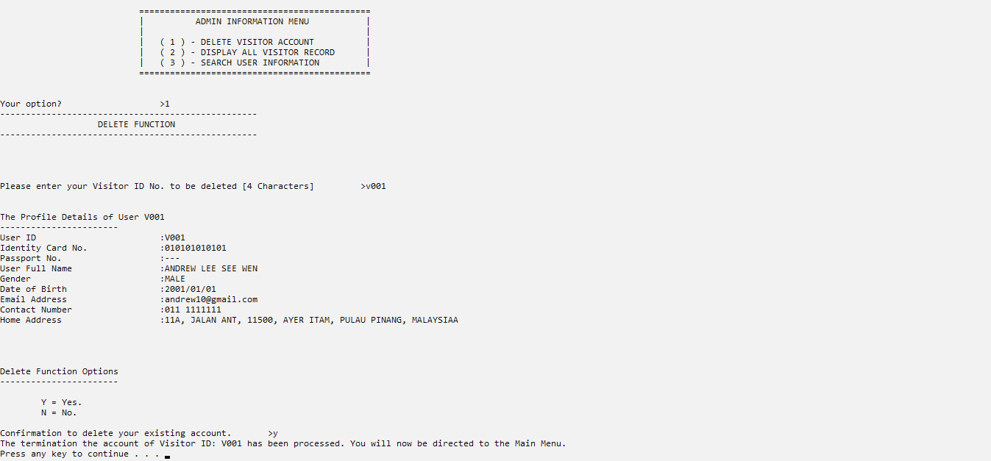

*Figure 4.1.25 shows the administration option regarding the visitor information.*

**Delete validation**

* Validation Check 1

When the user enters an invalid User ID, the system will prompt an error indicating the invalid character and prompt the user to enter a valid User ID. The criteria of a valid User ID is [4 characters consisting of one alphabet and 33 digits].

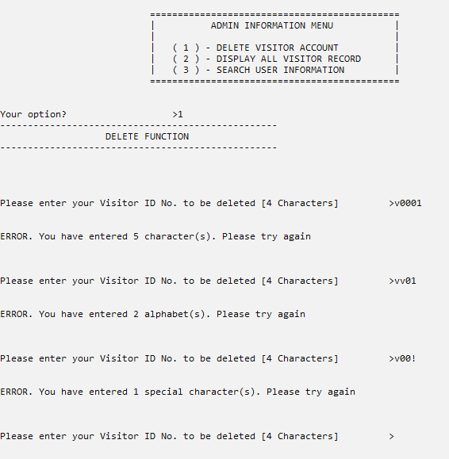

*Figure 4.1.26 shows the invalid input of user ID in the delete module.*

**6.Display All Visitor Account Interface**

* After choosing the Display All Visitor Record, the system will direct the administration to the display all visitor record interface.

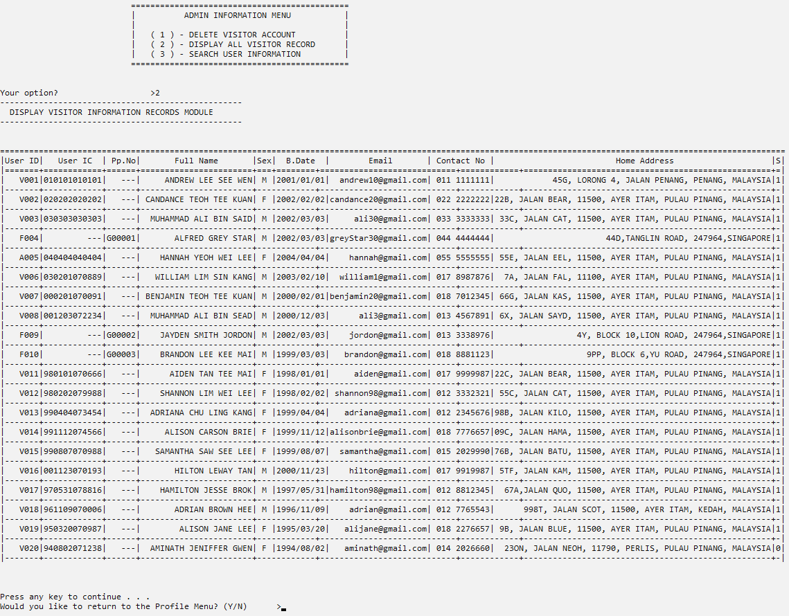

*Figure 4.1.27 shows the display all users record interface.*

* The system will read the text file which contains all the visitor information and display the details in a table format as shown. The table header consist of User ID, User IC, passport number, full name, sex, birth date, email address, contact number, home address and account status.

Display All User Record Validation

* Validation Check 1

When the user enters an invalid response, the system will prompt an error indicating the invalid character and prompt the user to enter a reponse. The criteria of a response is [Y = yes OR N = no].

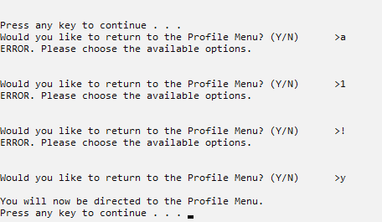

*Figure 4.1.28 shows the invalid response when exiting display all user record modules.*

**7.Search Visitor Information Interface**

* After choosing the Search Visitor Information option, the system will direct the administrator to the search visitor information interface.

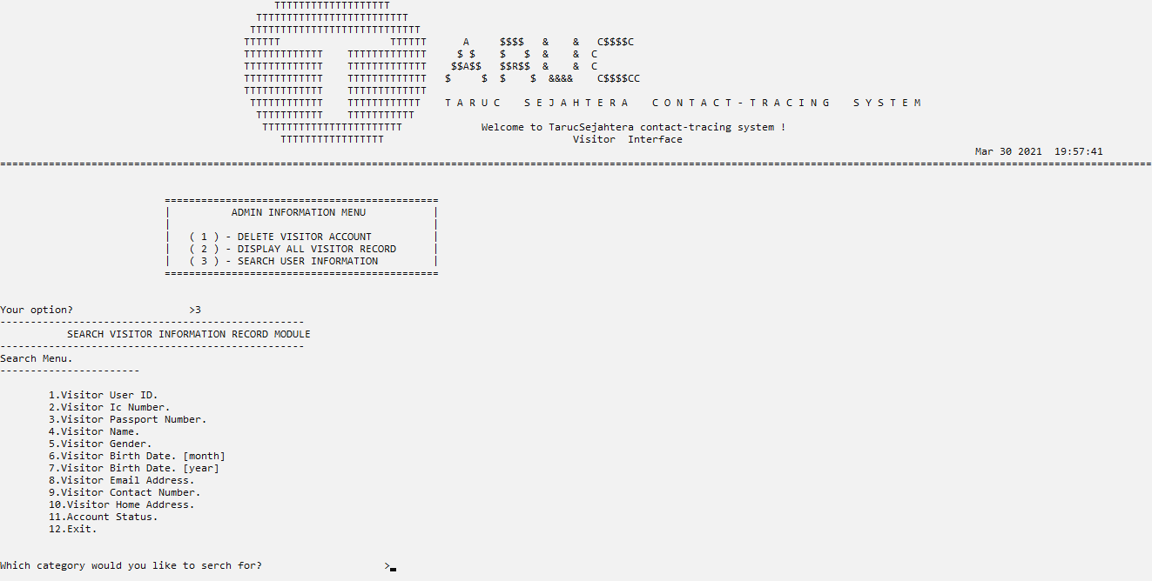

*Figure 4.1.29 shows the display all users record interface.*

* The Search interface will display the available category to search by in the current user account record in the system. The admin can search by User ID, identification card number, passport number, full name, gender, birth month, birth year, email address, contact number, home address and account status.
* After choosing one of the options, the admin is required to input the necessary keywords for the system to search by and compare with. The search result is then displayed in a list in a table as shown below.

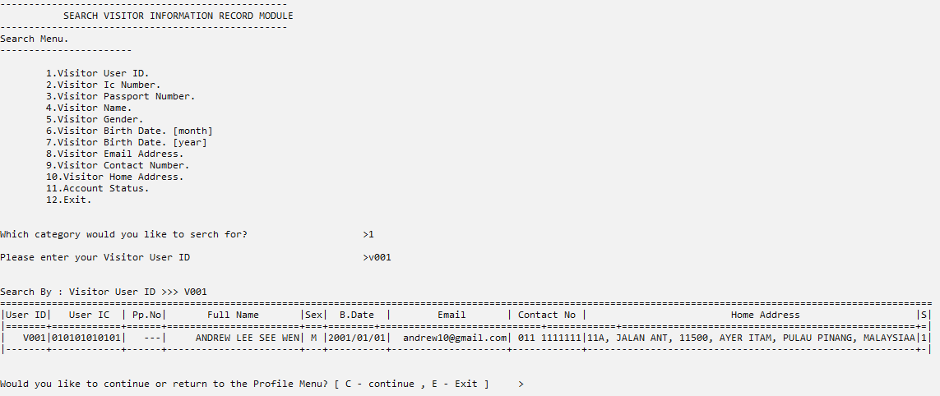

*Figure 4.1.30 shows the search visitor information interface.*

Search User Record Validation

* Validation Check 1

When the admin enters an invalid User ID, the system will prompt an error indicating the invalid character and prompt the user to enter a valid User ID. The criteria of a valid User ID is [4 characters consisting of one alphabet and 33 digits].



*Figure 4.1.31 shows the invalid input of user ID in the search module.*

* Validation Check 2

When the admin enters an invalid identity card number,the system will display the error message and prompt the user to enter a valid input. The criteria of a valid

Identity number is [ 12 digit characters ].



*Figure 4.1.32 shows the invalid input validation identity card number in search module.*

* Validation Check 3

When the admin enters an invalid passport number,the system will display the error message and prompt the user to enter a valid input. The criteria of a valid

Passport number is [e.g. G00001]

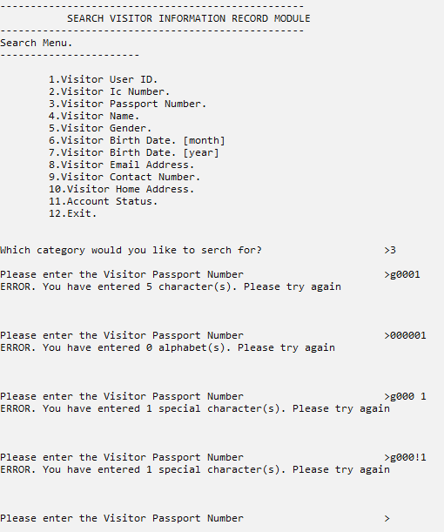

*Figure 4.1.33 shows the invalid input validation identity card number in search module.*

* Validation Check 4

When the user enters an invalid name, the system will prompt an error indicating the invalid characters in the name and prompt the user to enter a valid name. The criteria of a valid name is [ 85 maximum alphabetical character ]



*Figure 4.1.34 shows the invalid input validation full name in search module.*

* Validation Check 5

When the user enters an invalid gender, the system will prompt an error indicating the invalid characters of gender and prompt the user to enter a valid name. The criteria of a valid name is either [M = male or F = female]



*Figure 4.1.35 shows the invalid input of gender in the search module.*

* Validation Check 6

When the user enters an invalid month of birth, the system will prompt an error indicating the invalid digit and prompt the user to enter a valid digit. The criteria of a valid name is [between 1 - 12].



*Figure 4.1.36 shows the invalid input of month of birth in the search module.*

* Validation Check 7

When the user enters an invalid year of birth, the system will prompt an error indicating the invalid digit and prompt the user to enter a valid digit. The criteria of a valid name is [between 1900 - 2021].



*Figure 4.1.37 shows the invalid input of year of birth in the search module.*

* Validation Check 8

When the user enters an invalid email address, the system will prompt an error indicating the invalid character and prompt the user to enter a valid email. The criteria of a valid name is [must have ‘@’ and ‘.’ AND ‘@’ must come before ‘.’].



*Figure 4.1.38 shows the display if the user input a new invalid email address in search module.*

* Validation Check 9

When the user enters an invalid contact number, the system will prompt an error indicating the invalid character and prompt the user to enter a valid contact number. The criteria of a valid name is [max 13 numerical character with one [SPACE] ].



Figure 4.1.39 shows the invalid input of contact number in search module.

* Validation Check 10

When the user enters an invalid account status, the system will prompt an error indicating the invalid character and prompt the user to enter a valid input. The criteria of a account status is [1 = active OR 0 = deleted].

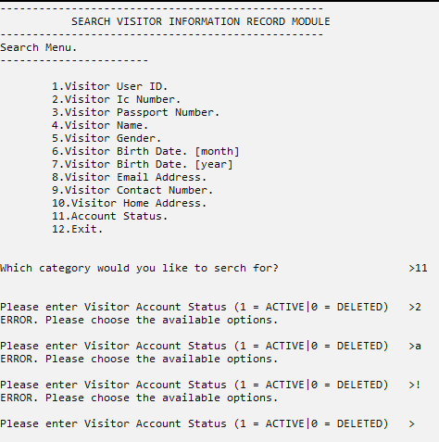

*Figure 4.1.40 shows the invalid input of account status in search module.*

# **4.2 Venue information module by < Tan Yan Pin >**

## 4.2.1 brief description

Venue information module is a module that stores all the information about the venue like venue id, venue name, venue operating time, and others. This module is mainly for admin only and visitors will not be able to access this venue information module. This module allows users to add, modify, display, search, make reservations and delete the venue record.

## 4.2.2 Outputs & Files Contents

First when the admin goes into the venue information module, this menu will show where all the available functions will display for admin and let admin to choose which function they want to perform, we have add, modify, display, search, make reservation and delete functions that can be performed by admin.

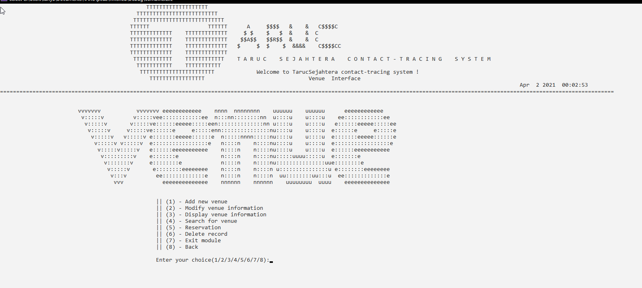

*Figure 4.2.2.1 venue information menu*

1. **Add Menu function**

If the admin chooses an add function, this menu will show up where it will let the admin key in the detail of the new venue like venue category, name, maximum visitor, etc.

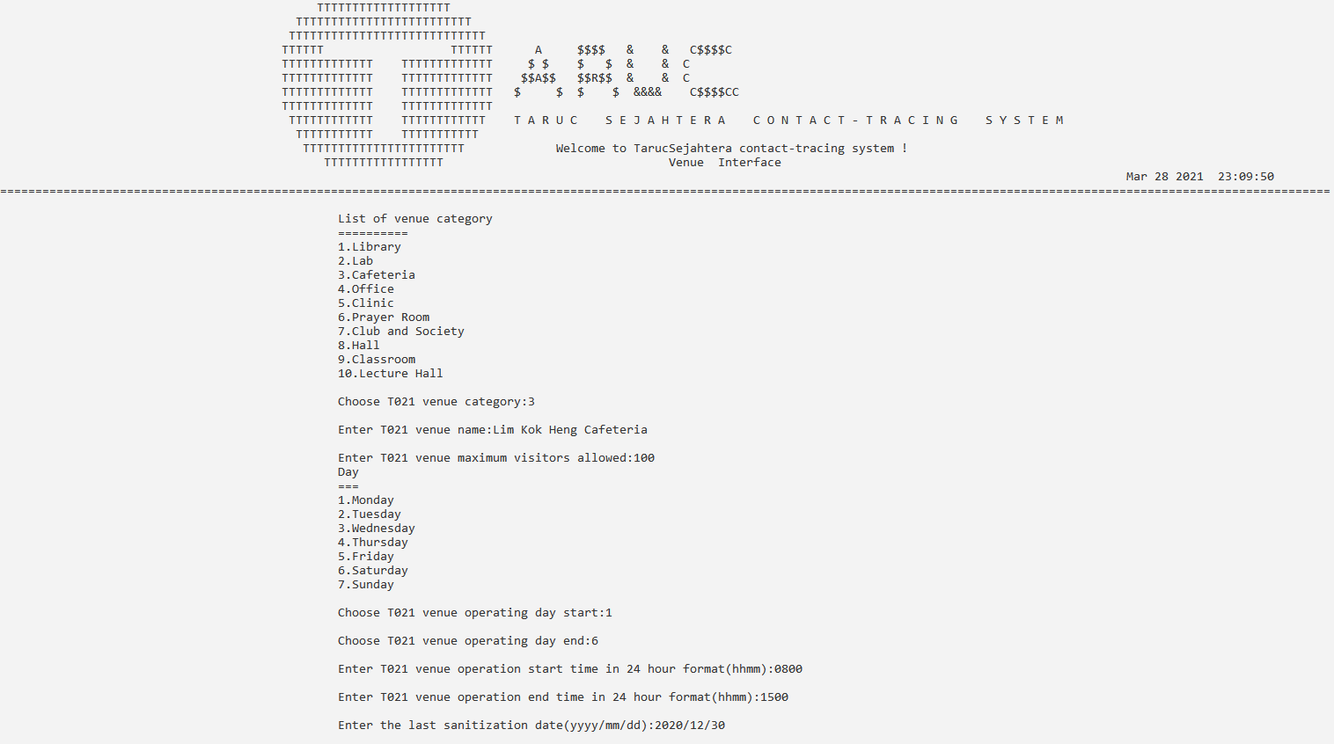

*Figure4.2.2.2 add function entering new information*

After they choose the correct venue category, the program will

After the admin key in the detail, the newly inputted venue information will be displayed out for admin and ask the user if they want to continue adding another venue information or go back to venue information menu

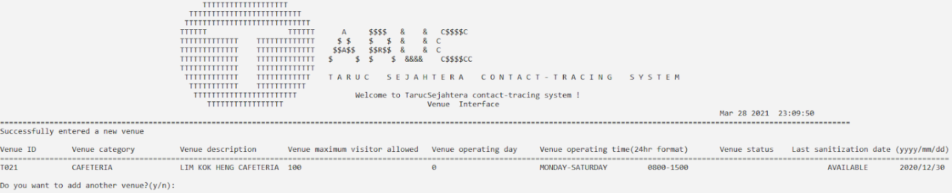

*Figure 4.2.2.3 displays out the new venue information*

Validation check for add function

* Validation check(1)

When the user key is in alphabet or any number that is greater than 10 or smaller than 0, the program will ask the user to enter again until the user enters the correct digit.

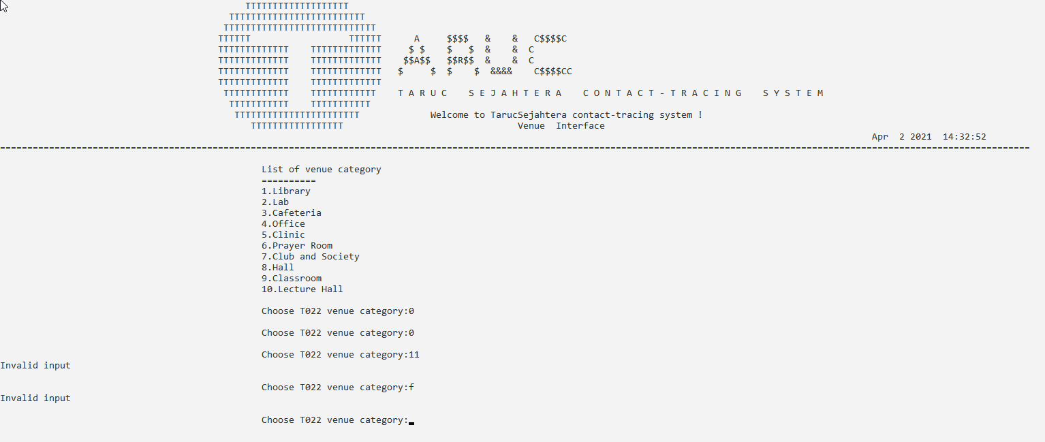

*Figure 4.2.2.4 check if the input is digit and within the range of 1 to 10*

* Validation check(2)

The program will run an existing check on the venue name, if the venue name already exists in the record, an error message will come out and prompt the user to re-enter again.

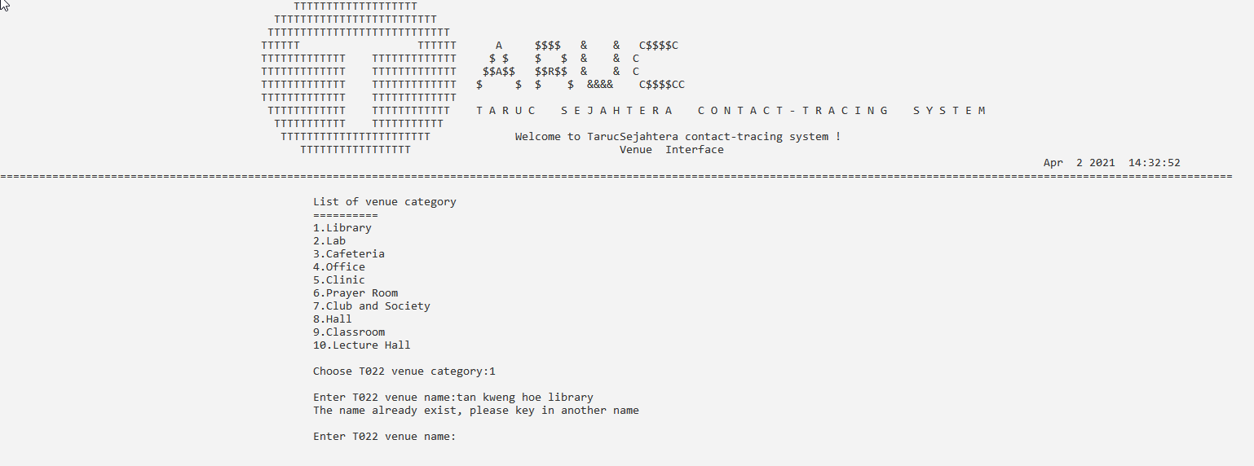

*Figure 4.2.2.5 user entered existing name*

* Validation check(3)

For maximum visitor allowed, the program will only check if the input is digit or not, if not, the program will prompt user to enter again

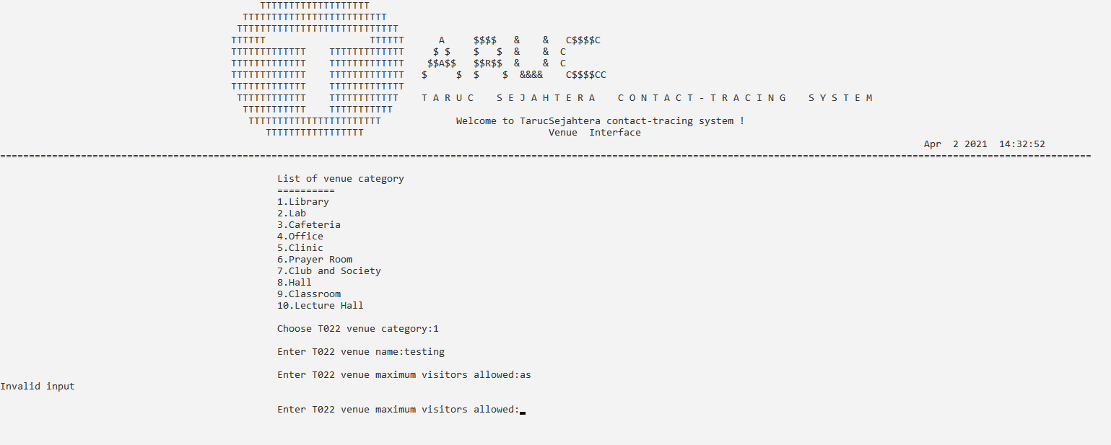

*Figure 4.2.2.6 check digit*

* Validation check(4)

If the operating day start time is earlier than the end time, the program will prompt the user to re-enter again

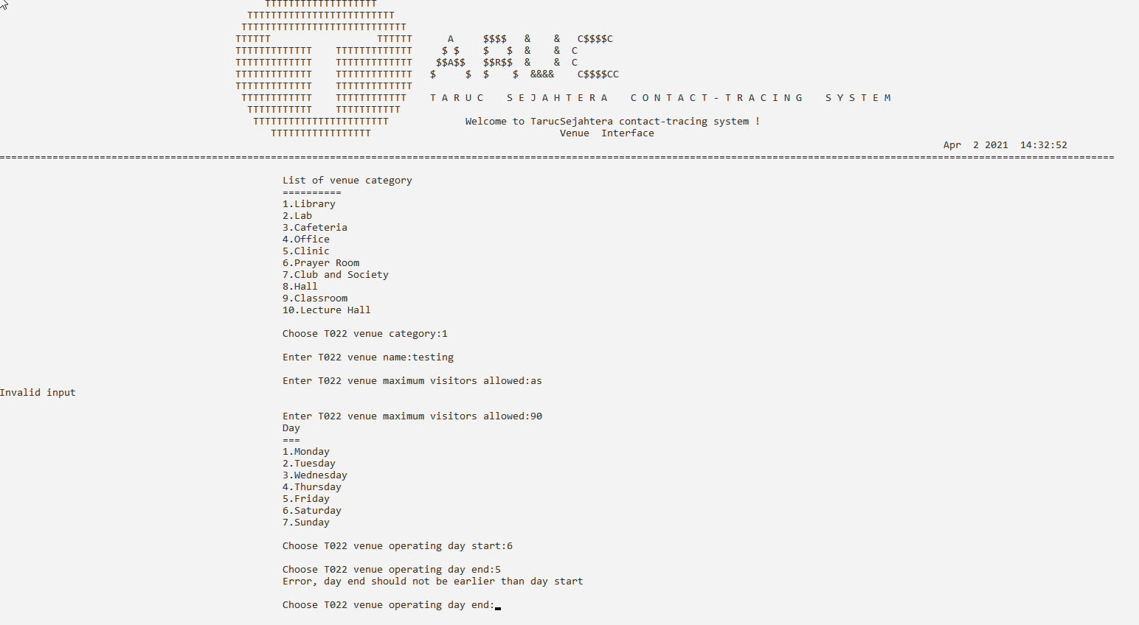

*Figure 4.2.2.7 check operating day*

1. **Modify venue function**

When the user selects modify venue information, a list of venue information will be displayed and let the user key in the ID of the venue that they wish to modify.

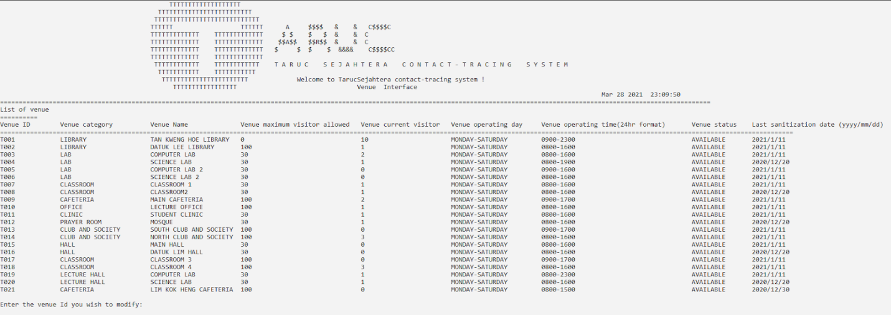

*Figure 4.2.2.8 list out all venue information and let user choose*

Once they select the venue that they want to modify, this menu will show up the venue detail and displays all time of the data field that the user can modify and let the user choose.

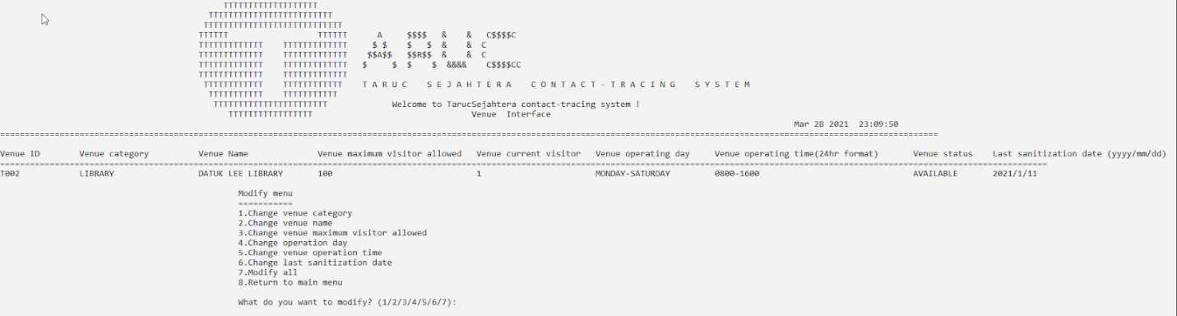

*Figure 4.2.2.9 modify menu*

Once they select the field type they want to modify, the program will prompt the user to key in the new data to replace the old one, below use “modify all” choices as an example as it updates all the datafield in the venue information.

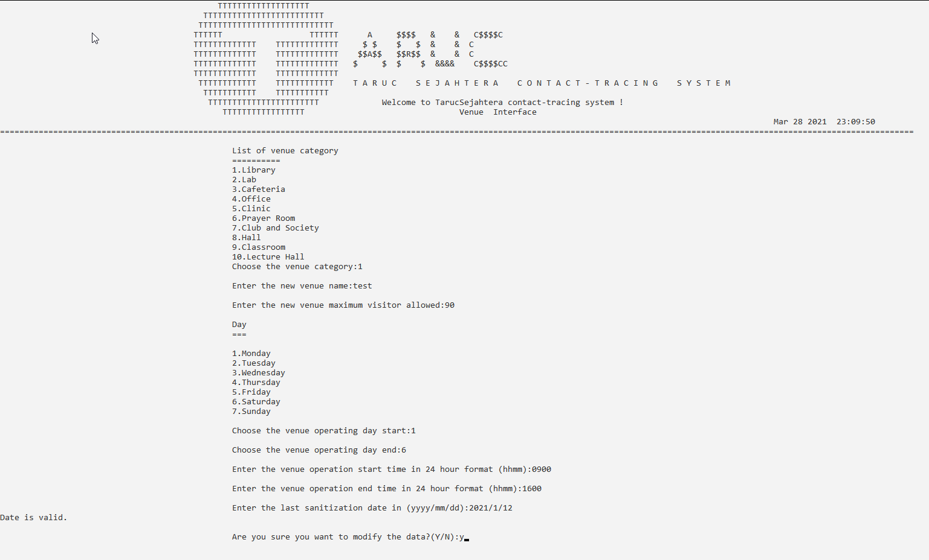

*Figure 4.2.2.10 entered new information to modify the venue information*

After they key in every information for the venue, the program will ask the user if the user wants to modify the record, if they choose yes, then the record will be updated to the new data and display the updated record to the user, and ask if they want to modify other records.

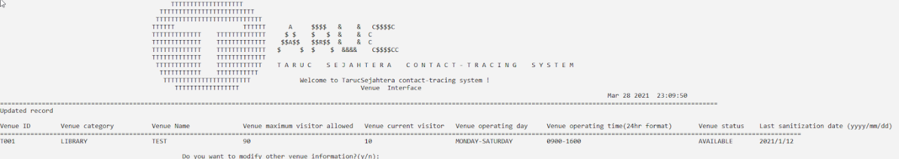

Figure *4.2.2.*11 display the updated venue information and prompt user to do again or quit

If the user chooses to modify another record, the function will loop and redo the first step where it lists out all the records and let the user choose which venue they want to modify.

Validation check on modify function

* Validation check (1)

The program will do an existing check on the record id, if the id that the user entered does not match to any existing record, the program will ask if the user wants to modify another record and then let the user enter the id again.

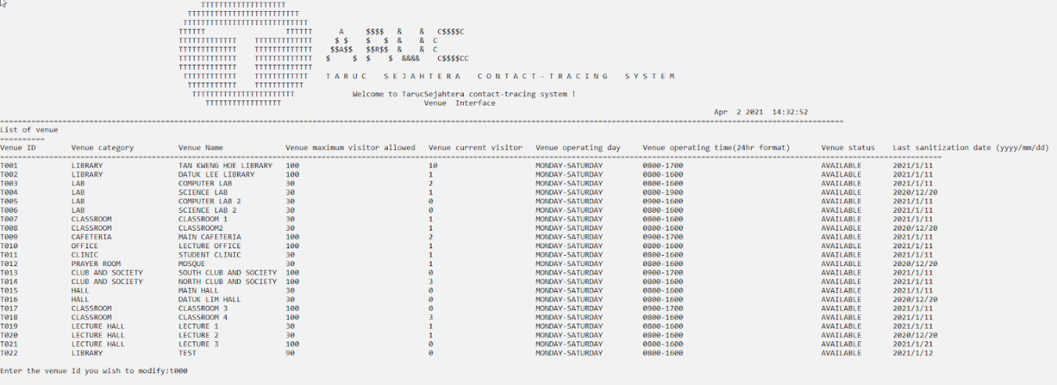

*Figure 4.2.2.12 entering venue id that doesn’t exist*

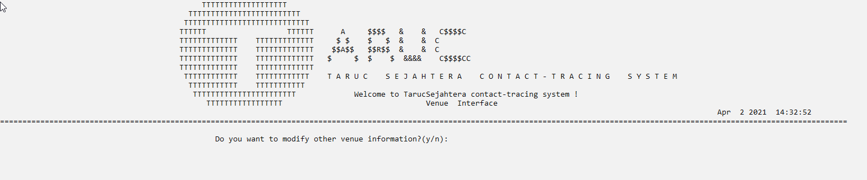

*Figure 4.2.2.13 error message*

* Validation check (2)

When the user key is either alphabet or number that is greater than 8 or smaller than 0, the program will prompt the user if they want to modify it again then let them enter the id again.

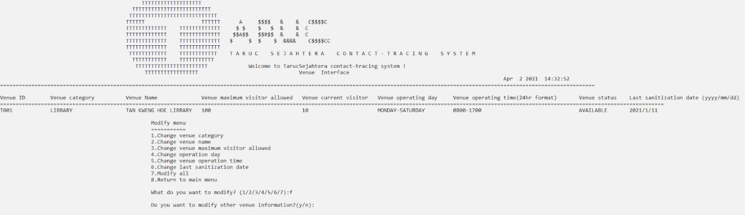

*Figure 4.2.2.14 user entered alphabet*

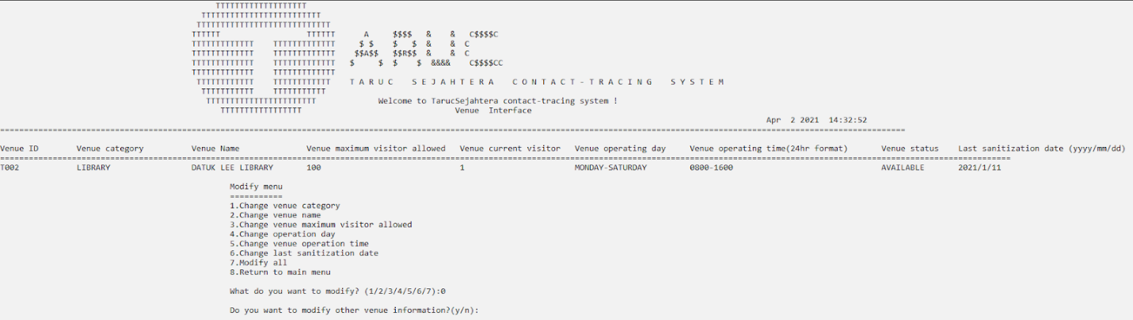

*Figure 4.2.2.15 user entered invalid value*

* Validation check (3)

When the user enters the alphabet or number greater than 10 or smaller than 1, the program will prompt the user to enter again.

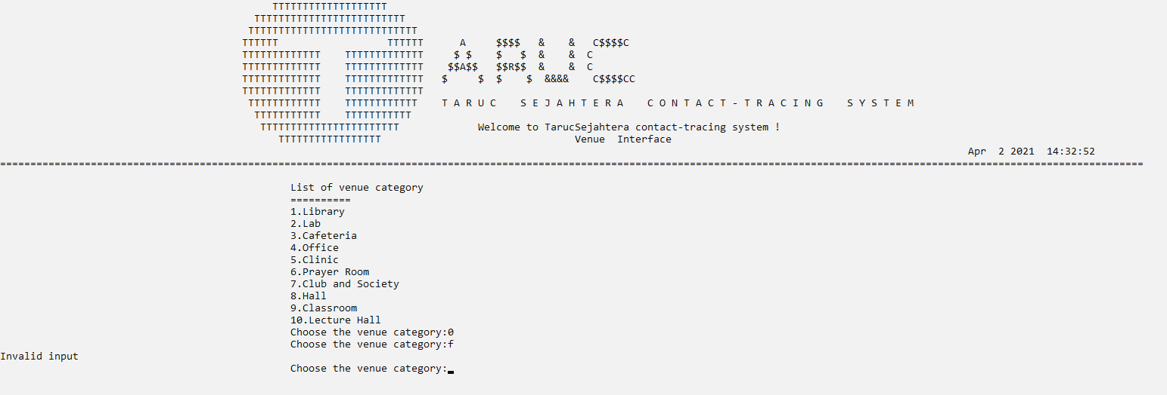

*Figure 4.2.2.16 invalid input error*

* Validation check (4)

When the name entered already exist in the record, the program will prompt the user to enter again

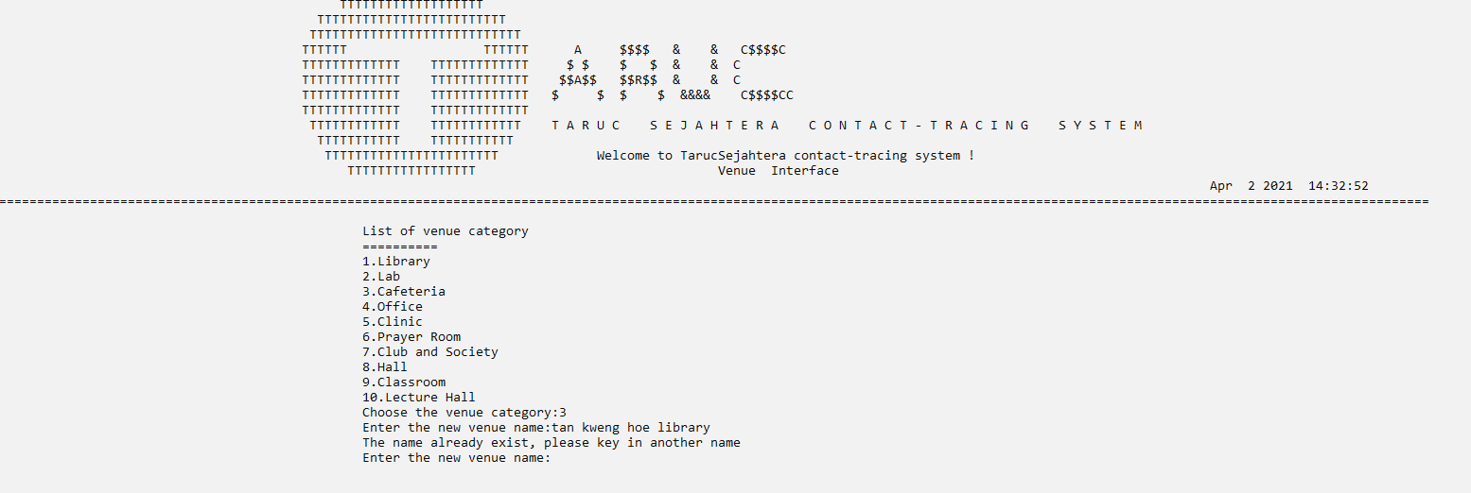

*Figure 4.2.2.17 existed name*

1. **Display venue function**

For display function, it's very straightforward. First, there are 2 types of records that the user can view. First one displays all the venue information and the second choice displays all the reservation records.

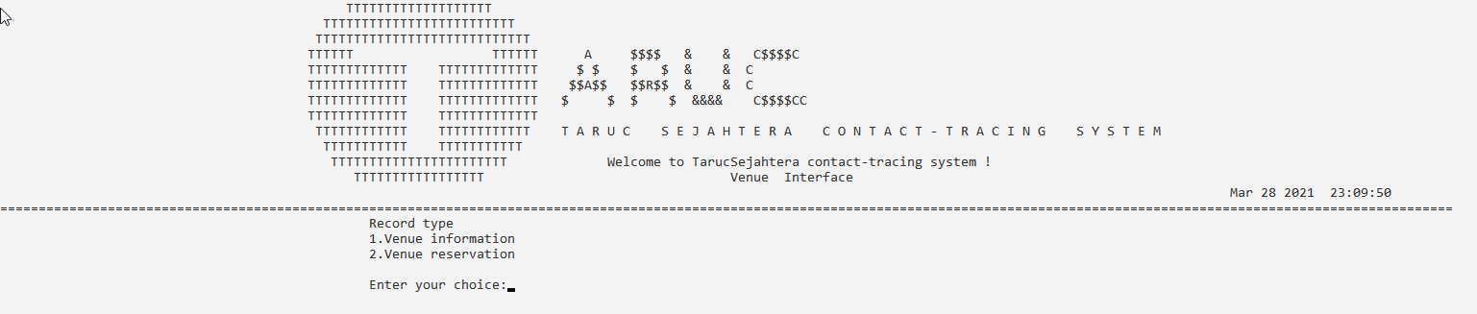

*Figure 4.2.2.18 display menu*

If the user chooses to display all the venue information, the program will display all venue information and prompt the user if they want to display again. If they choose yes, then the program will loop to the first picture and let them choose what record to display again.

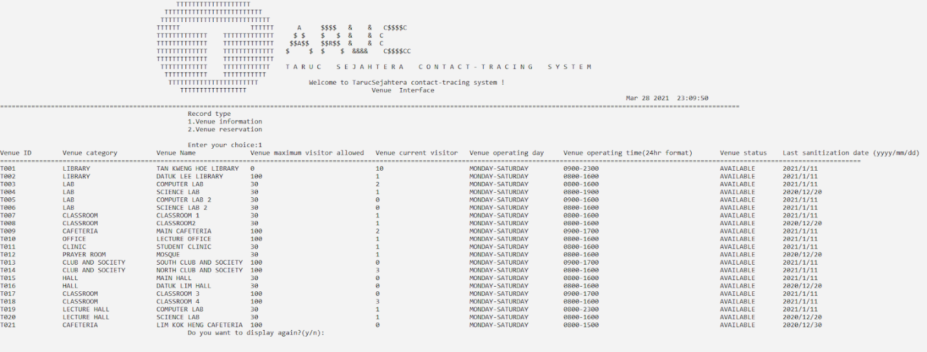

*Figure 4.2.2.19 displays all the record for the selected record type*

1. **Search venue function**

For search function, the program will display all types of data fields that can be searched by the user. The user will have to choose which data field they want to search.

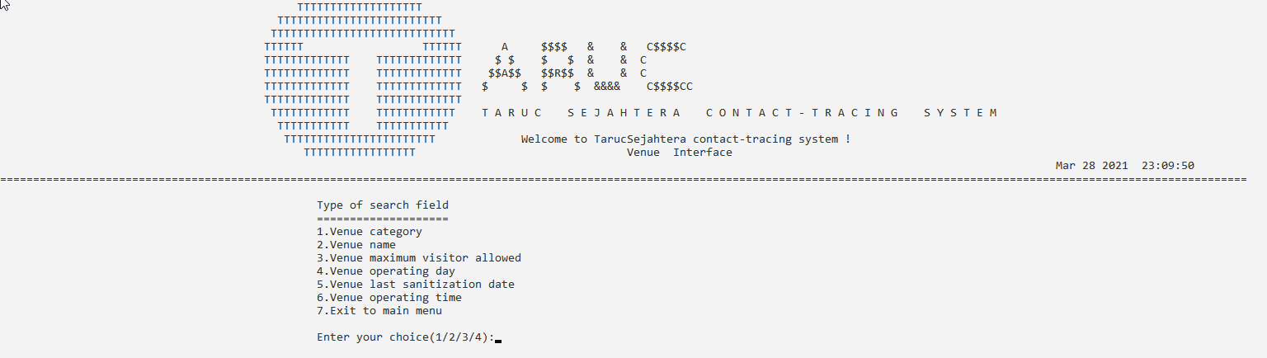

*Figure 4.2.2.20 search menu*

After they choose what data field they want to search, the program will prompt them to either key in the key word that they want to search or select a certain keyword to search.

Once they key in the keyword, the program will display all the records with the same keyword.

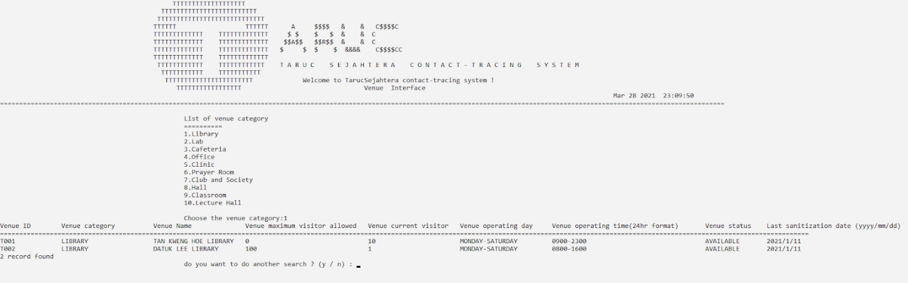

*Figure 4.2.2.21 entered searching keyword and result*

1. **Reservation venue function**

The extra function for venue information is reservation, where the user can make reservations for the venue for certain cases like cleaning, renovating and others. First the program will display all the venue information and let the user key in the venue id that they want to make reservations.

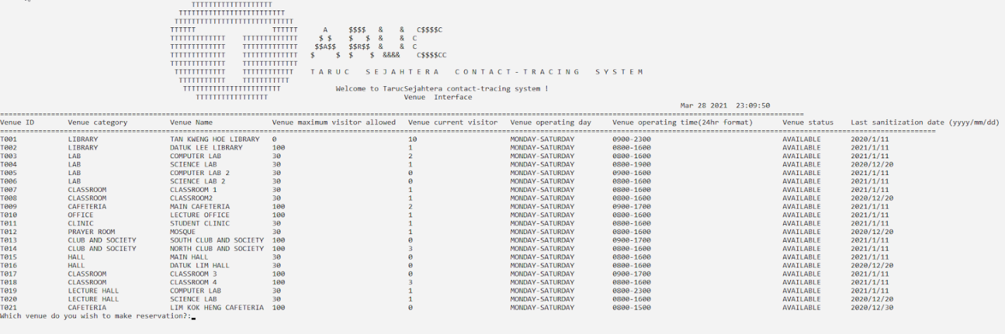

*Figure 4.2.2.22 list of venue to let user choose*

After they key in the venue id that they want to make a reservation, the program will prompt the user to enter the date and time of the reservation. Then the program will display the info that the user just entered and reservation will be made.

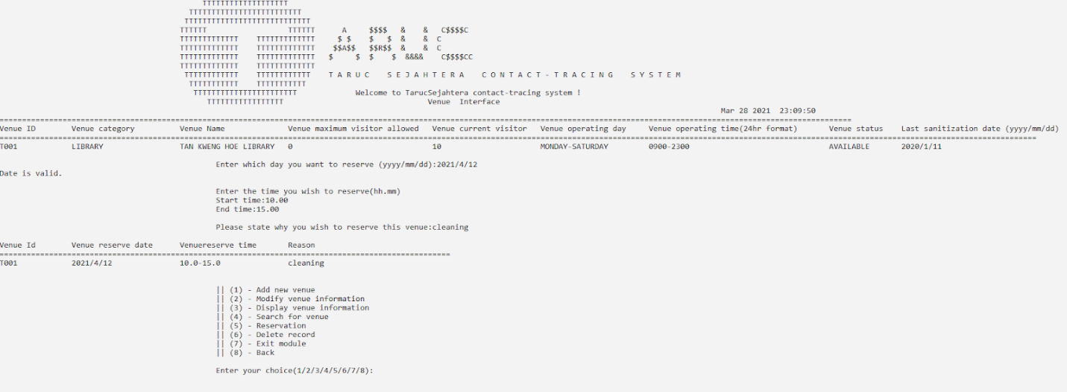

*Figure 4.2.2.23 display the reservation date and time after they successfully make the reservation*

* Validation check (1)

When the date that the user entered is earlier than today’s date, the program will prompt the user to enter the date again.

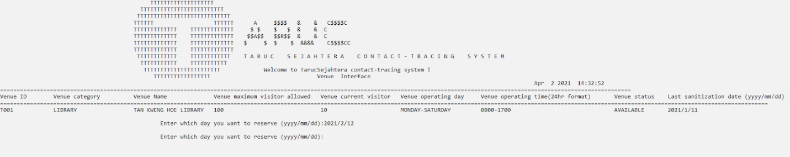

*Figure 4.2.2.24 entering past date*

* Validation check (2)

When the user enters the time that is earlier or later than the venue’s operating time, the program will prompt the user to enter the time again.

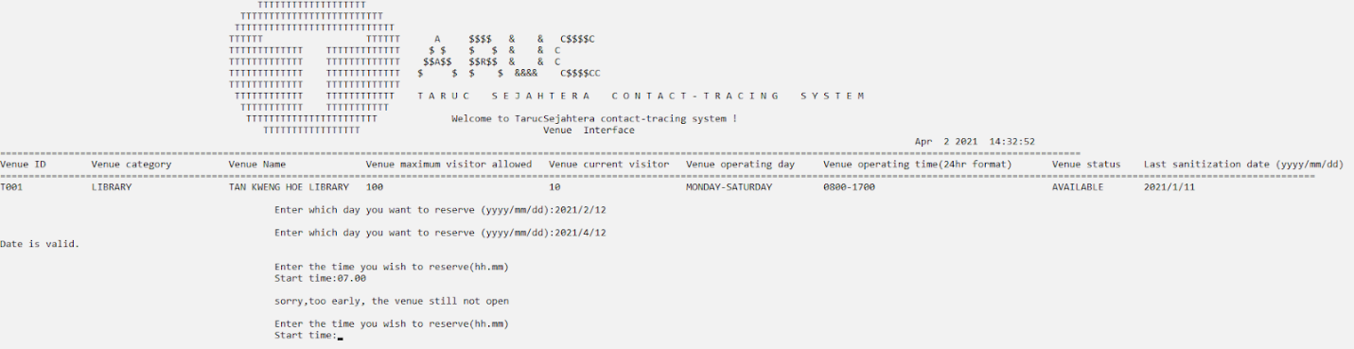

*Figure 4.2.2.25 the user enter time earlier than starting operating time.*

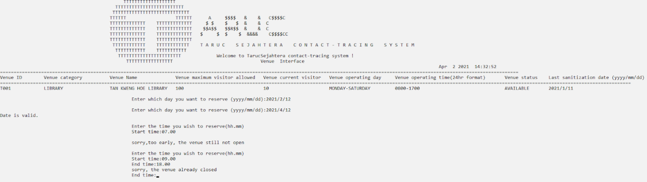

*Figure 4.2.2.26 the user enters the ending time later than the operating time ends.*

1. **Delete venue function**

When users want to delete the venue information record, they have to key in the venue id that they wish to delete, if the record is found, the program will display the venue information out and prompt users if they are sure they want to delete.

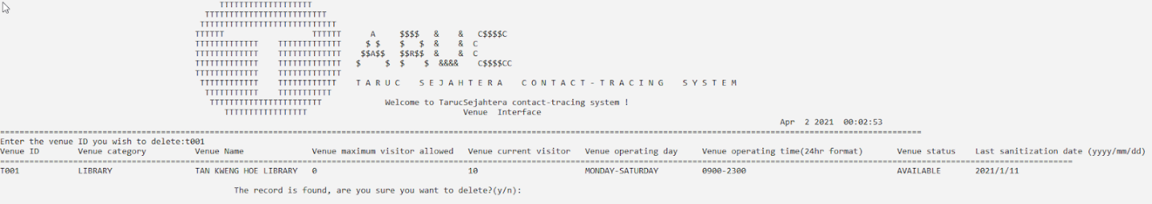

Figure *4.2.2.27 display the venue information and confirmation message*

 If yes then the reservation will be deleted and the program will ask if the user wants to delete another record.

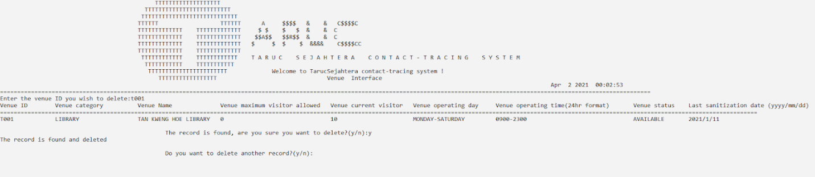

*Figure 4.2.2.28 deleted record message and prompt user if they want to repeat again*

# **4.3 Administrative Staff Module by <Cheng Ling Ern>**

## 4.3.1 Brief Description

The Administrative module of TarucSejahtera Contact-Tracing system is the module that stores all the administrative personal information, especially admin ID and password. This is because if the existing admin *(i.e. those who will log in and perform activities on various aspects of the system)* wants to perform any data modification on the existing records (e.g. admin record, visitor record, venue records etc.), then he/she has to first login into their personal account. (refer to figure 4.1.2) for authentication purposes.

## 4.3.2 Outputs & File Contents

1. **Login Function**

Before the admin is able to perform any actions of data modification, he/she has to first direct to the admin login interface for login authentication.

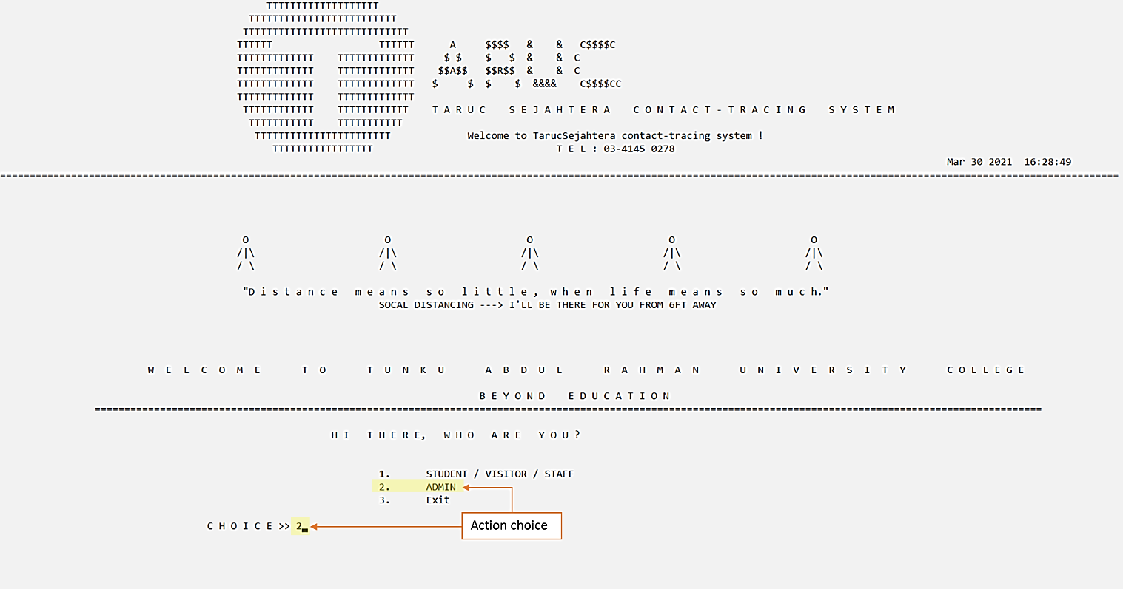

*Figure 4.1.1 Home page (main)*

Then, the user has to input his/her admin/staff ID, along with the corresponding account password. If the user has been verified successfully, he/she will be directed to the main menu (admin side). Else, login denied message will be prompted.

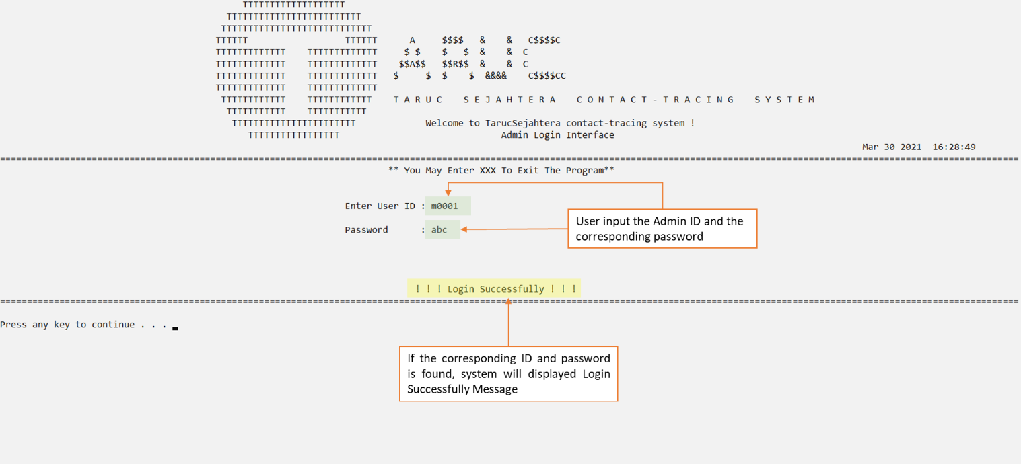

*Figure 4.3.2 Admin Login Interface*

User is directed to the main menu (admin side) after login successfully.

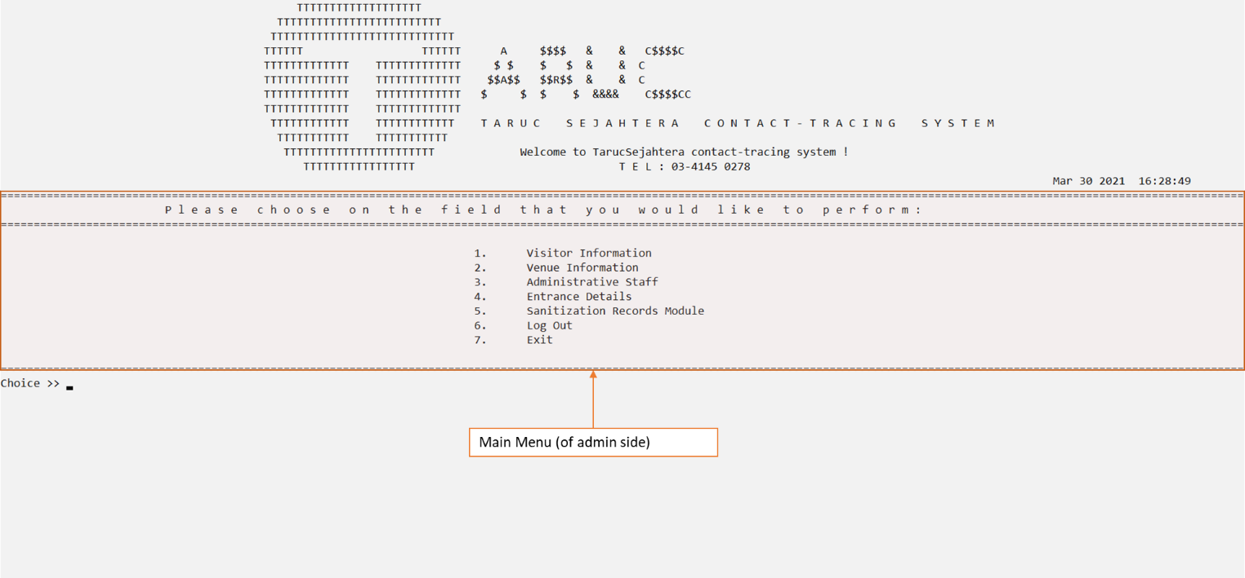

*Figure 4.3.3 Main Menu (of admin side)*

* **Login Validation Check**

**Validation 1**: For login module, if the user input the existed admin/staff ID with incorrect password, then the system will show error message of “Incorrect Password.”

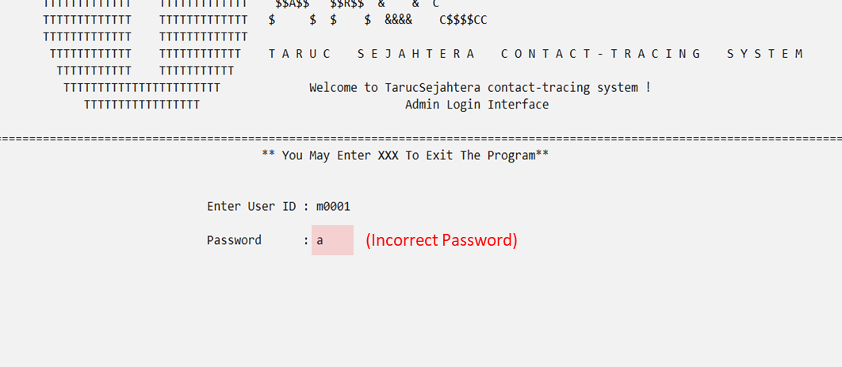

*Validation figure 1: Screenshot of wrong password entered (1)*

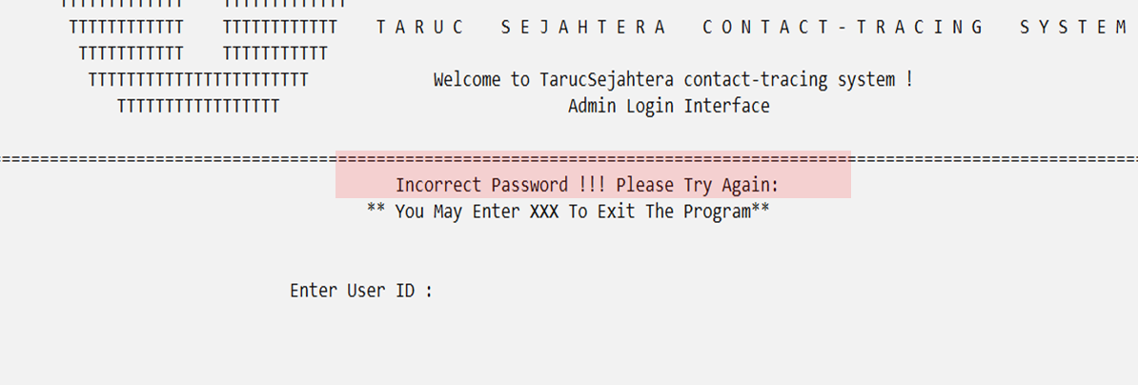

*Validation figure 2: Screenshot of wrong password entered (2)*

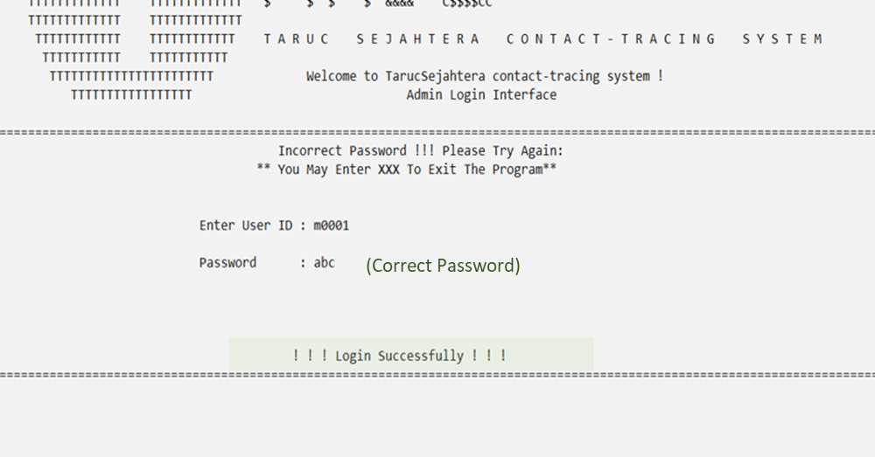

*Validation figure 3: Screenshot of wrong password entered (3)*

**Validation 2**: If the user input the admin/staff ID which is not existed, then the system will show error message of “User does not exist.”

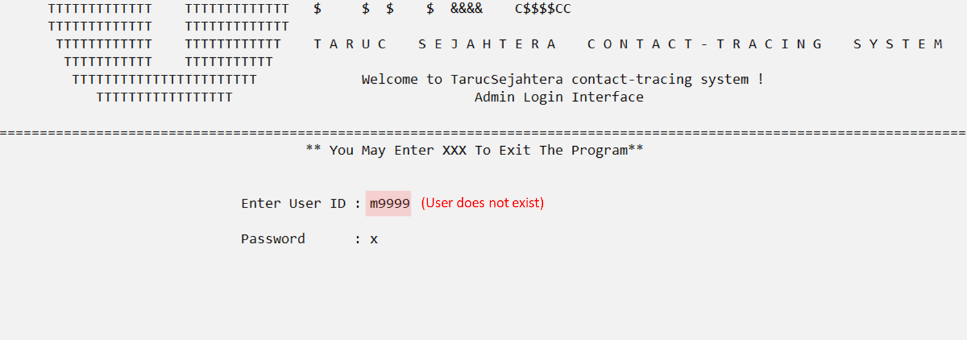 *Validation figure 4: Screenshot of invalid id entered (1)*

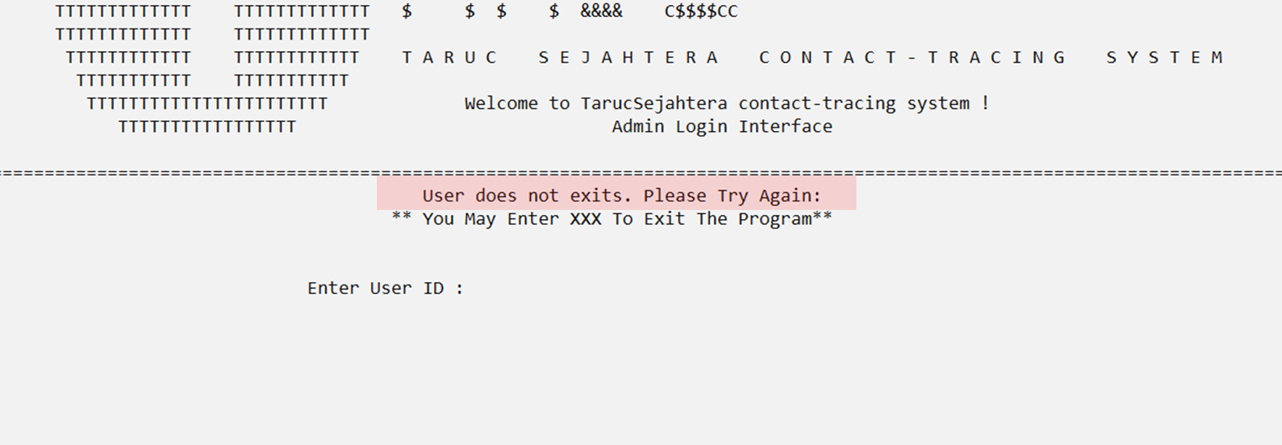 *Validation figure 5: Screenshot of invalid id entered (2)*

1. **Register New Admin (Add New Record Function)**

If the existing admin wants to add another employee of TARC UC as a new admin, he/she has to first login into their personal account. (refer to figure 4.1.2) After the authentication process has been succeeded proved, he/she can go into the Administrative module by choosing the number of 3 in the main menu (refer to figure 4.1.3), then he/she will be directed to the admin login interface (admin module) and now he/she can just choose 1 (action choice) to add new user admin.

Firstly, the user has to input all the related admin personal information of the new admin. (Related validation fields will be provided in the section below) Once the record has been successfully saved, the system will prompt a “Record Saved” message to inform the end-user.

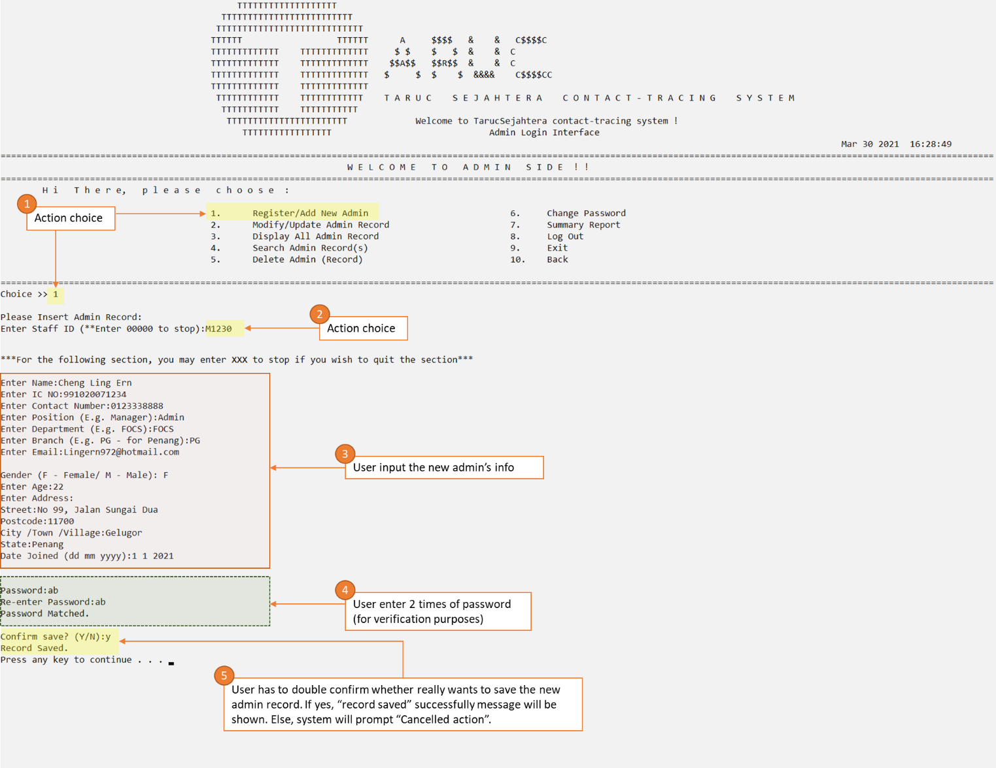

*Figure 4.3.4 Screenshot of Add New Admin Record*

* **Input data validation check**

**Validation 3**: If the user input the invalid admin/staff ID (e.g. not existed), then the system will display error message (loop) until the user input the valid id.

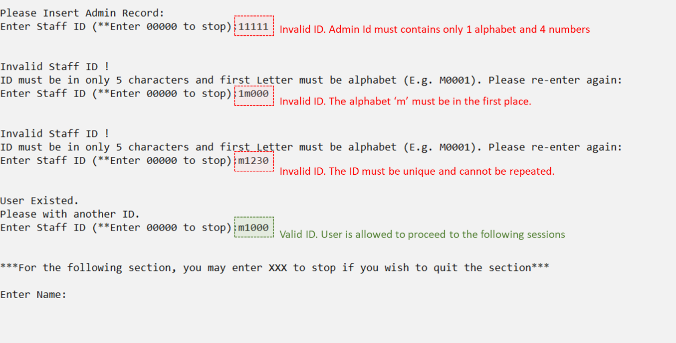 *Validation figure 6: Screenshot of invalid id entered*

**Validation 4**: If the user input the invalid IC numbers, then the system will display error message (loop) until the user input the valid IC no.

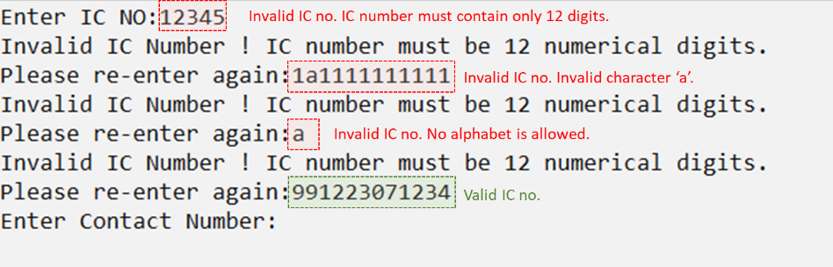

*Validation figure 7: Screenshot of invalid IC no entered*

**Validation 5**: If the user input the invalid branch, then the system will display error message (loop) until the user input the valid branch abbreviation.

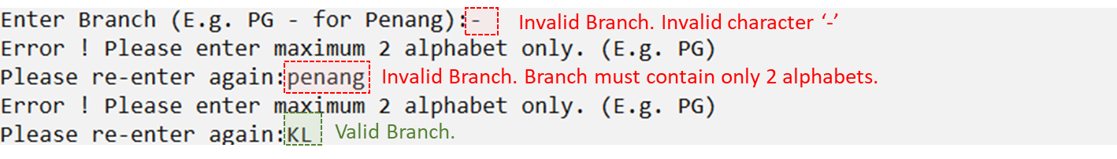 *Validation figure 8: Screenshot of invalid branch abbreviation entered*

**Validation 6**: If the user input the invalid email address, then the system will display an error message (loop) until the user input the valid email address.

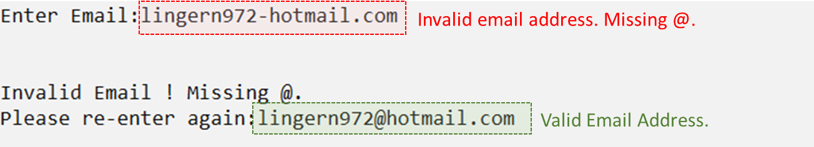 *Validation figure 9: Screenshot of invalid email entered*

**Validation 7**: In order to prevent or minimize data entry error, auto assign gender feature is adopted.

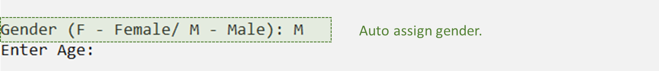 *Validation figure 10: Screenshot of auto assign value （gender）*

**Validation 8**: If the user input the invalid postcode, then the system will display an error message (loop) until the user input the valid postcode number.

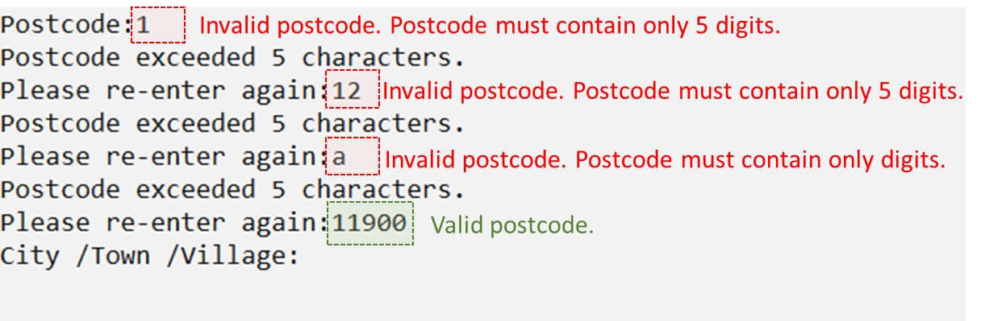

*Validation figure 11: Screenshot of invalid postcode entered*

**Validation 9**: If the user input the invalid date, then the system will display an error message (loop) until the user input the valid date (include valid day, month and year).

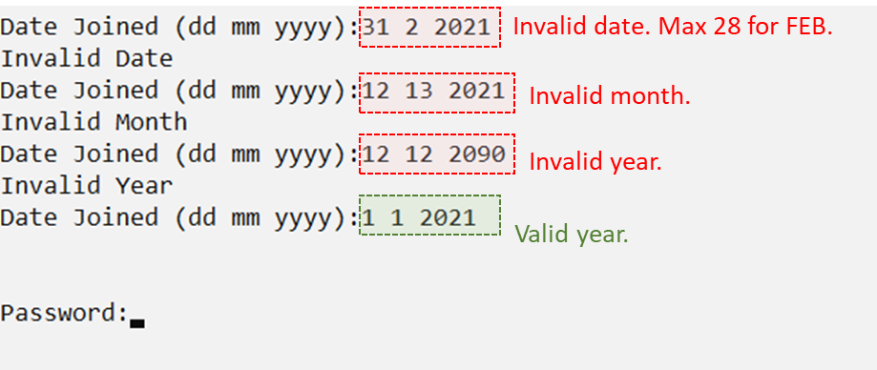

*Validation figure 12: Screenshot of invalid date entered*

1. **Update Admin Info** (Modify Function)

If the admin wants to update his/her own information, or even others admin information, the admin has to first login into their personal account (refer to figure 4.1.2) , after the authentication process has been succeeded proved, he/she can go into the Administrative module by choosing the number of 3 in the main menu (refer to figure 4.1.3) , then he/she will be directed to the admin login interface (admin module) and now he/she can just choose 2 (action choice) to make modification on the existing admin records.

Now, the user has to first enter the admin id to be updated, the record will be displayed if the admin existed. Else, the system will display no record found message. If the admin exists, the user is now required to input all the updated admin info in the following spaces provided.  (Related validation fields will be provided in the section below) Once the record has been updated successfully, the system will prompt a “Record Updated” message to inform the end-user.

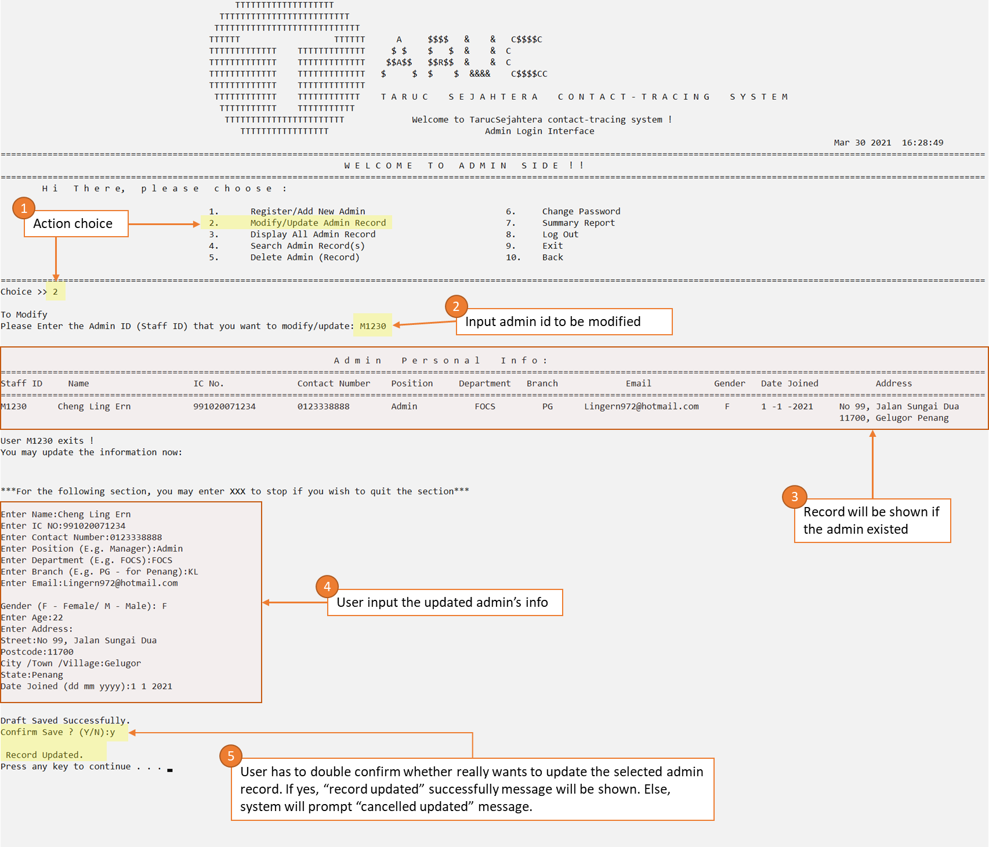

*Figure 4.3.4 Screenshot of Update Existing Admin Record*

1. **Display all Admin Records** (Display Function)

If the admin wants to display all the existing admin records, the admin has to first login into their personal account (*refer to figure 4.3.2*), after the authentication process has been succeeded proved, he/she can go into the Administrative module by choosing the number of 3 in the main menu (*refer to figure 4.3.3*), then he/she will be directed to the admin login interface, and now he/she can just choose 3 (action choice) to view all the existing admin records.

All records will be displayed in a tidy table format (excluded password).

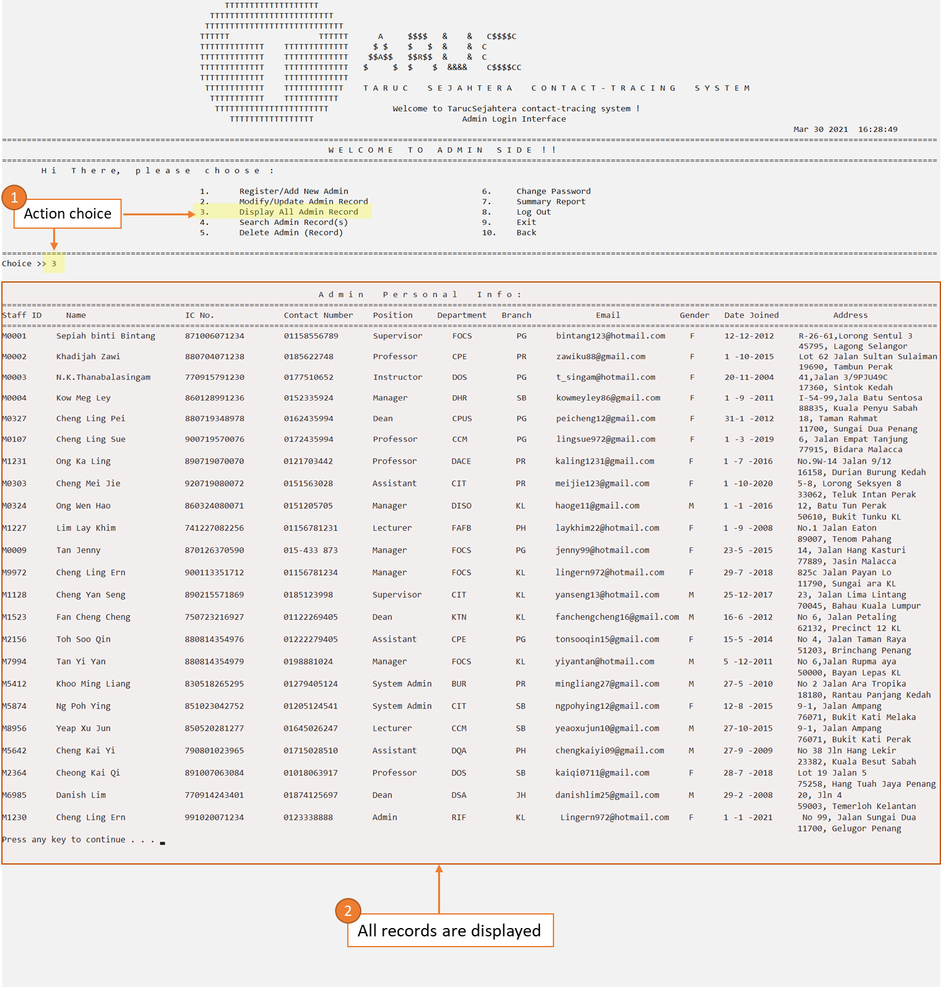

*Figure 4.3.5 Screenshot of Display all Admin Records*

1. **Search for Existing Admin Record(s)** (Search Function)

If the admin wants to search for the existing admin records based on the special conditions, the admin has to first login into their personal account, after the authentication process has been succeeded proved, he/she can go into the Administrative module by choosing the number of 3 in the main menu, then he/she will be directed to the admin login interface and now he/she can just choose 4 (action choice) to perform the search action.

1. User choose on the “search admin record(s)” by inputting the number “4”.

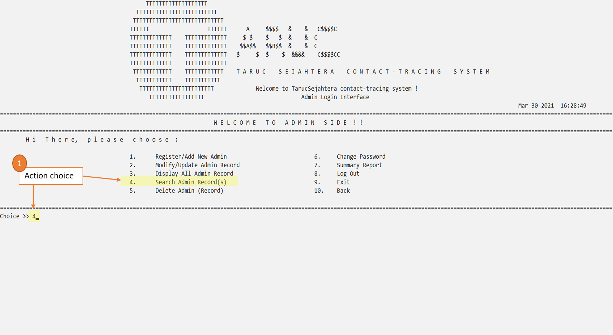

*Figure 4.3.6 Screenshot of Search Existing Admin Record (step 1)*

1. Note that the menu will be changed to prompt the user enter 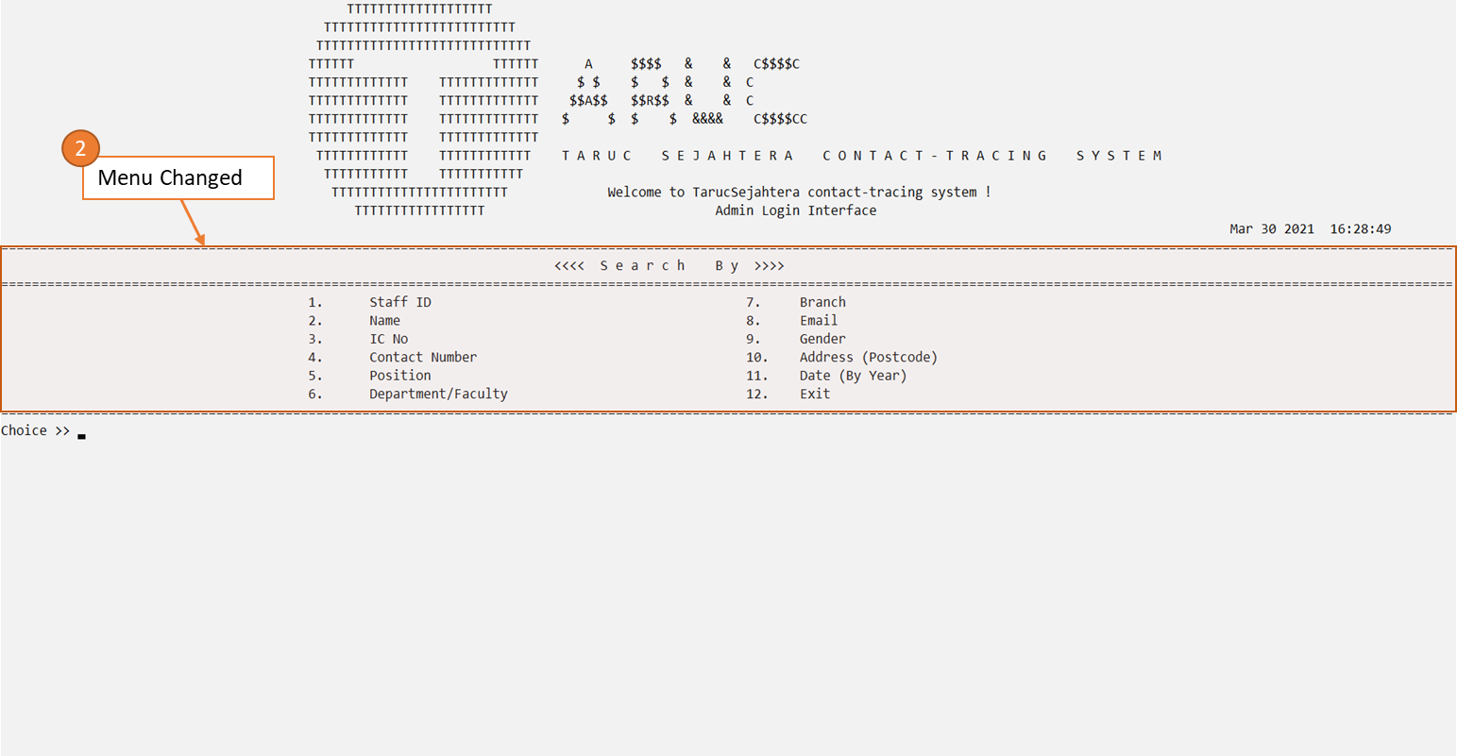which field to search.

*Figure 4.3.7 Screenshot of Search Existing Admin Record (step 2)*

3. If the user wants to search for the staff/admin Id, then just input “1”, the system will then ask for the admin Id to be searched.

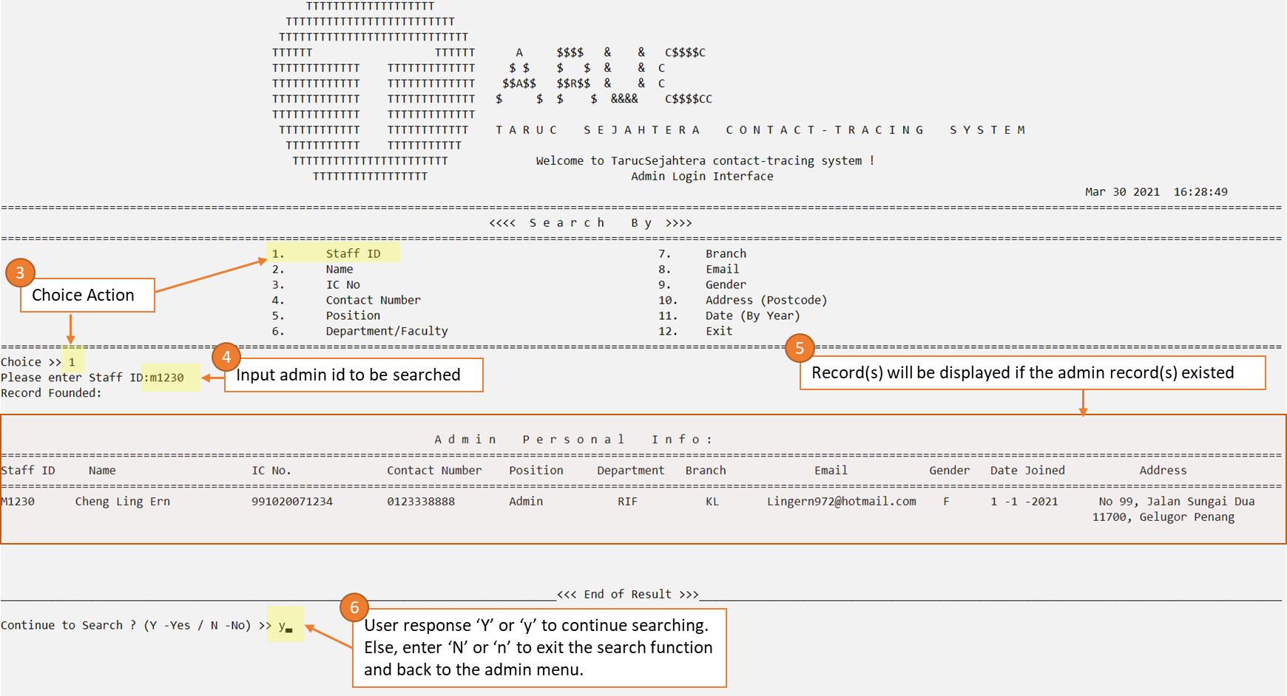

*Figure 4.3.8 Screenshot of Search Existing Admin Record (step 3)*

*If a user keeps on entering ‘Y’ or ‘y’ (indicated response – yes), the system will keep on looping the search function for user’s searching purposes until user input ‘N’ or ‘n’ (indicated response – No) to exit the search function. When user enter ‘N’ or ‘n’, the program will back to the admin menu:

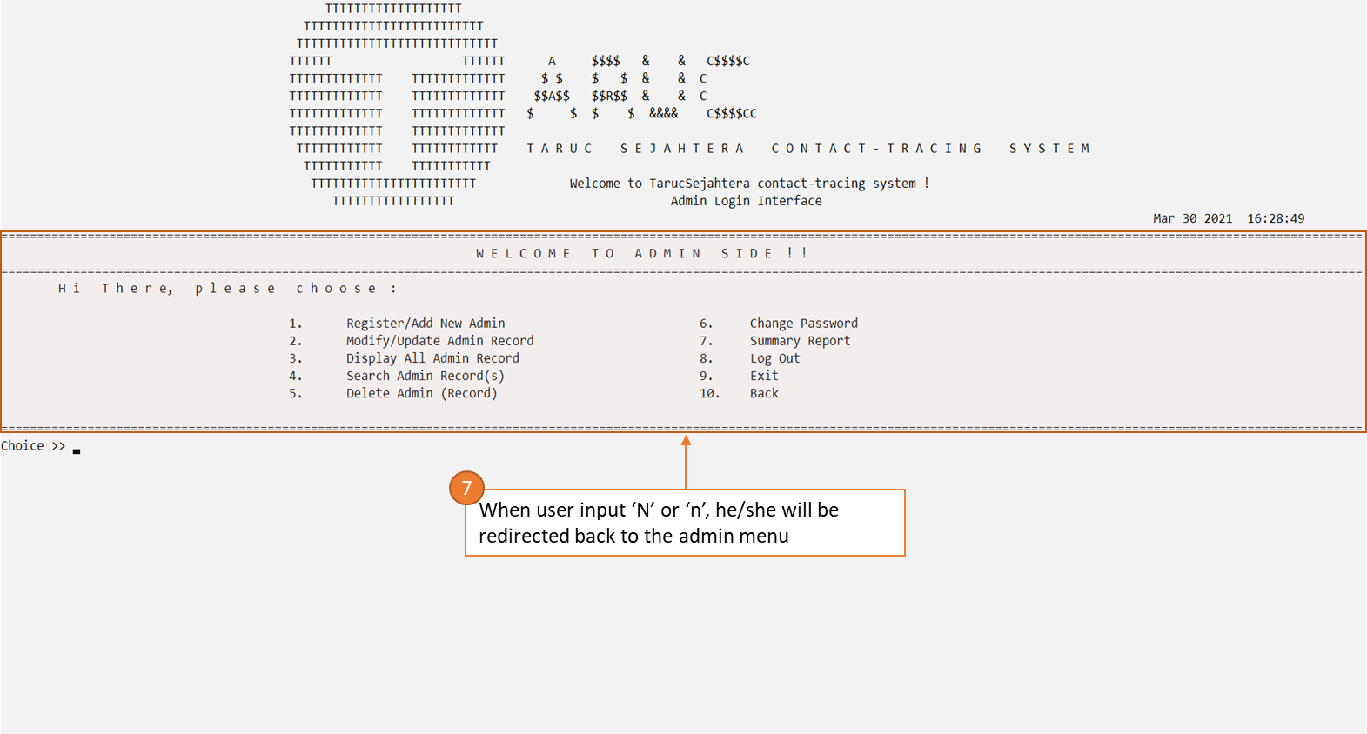

*Figure 4.3.9 Screenshot of Search Existing Admin Record (step to quit the search function)*

1. **Delete Existing Admin Record(s)** (Delete Function)

If the admin wants to display all the existing admin records, the admin has to first login into their personal account, after the authentication process has been succeeded proved, he/she can go into the Administrative module by choosing the number of 3 in the main menu, then he/she will be directed to the admin login interface and now he/she can just choose 5 (action choice) to perform delete action.

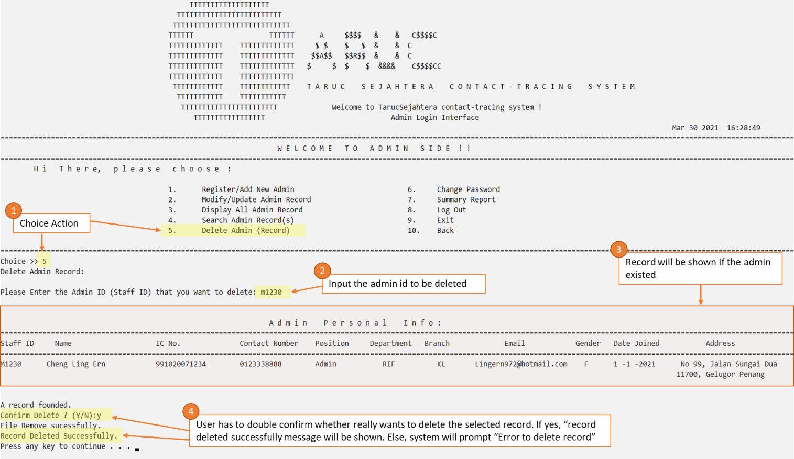

*Figure 4.3.10 Screenshot of Deleting Existing Admin Record*

Now, user is no longer able to found the staff/admin id after deleted.

However, in order to double confirm the record has been deleted successfully, let’s search again the deleted id (i.e. M1230) in the search function, to make sure the record is no longer save inside the system(file).

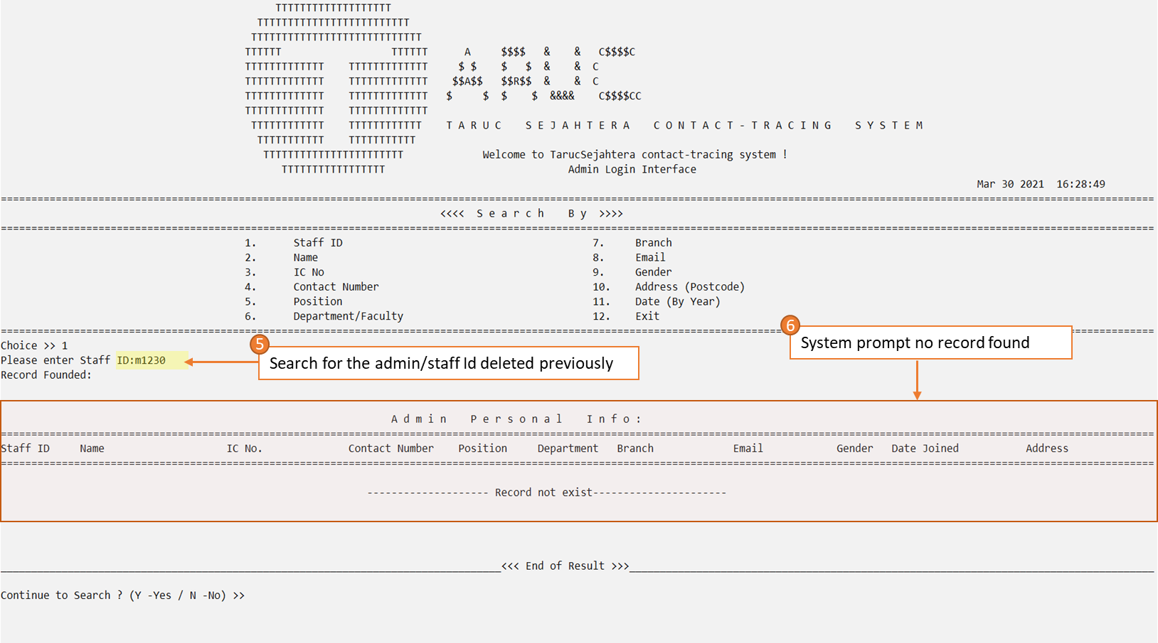

*Figure 4.3.11 Screenshot of Search record after deleting the record (i.e. M1230)*

1. **Change Admin’s Password (Modify/Update Function)**

If the admin wants to change his/her own password, the admin has to first login into their personal account, after the authentication process has been succeeded proved, he/she can go into the Administrative module by choosing the number of 3 in the main menu, then he/she will be directed to the admin login interface and now he/she can just choose 6 (action choice) to change his/her password.

*For changing password, although function is similar to modify function but the difference is the user must be the admin his/herself, this is to maintain the data integrity (of admin’s password). As the admin has to first enter his/her current password before they are allowed to enter the new password.

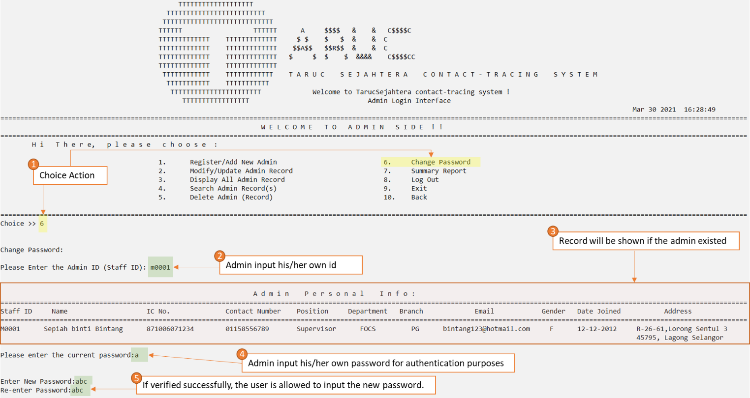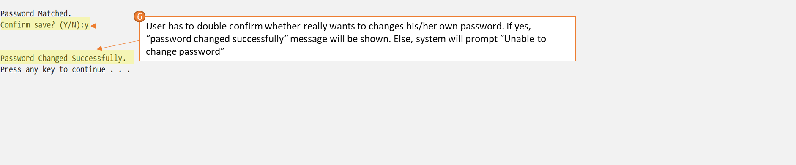 *Figure 4.3.12 Screenshot of changing password (admin)*

1. **Report Function**

If the admin wants to display and/or download the report, the admin has to first login into their personal account, after the authentication process has been succeeded proved, he/she can go into the Administrative module by choosing the number of 3 in the main menu, then he/she will be directed to the admin login interface and now he/she can just choose 7 (action choice) to view the report.

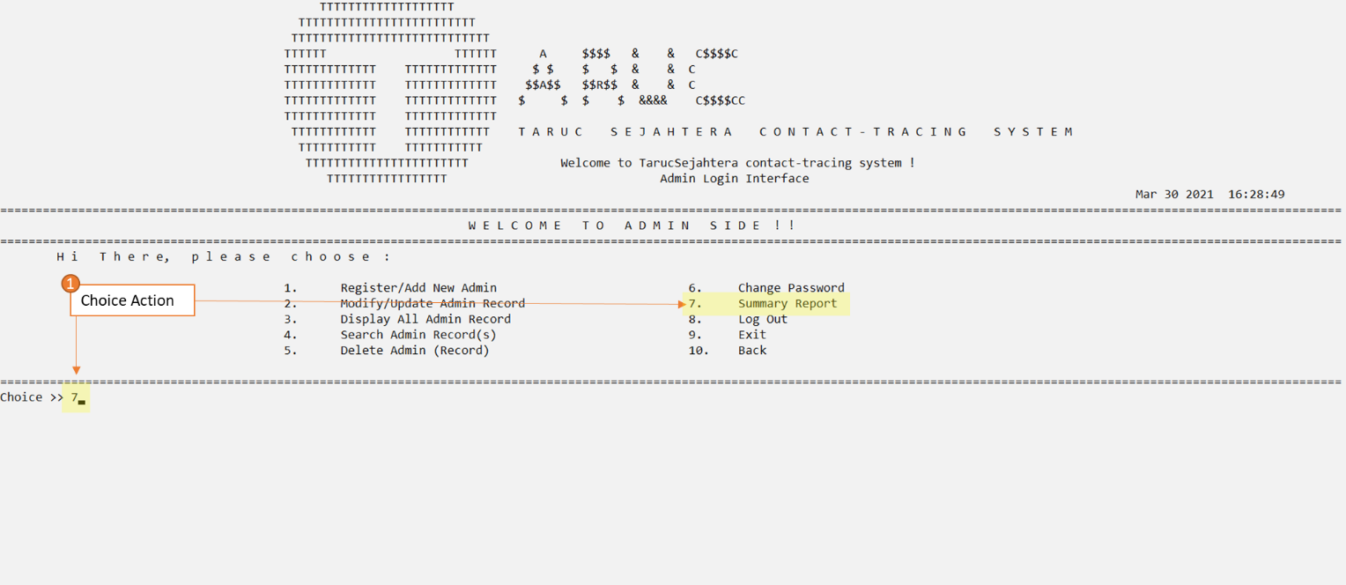

*Figure 4.3.13 Screenshot of generate report function (1)*

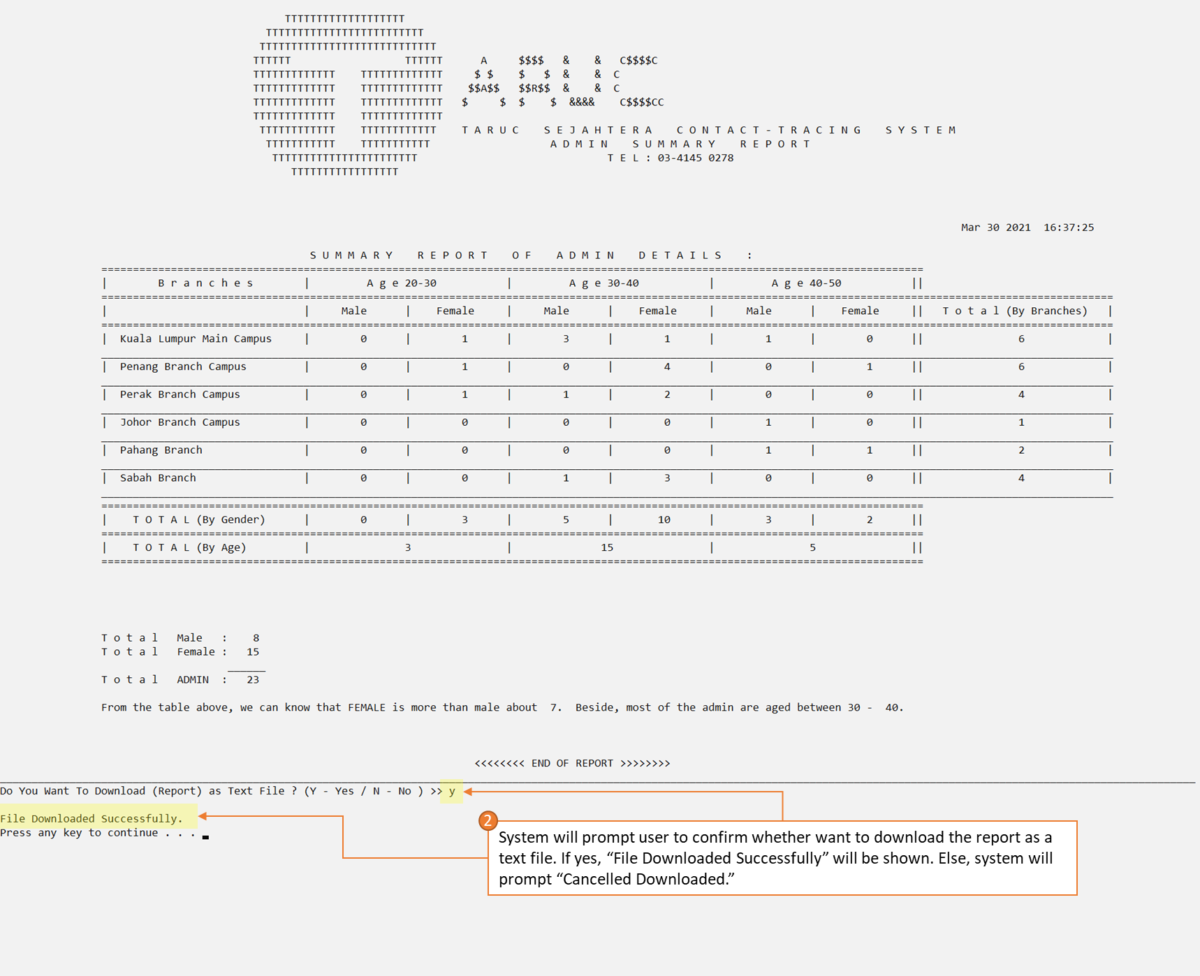 *Figure 4.3.14 Screenshot of generate report function (2)*

 *Figure 4.3.15 Screenshot of generate report function (3) – User may get it at the file explorer*

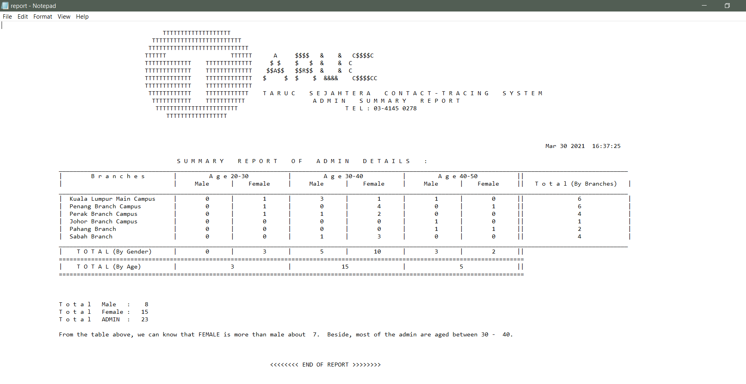 *Figure 4.3.16* *Screenshot of generate report function (4) – report is downloaded in a txt. format*

1. **Log out (not exit)**

If the admin wishes to logout (but not exit the program), then he/she may just choose 8 to logout his/her admin account and back to the login screen.

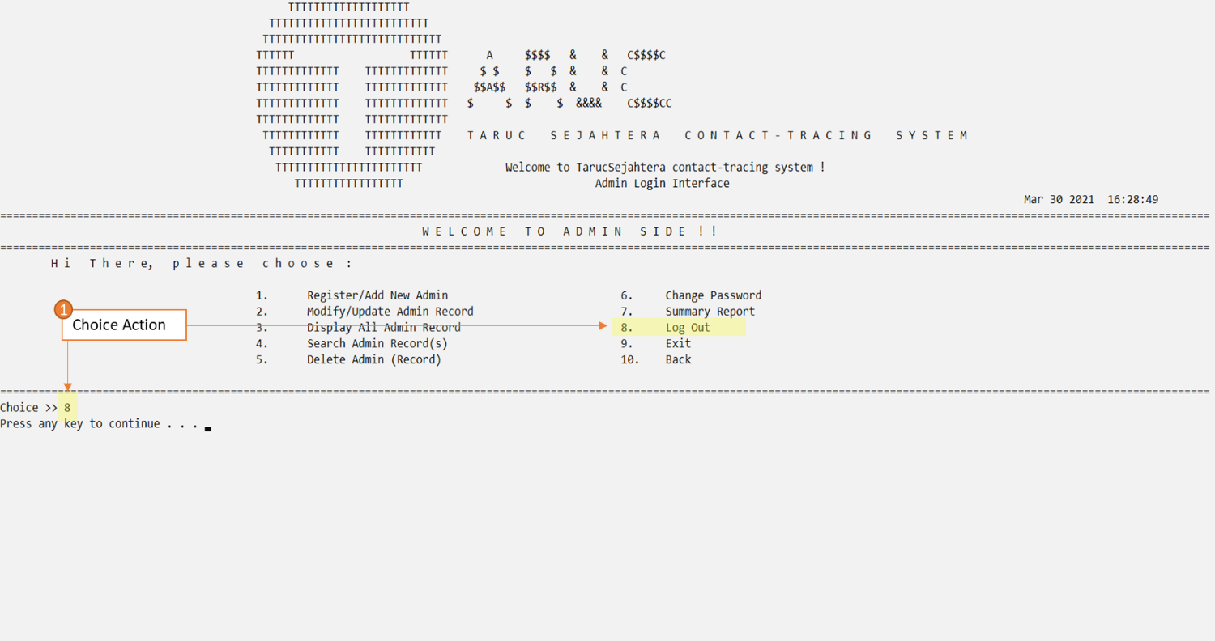 *Figure 4.3.17 Screenshot of logout (step 1)*

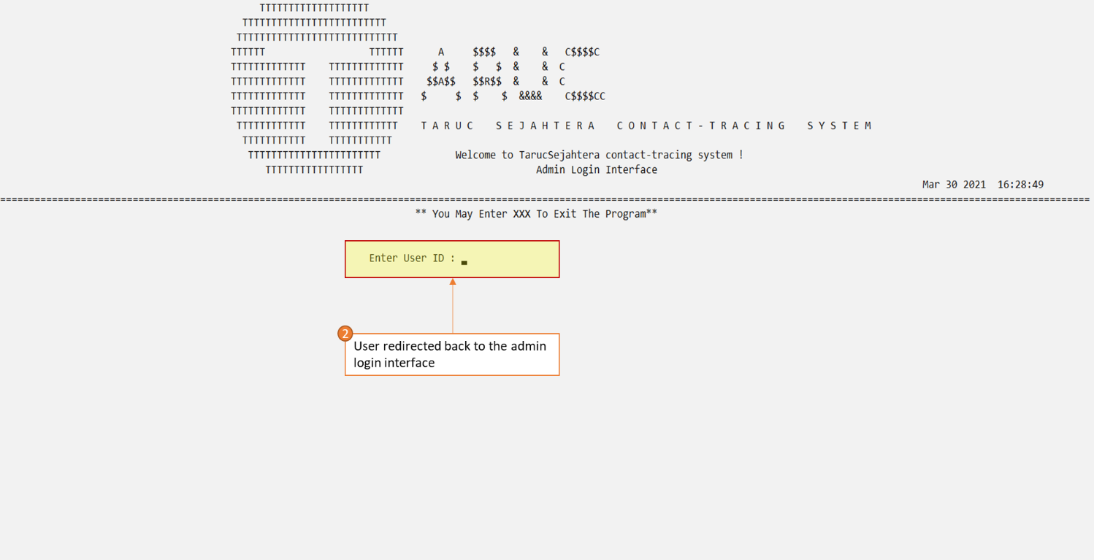 *Figure 4.3.18 Screenshot of logout (step 2)*

In addition, if user wish to exit the whole program directly then he/she can just choose 9 (action choice) or even choose 10 (action choice) to back to the previous menu (*refer to figure 4.3.*)

# **4.4 Visit And Exit by < Tan Jenny >**

## 4.4.1 Brief Description

Visit and exit module is to assist in monitoring COVID-19 pandemic in country that used by students or staff in Tarc college by empowering students or staff to assess current risk against covid-19.This module is a digital check-in and out system which recording students or staff visit and exit time .It reduces the manual effort to track visitor movements as well as eases crowds at entry points to keep the college safe .For the check-in system, it will provide an entry ID when they visit a venue . Students or staff must provide their temperature , current status and purpose. For those who temperature up to 37 and have the symptoms of covied-19 are not allowed to check-in. Besides, each venue only can store a specific amount of students or staff , if achieving the maximum number of people they will not be allowed to enter .After they check-in for a place , the system will automatically save their information so that they can track their movements if needed. Thus,the system will automatically help them check-out if they forgot to check-out when they exit a place and the check-out time shown is 23:59. For the check-out system , students or staff must provide feedback of the SOP and also the rating of the system in order for the top management to be able to know about the problems and make some improvements. Hence, admins are able to manage the modify , delete and report function .

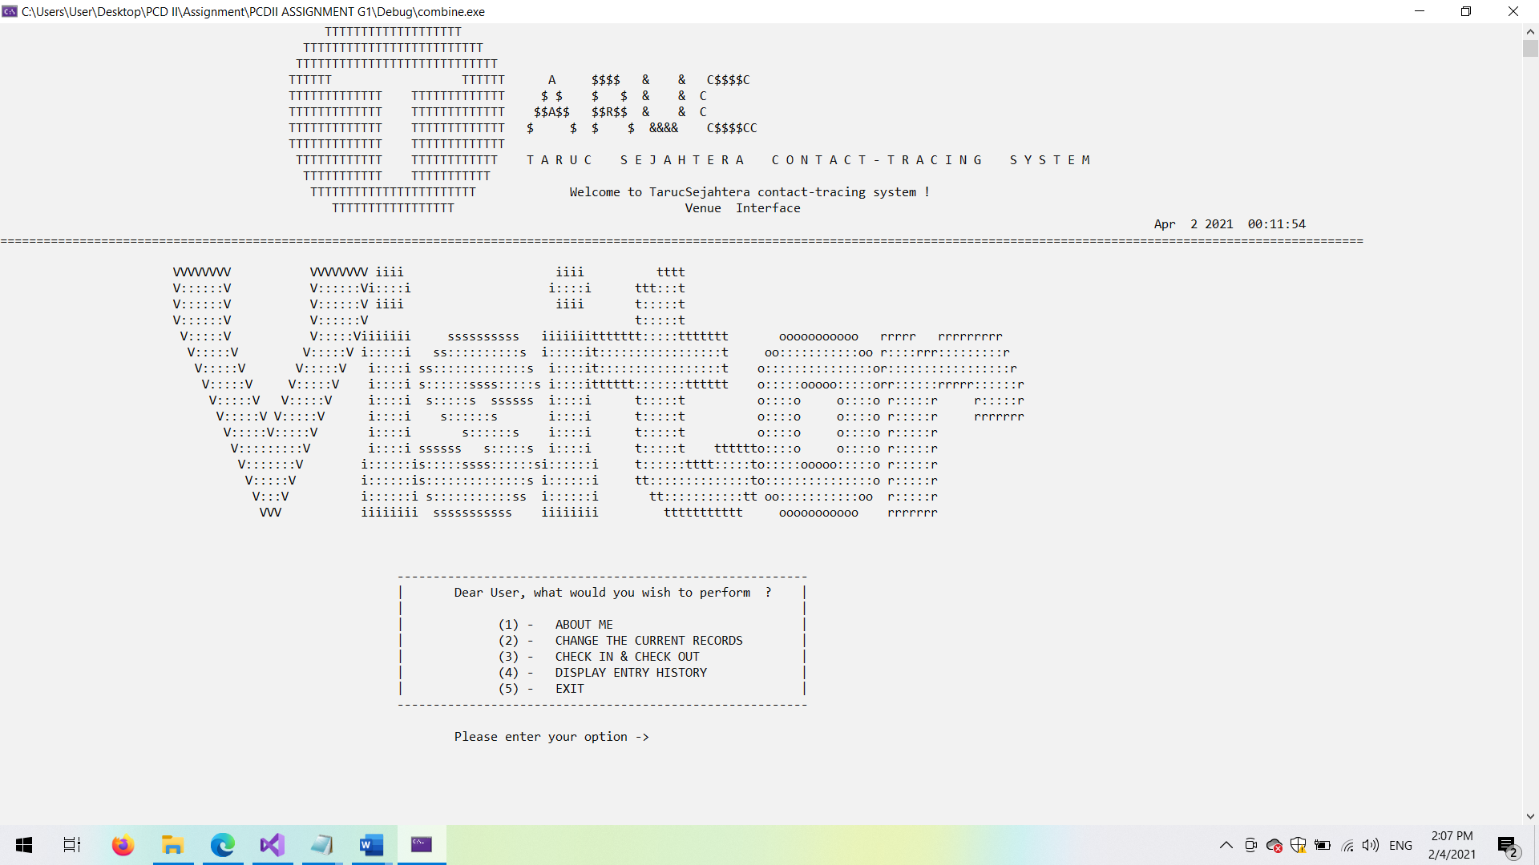

*Figure 4.4.1 Screenshot of Visit and exit menu （Homepage)*

## Outputs & File Contents

**1. Entrance interface**

-Let students or staff to choose the entry type which is check-in or out

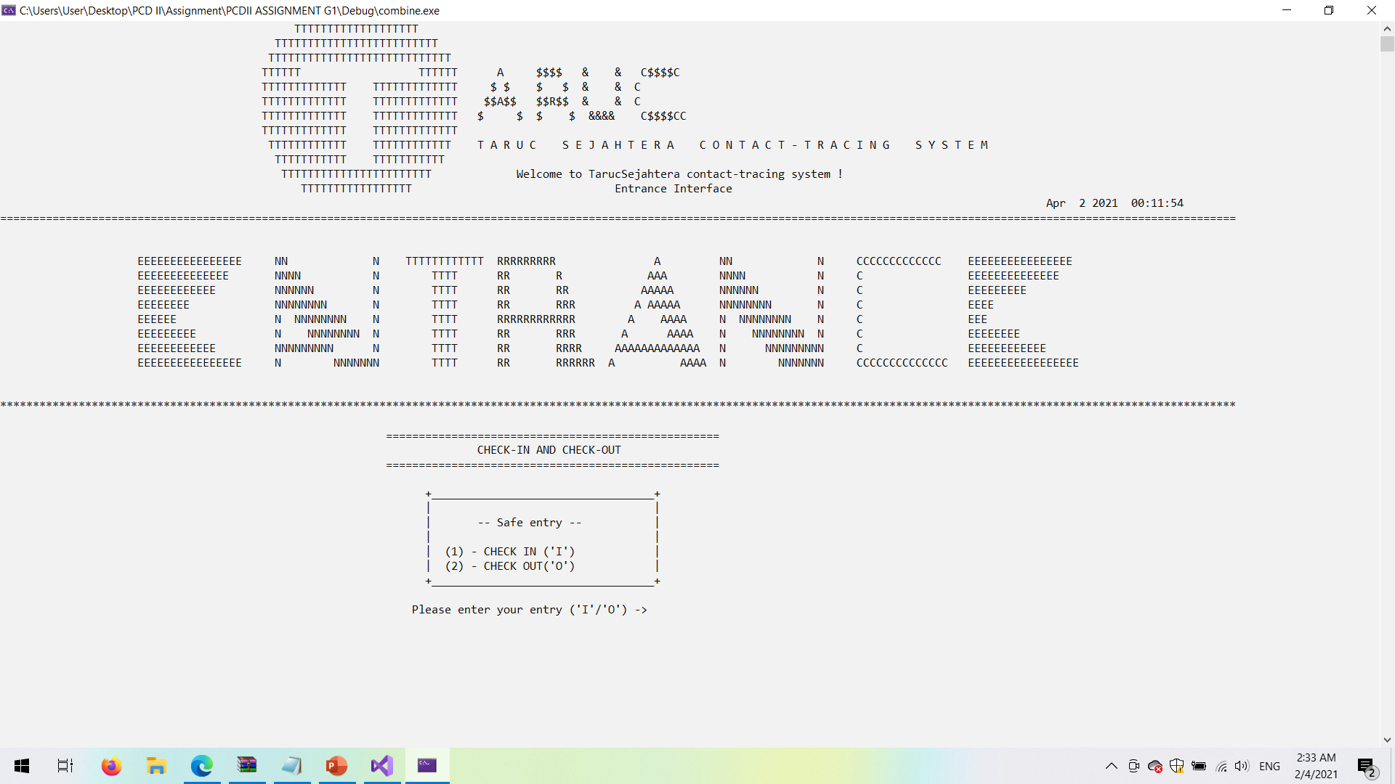

*Figure 4.4.2 Screenshot of visitors entry part*

**1.1 Check-in interface**

-Show the current visitors details and provide an entry ID ,allowing the user to choose the venue.The venue ID only displays the available time , no reservation place and the available current visitors less than the maximum visitors that allow to enter for the user. For example, T001 is fully visited so it will not show in the venue ID list to let more visitors check-in.

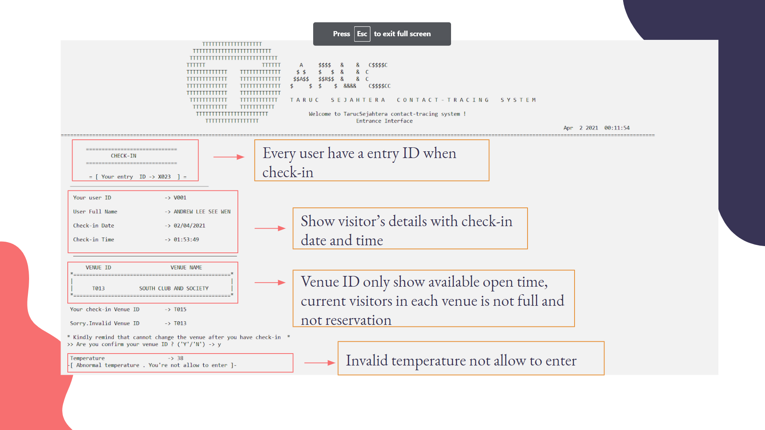

*Figure of 4.4.3 Screenshot of check-in interface (When temperature is over 37 and invalid Venue ID)*

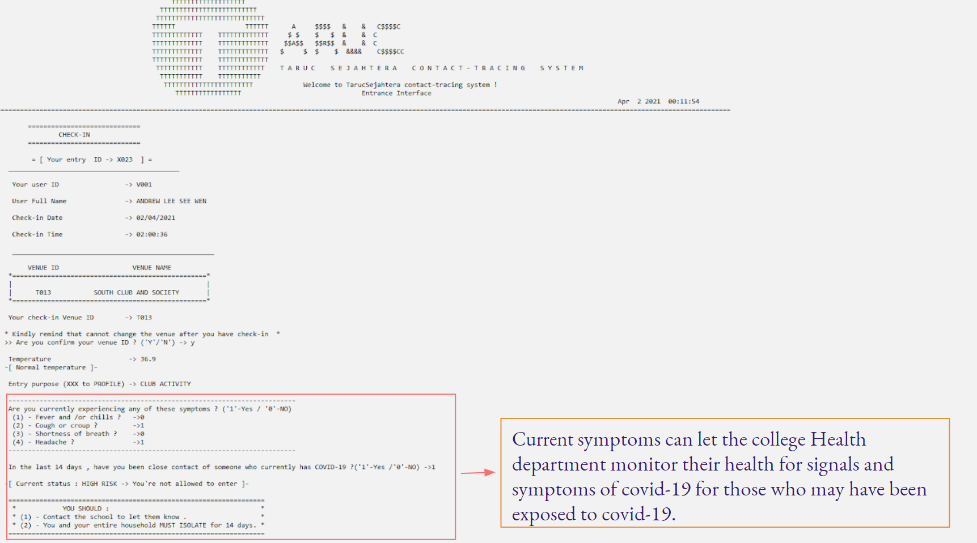

*Figure of 4.4.4 Screenshot of check-in interface (When experiencing covid-19 current symptoms- Part 1 )*

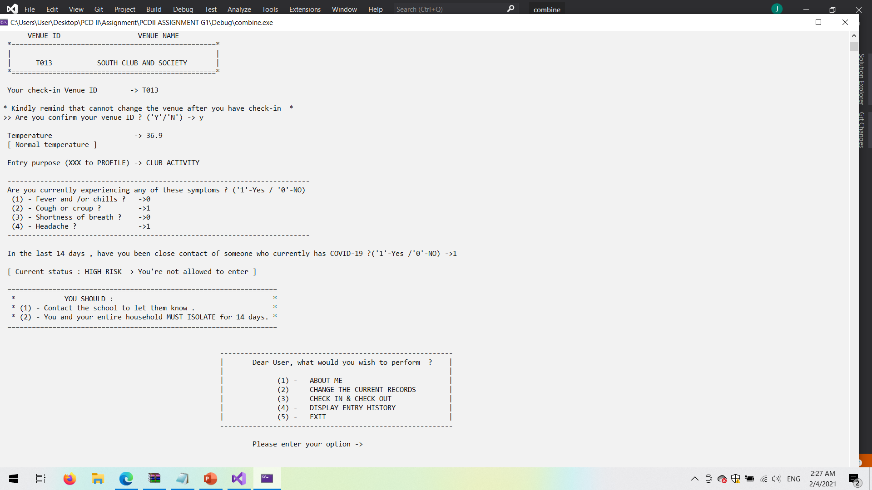

*Figure of 4.4.5 Screenshot of check-in interface (When experiencing covid-19 current symptoms- Part 2 )*

-If the user enters the unavailable venue ID , it will not allow them to check-in . Besides, the system will ask whether the user confirms to check-in for that particular venue ID or not .It is user-friendly as the user misentering the venue ID. Thus , the system will ask the current symptoms of covid-19 in order to safeguard the college risk.After confirming check-in , it will prompt a message asking whether the user wants to check-out or not .

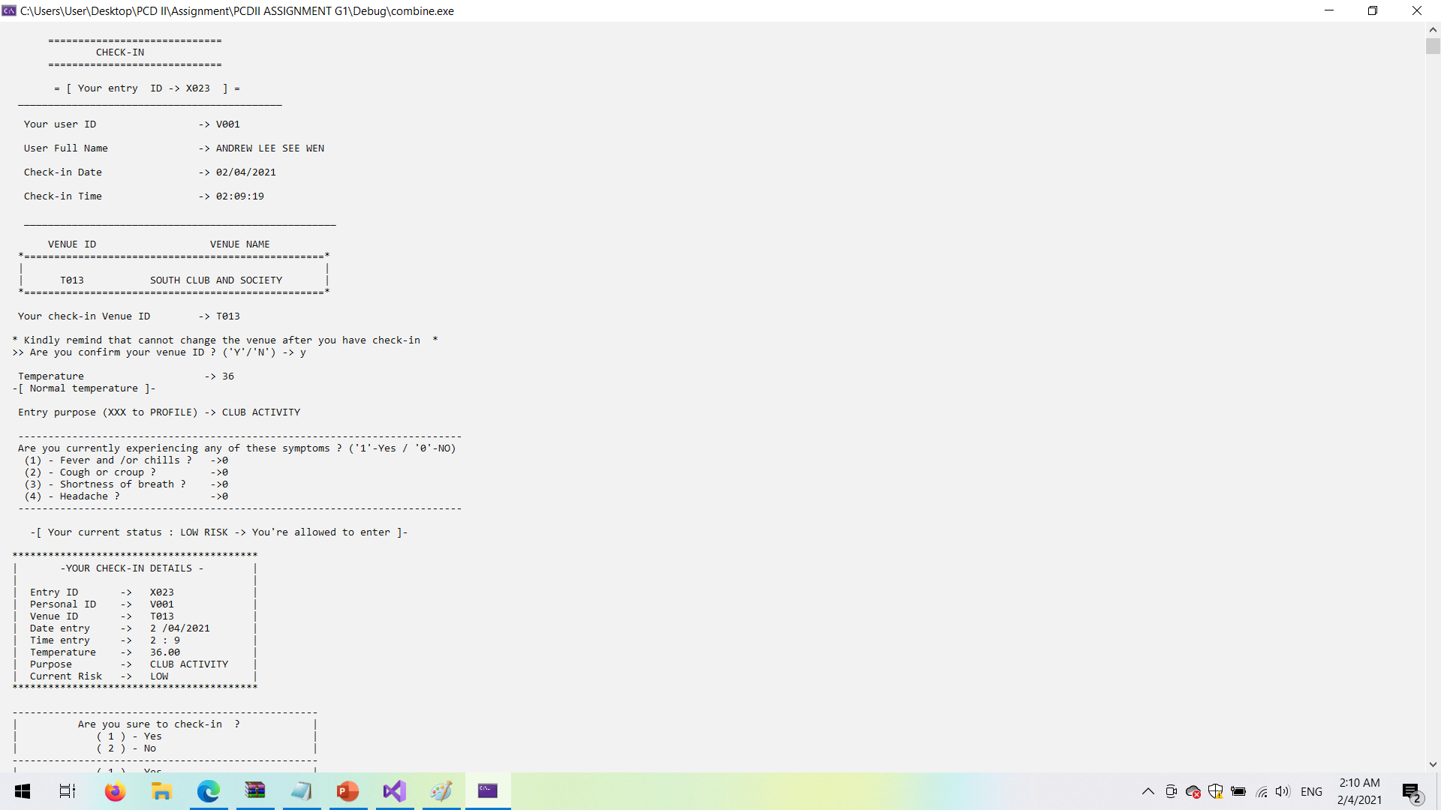

*Figure of 4.4.6 Screenshot of check-in interface (With correct details)*

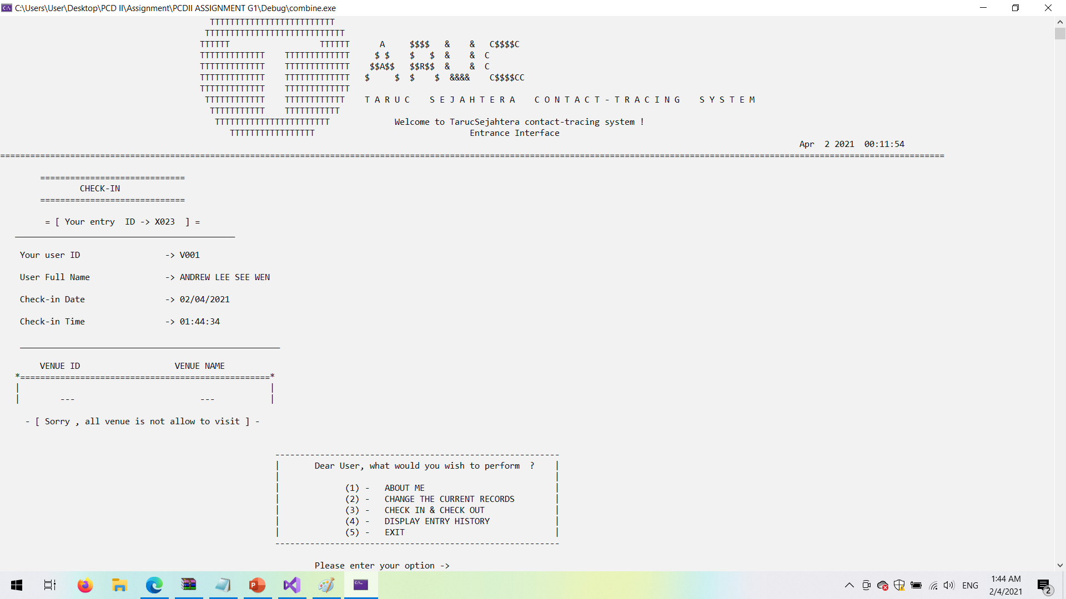

*Figure of 4.4.7 Screenshot of check-in interface (When no venues are available)*

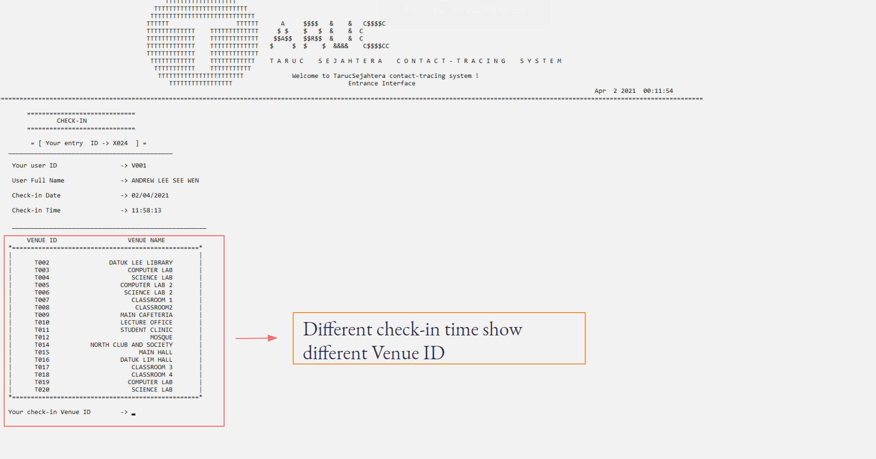

*Figure of 4.4.8 Screenshot of check-in interface (With different check-in time)*

**1.2 Check-out interface**

- When the user wants to check-out , it is needed to provide the feedback and rating for the system .From the feedback given by the users, the manager can make improvements and know where they did not well.The system will retrieve the date and time from the system so that user do not need to fill up manually.

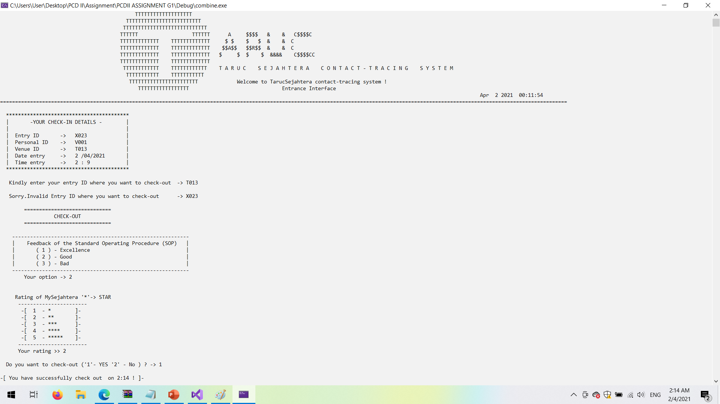

*Figure of 4.4.9 Screenshot of check-out interface*

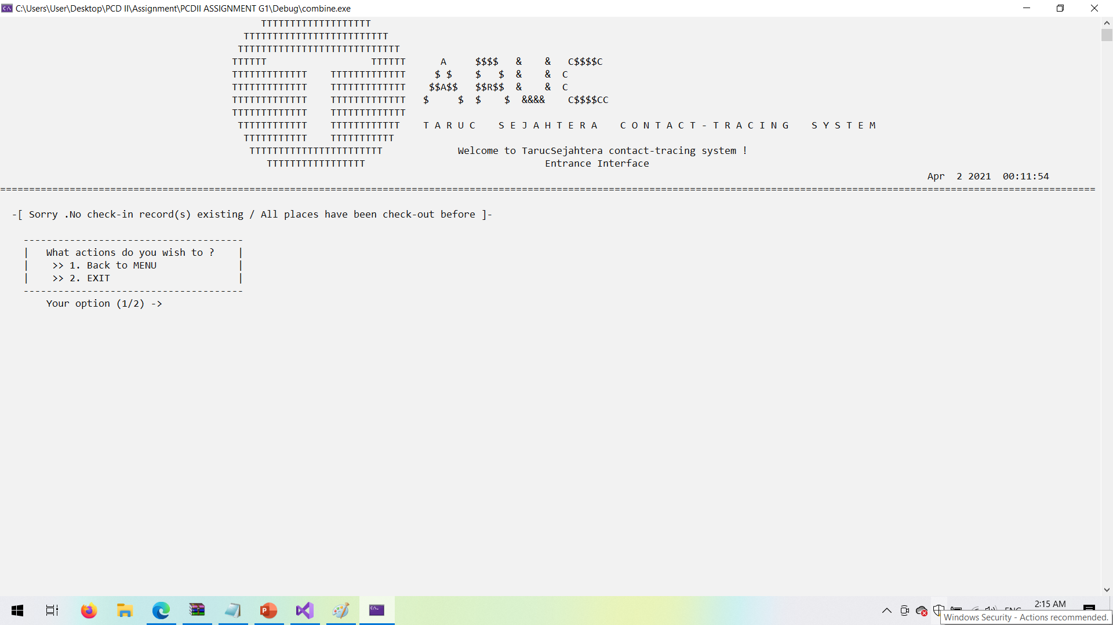

*Figure of 4.4.10 Screenshot of check-in interface (When no venues are available)*

**2.1 Display user entry history**

It will display the check-in and out history along with their personal details.

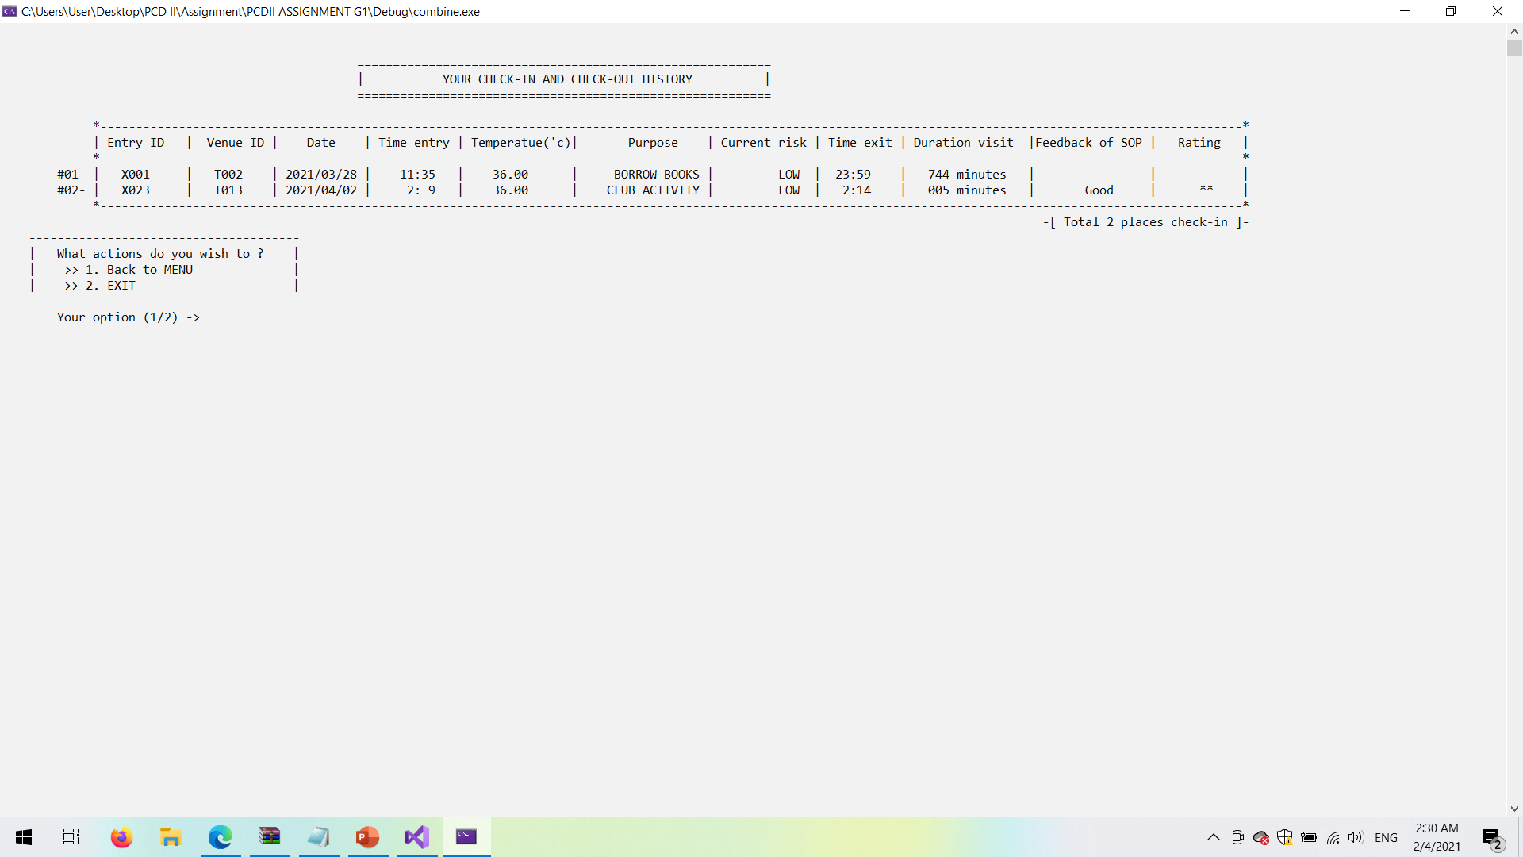

*Figure of 4.4.11 Screenshot of check-in and check-out summary*

**Admin Menu**

* Admin have the priority to fully access the function such as display,update,search, delete and also report.

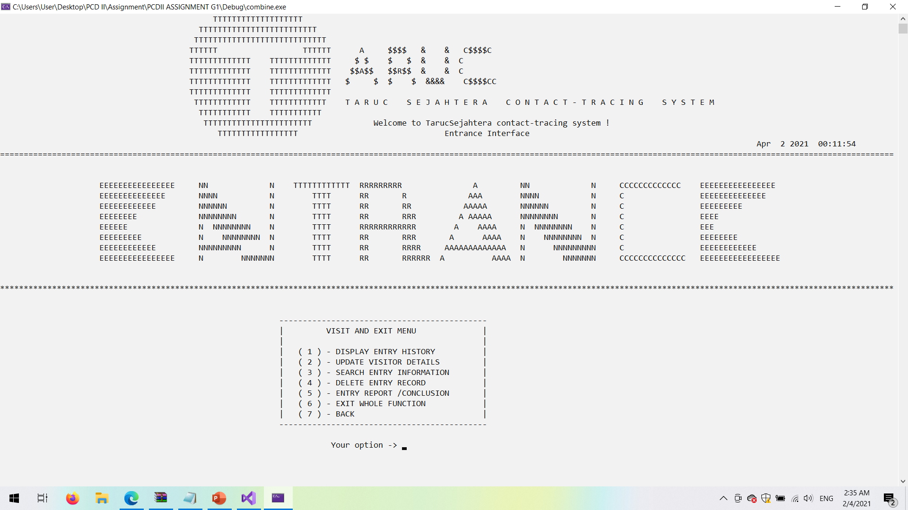*Figure of 4.4.12 Screenshot of admin menu*

**2.2 Admin display entry menu**

* For the display module type it will filter the current info or the delete info for the admin. It is useful when the admin wants to find back the deleted data.

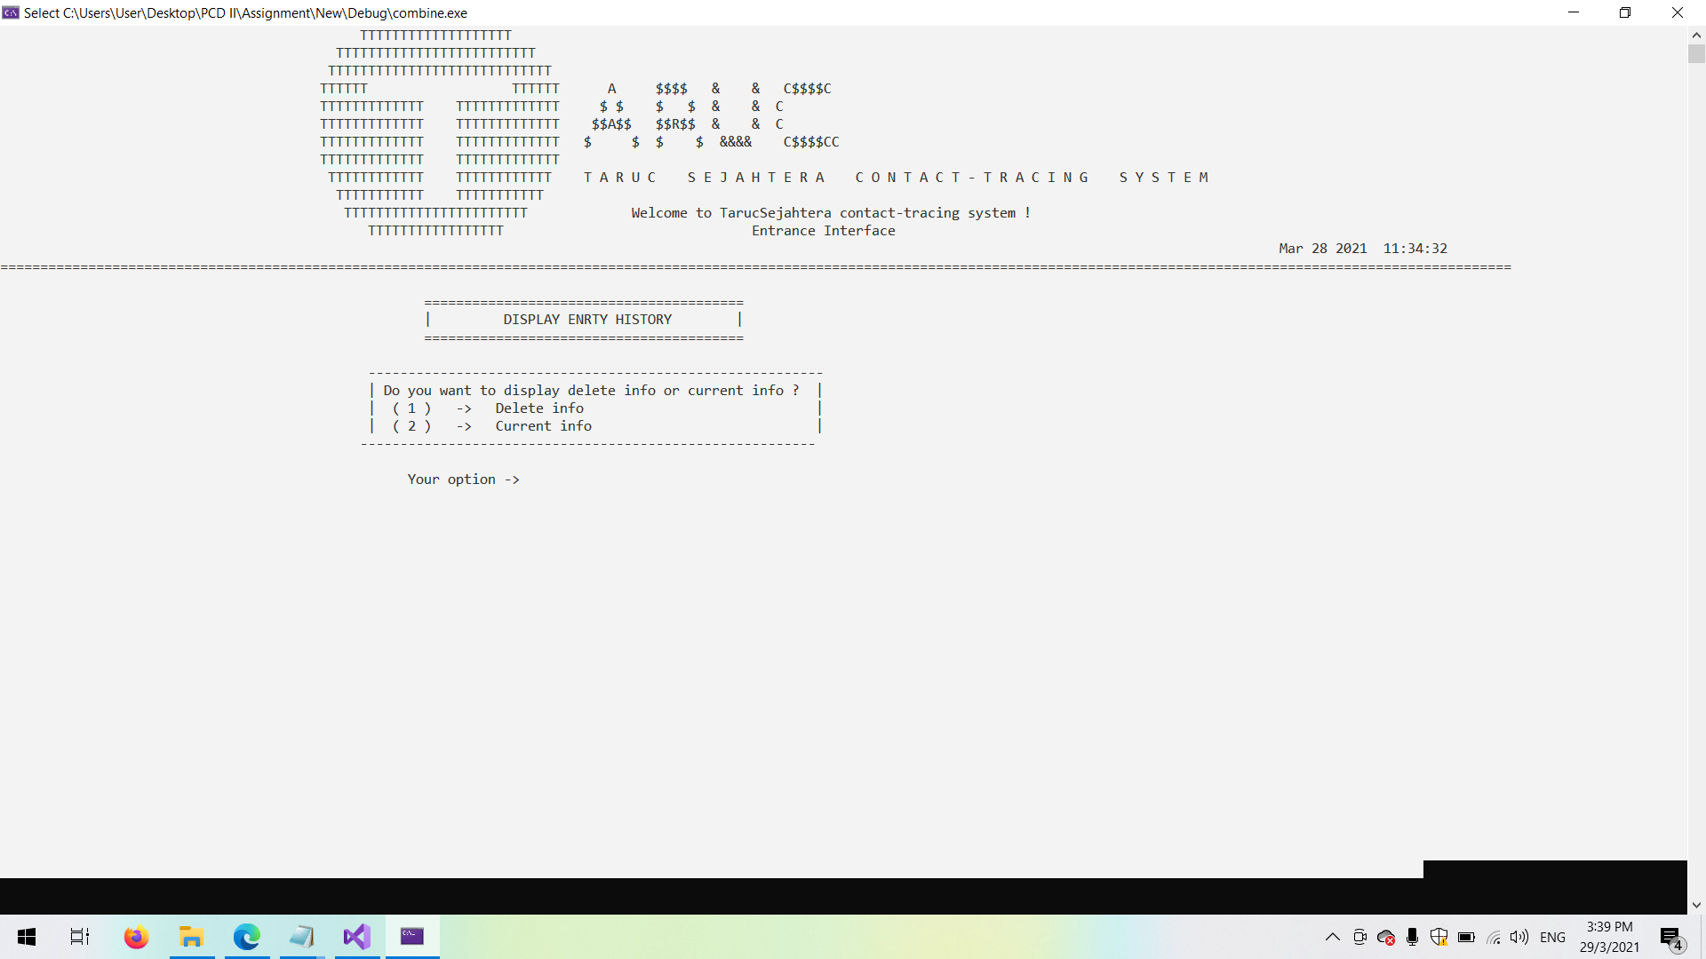

*Figure of 4.4.13 Screenshot of admin display function menu*

**2.2.1 Deleted entry history**

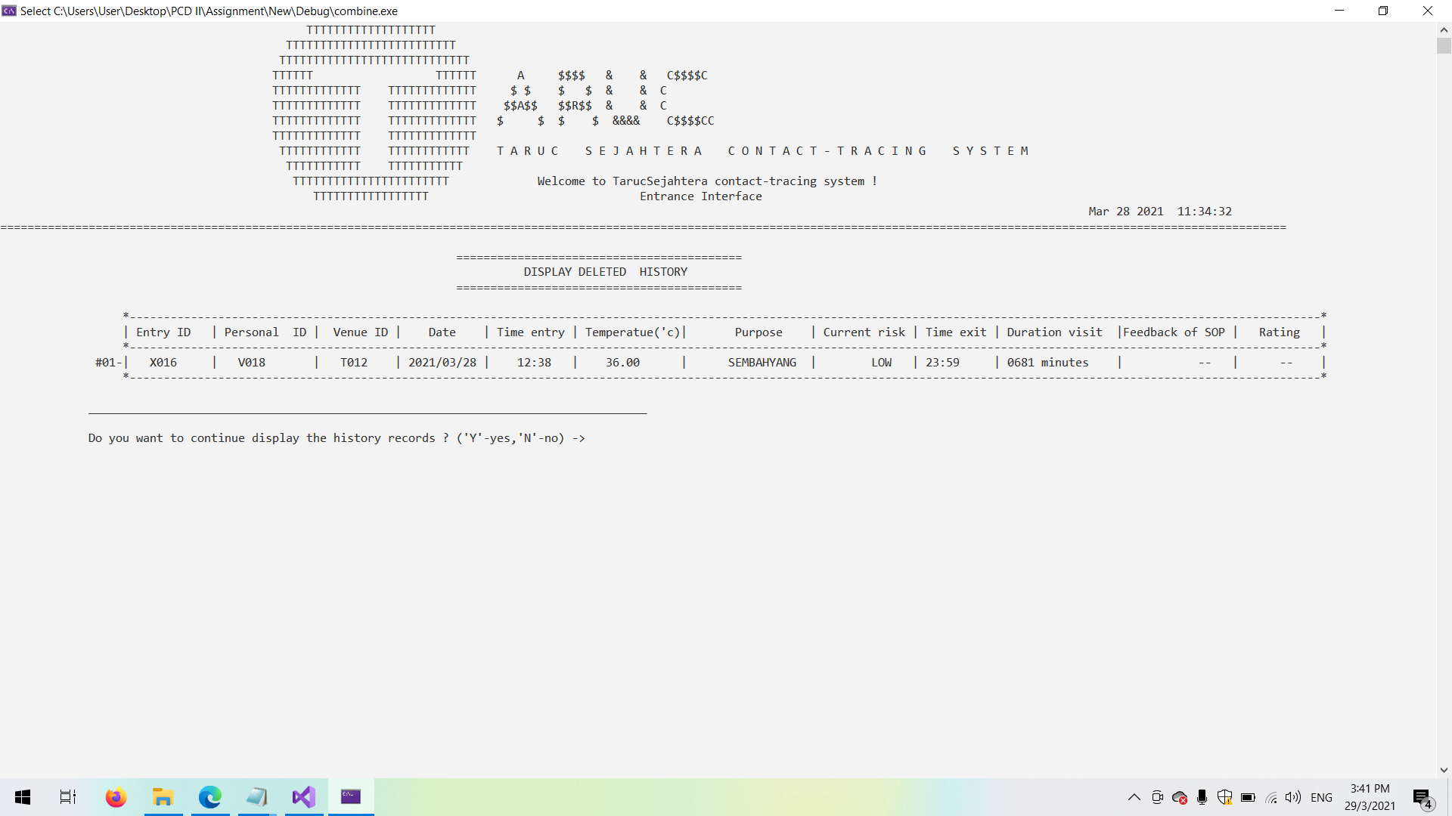

*Figure of 4.4.14 Screenshot of delete history of visit and exit*

**2.2.2 Current info menu**

* For the admin to choose what type of info they want to display

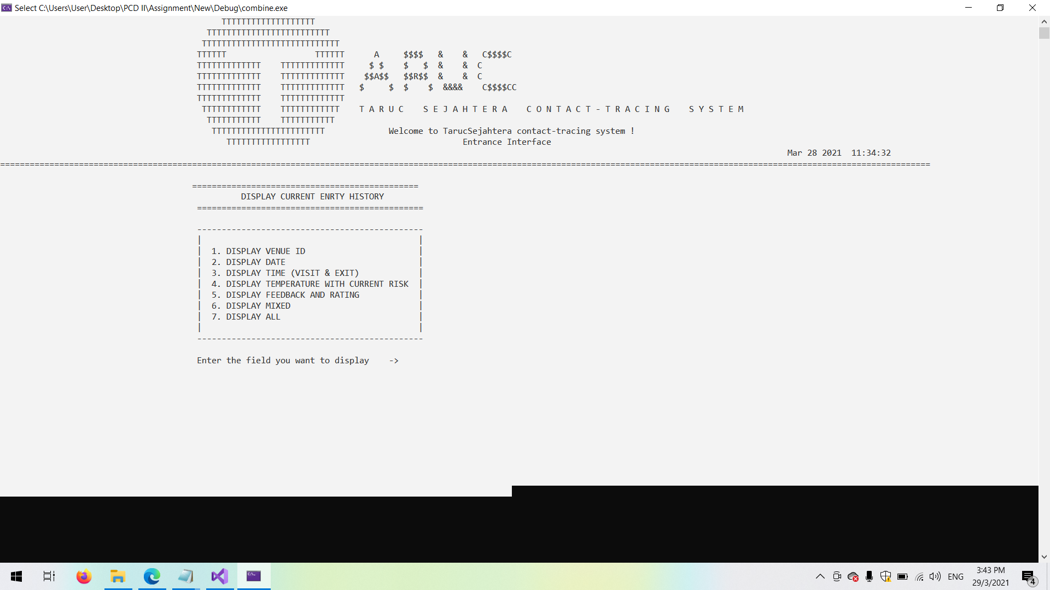

*Figure of 4.4.15 Screenshot of current info menu(Nested display)*

**2.2.2.1 Display venue ID**

* It can let the top management to view visitors’ visit and exit records

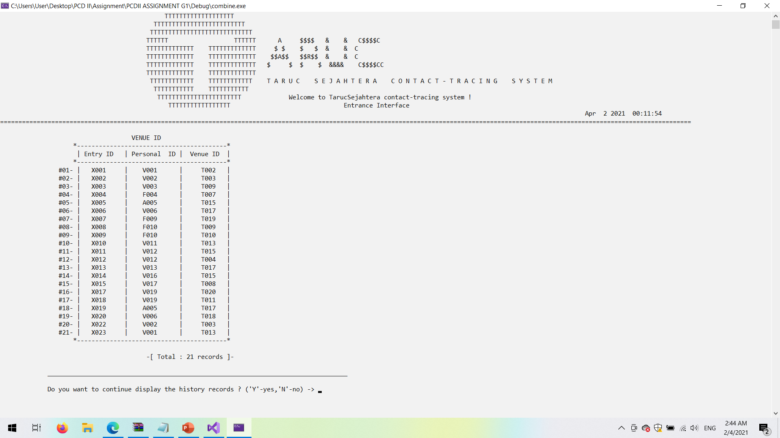

*Figure of 4.4.16 Screenshot of display venue ID*

**2.2.2.2 Display visit date**

* It can let the top management view visitors’ entry dates for report purposes.

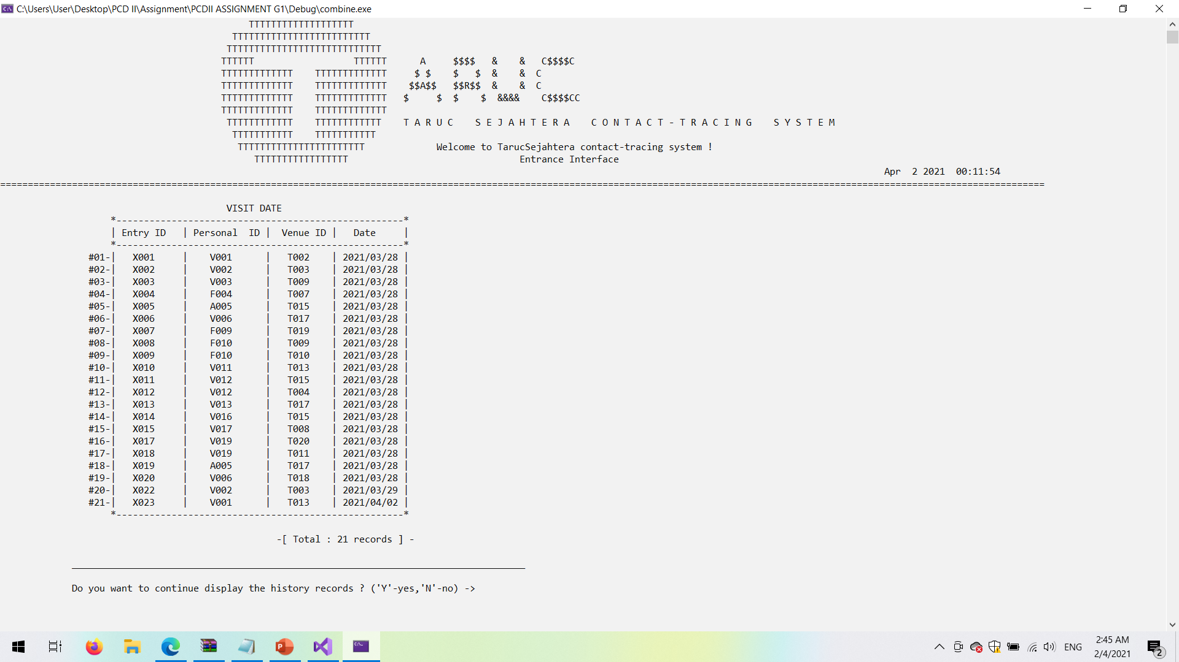

*Figure of 4.4.17 Screenshot of display visit date*

**2.2.2.3 Display visit time**

* It can let the top management view visitors’ entry time for report purposes.

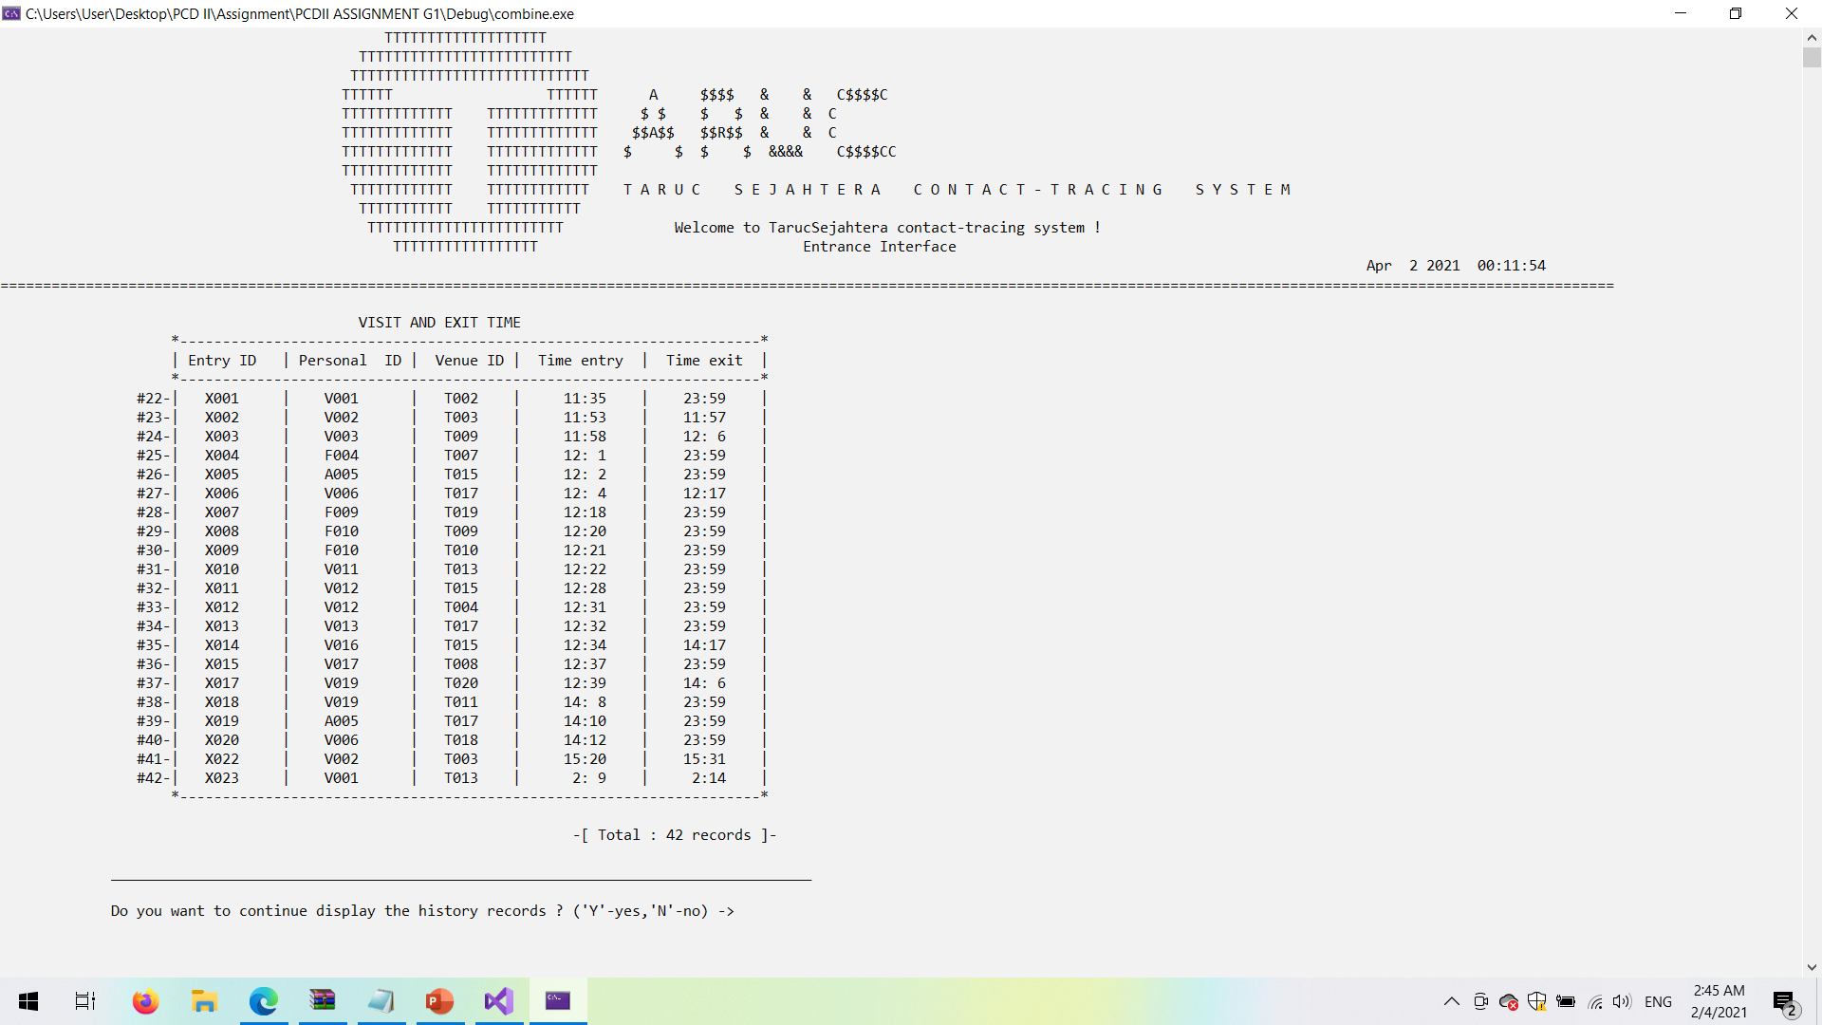

*Figure of 4.4.18 Screenshot of display visit time*

**2.2.2.4 Display current risk**

* It can let the top management know the current status of college to ensure the safety of college and let the Sanitization Department to sanitize the venue if needed.

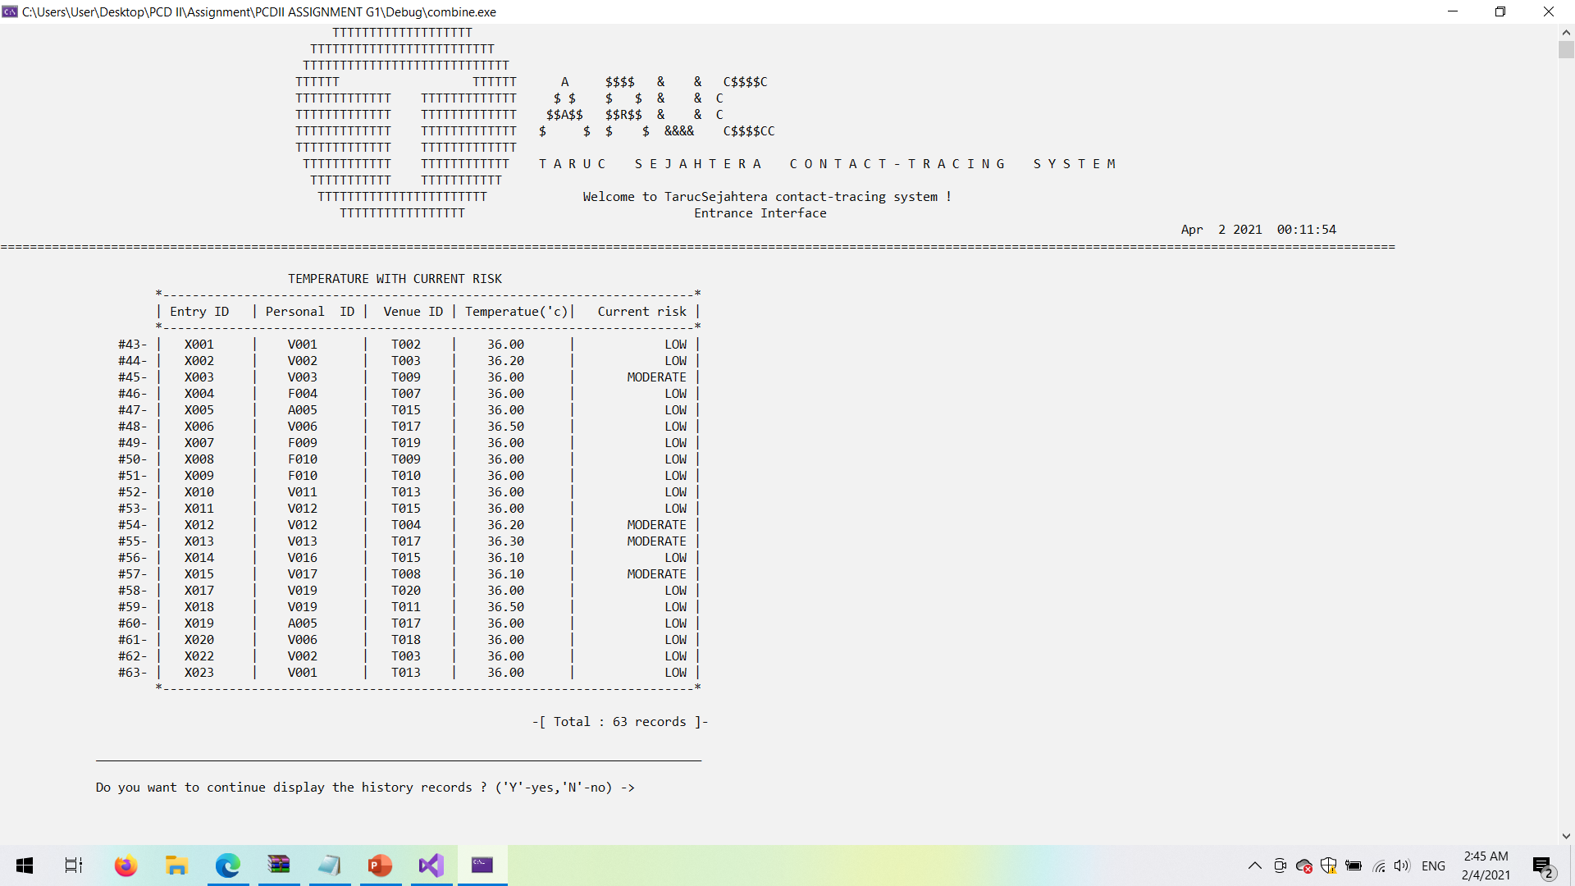

*Figure of 4.4.19 Screenshot of display current risk*

**2.2.2.5 Display feedback and rating**

* It can let the top management get the feedback and rating from visitors, students and also staff to see whether the system and each venue’s SOP is good . If the rating and feedback are bad, the top management can quickly take actions to make improvements.

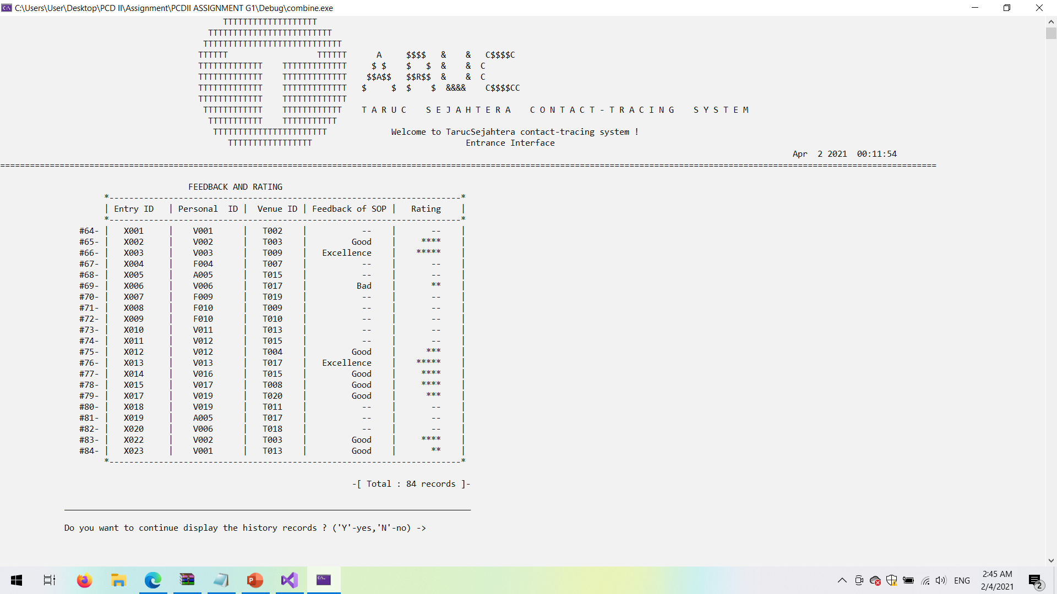

*Figure of 4.4.20 Screenshot of display feedback and rating*

**2.2.2.6 Display mixed function**

* It allows the admin to choose up to 2 info they want to display.
* Not allowed to skip all .

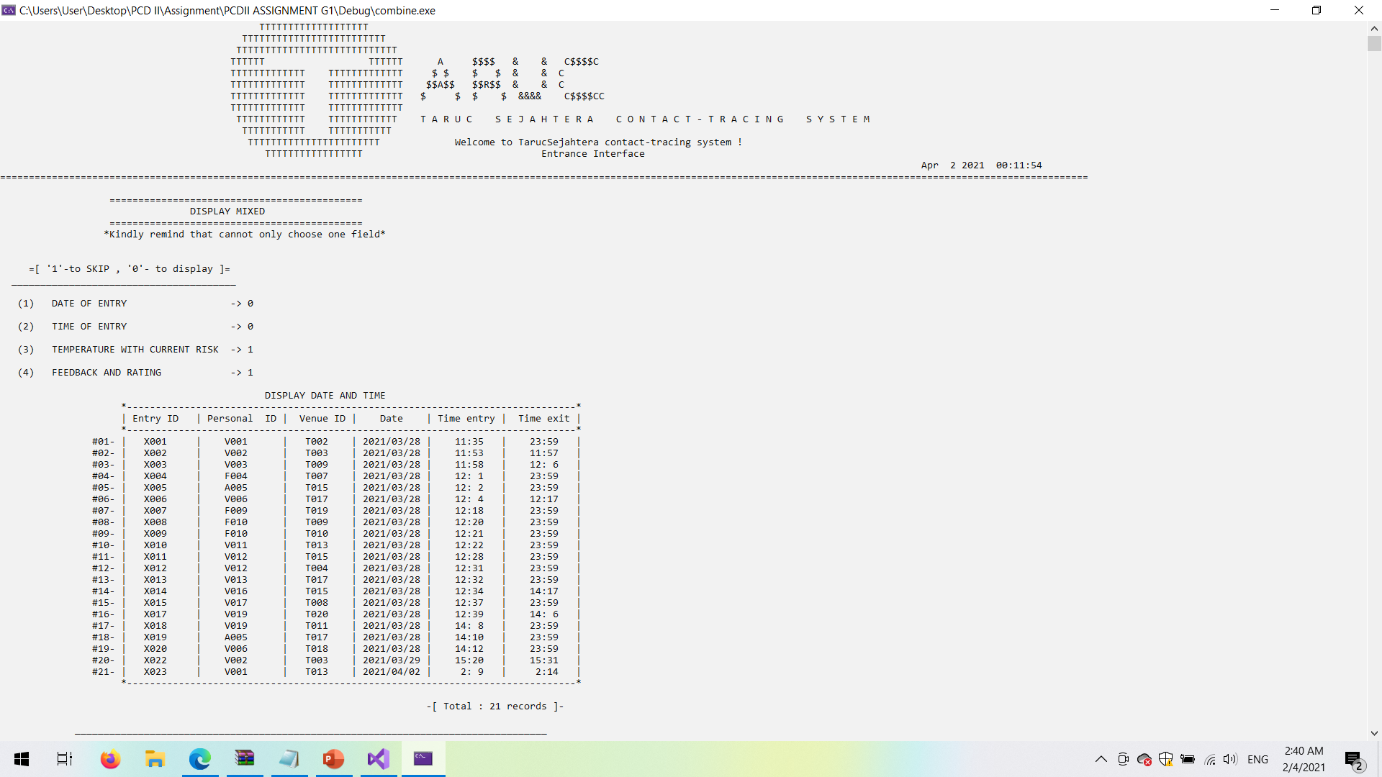

*Figure of 4.4.21 Screenshot of mixed display function*

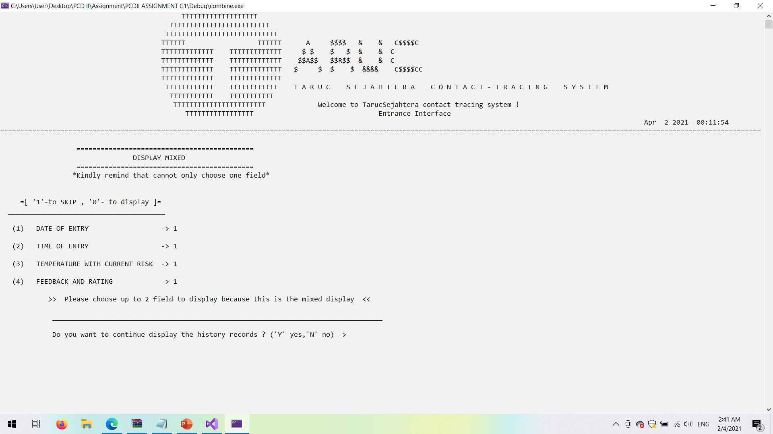

*Figure of 4.4.22 Screenshot of mixed display function( Skip all fields)*

**2.2.2.7 Display all records output**

* Display all visitors' information.
* For the user who does not check-up the system will automatically assign the time to 23:59 which is the end time of the day.

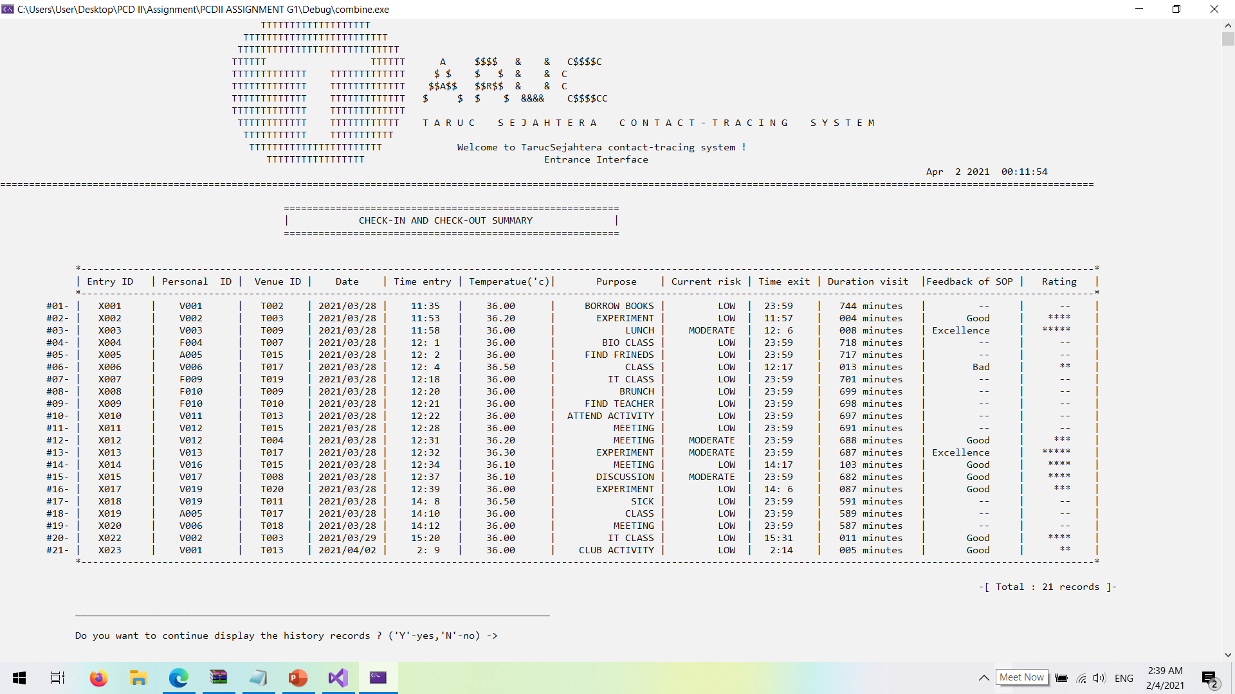

*Figure of 4.4.23 Screenshot of display all records*

**3. Search visitor information**

**i) Search visitor information ( 1 criteria )**

* It allows the admin to search up to 4 criteria. The system design is also able for admin to skip those criteria they unwanted.

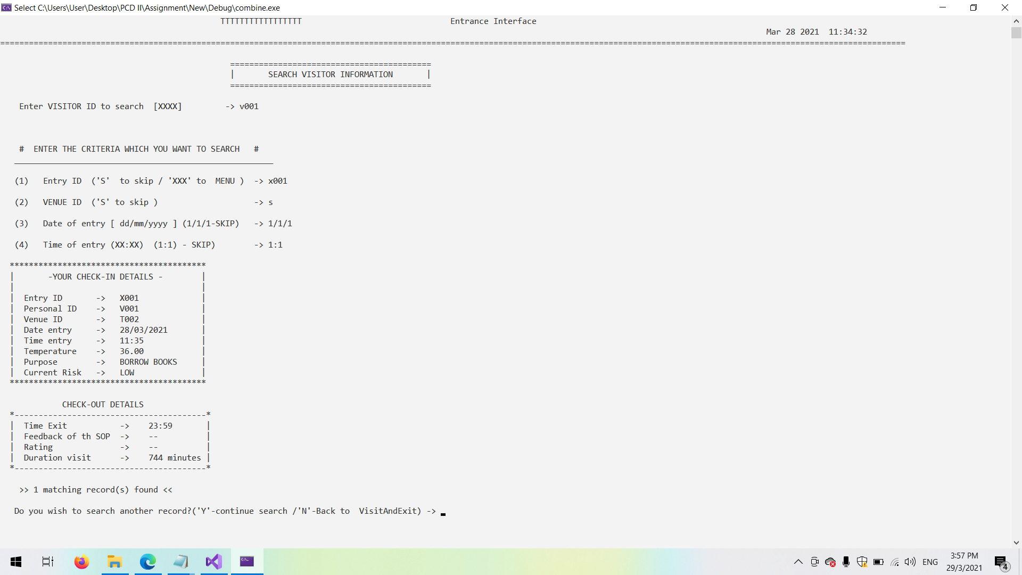

*Figure of 4.4.24 Screenshot of search visitor information (Search with 1 criteria)*

**ii) Search visitor information ( 2 criteria )**

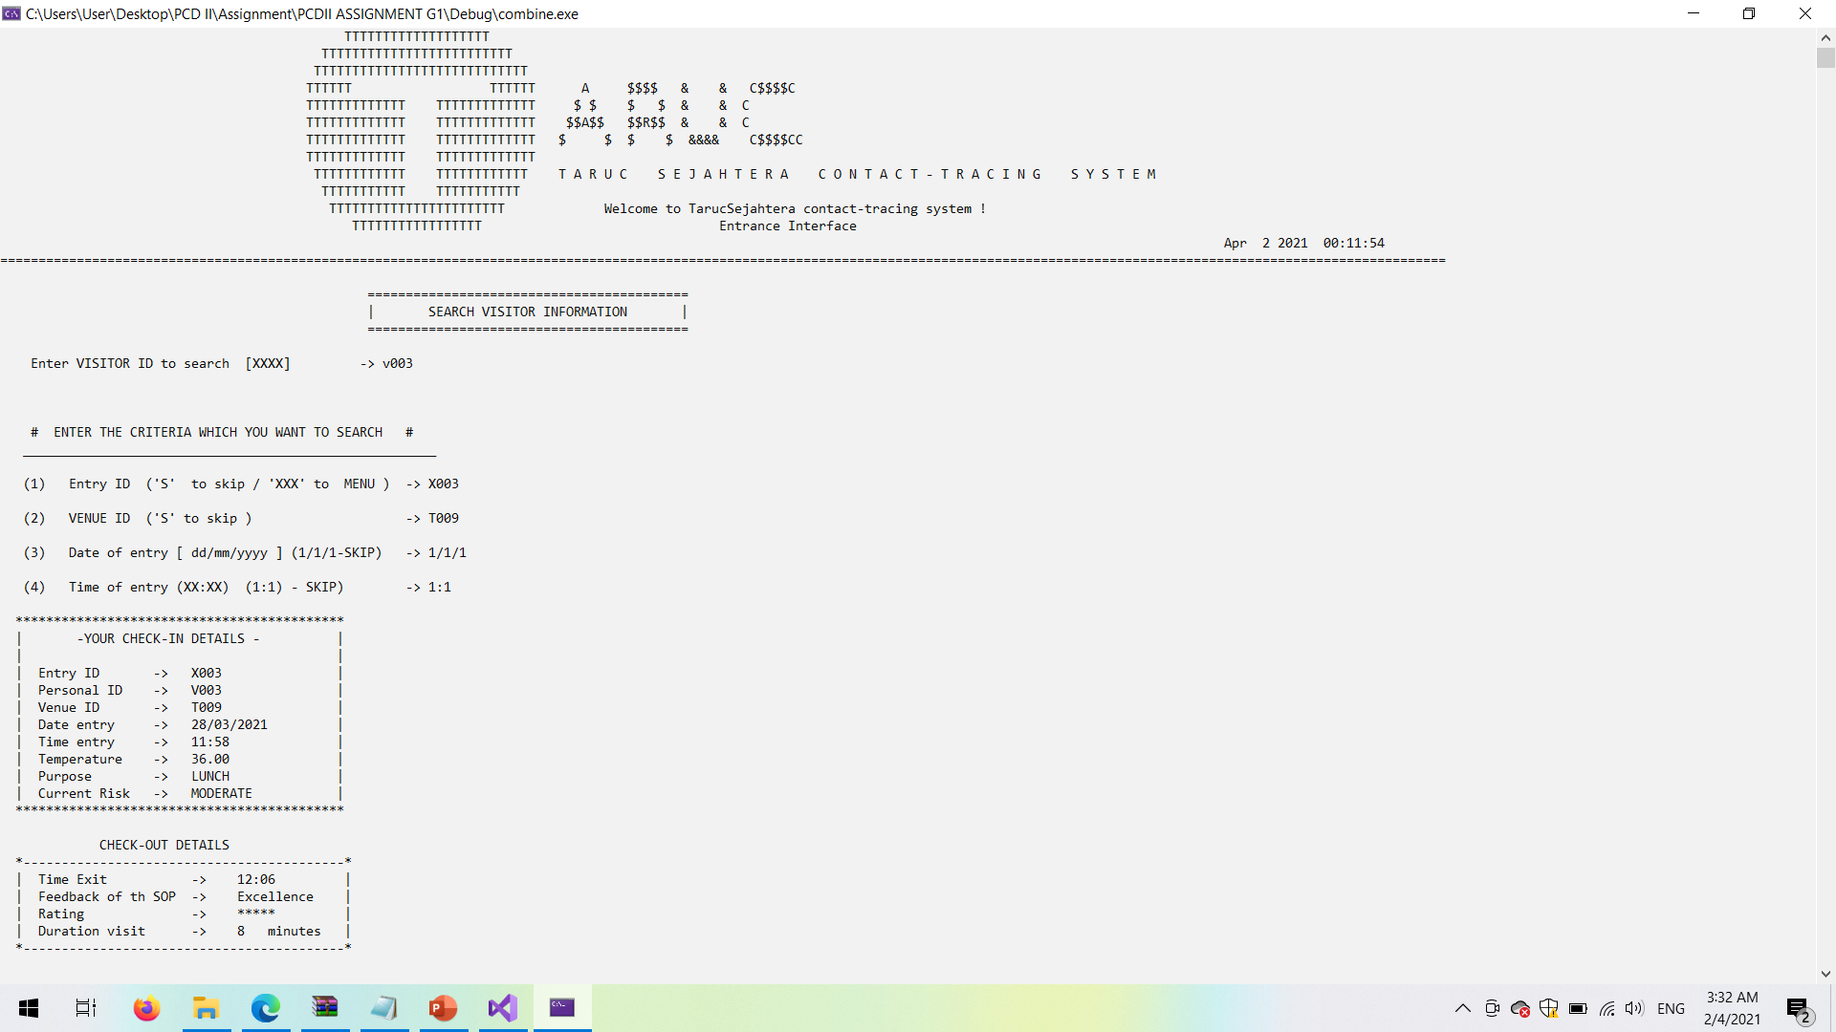

*Figure of 4.4.25 Screenshot of search visitor information (Search with 2 criteria)*

**iii) Search visitor information ( 3 criteria )**

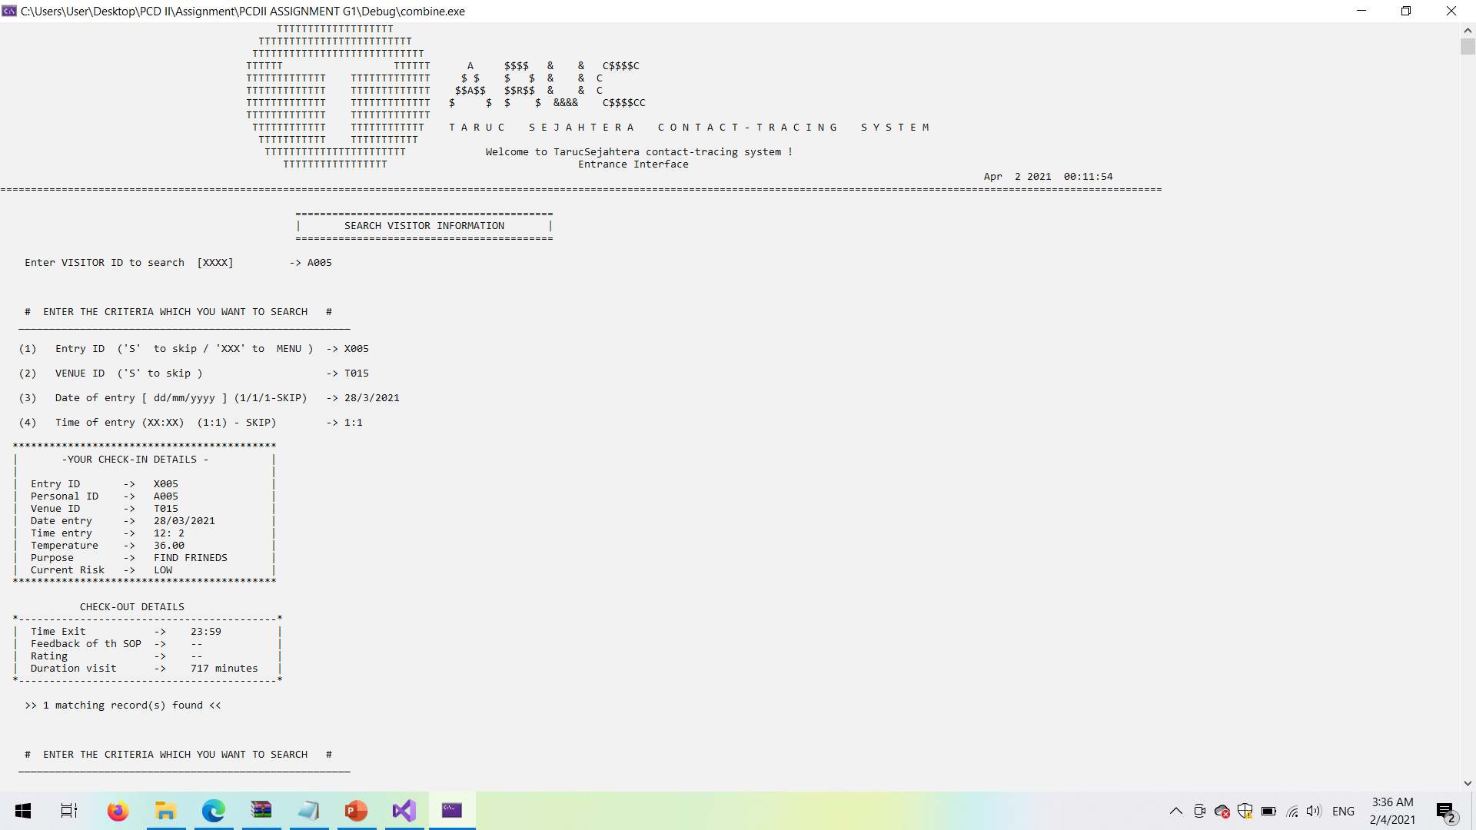

*Figure of 4.4.26 Screenshot of search visitor information (Search with 3 criteria)*

**iv) Search visitor information ( 4 criteria )**

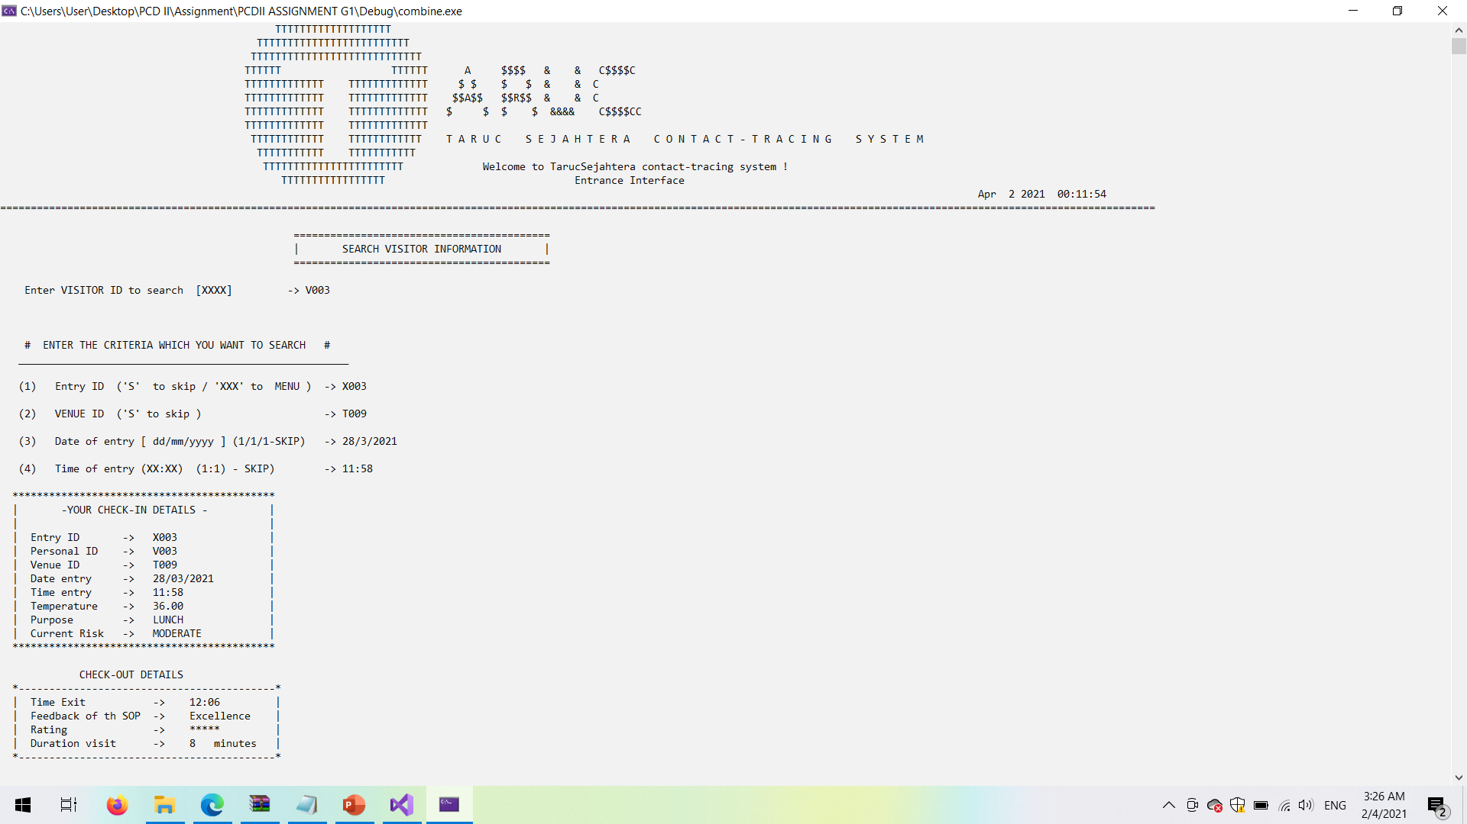

*Figure of 4.4.27 Screenshot of search visitor information (Search with 4 criteria)*

**v) Search visitor information ( Skip all criteria )**

-It will not allow user to skip all

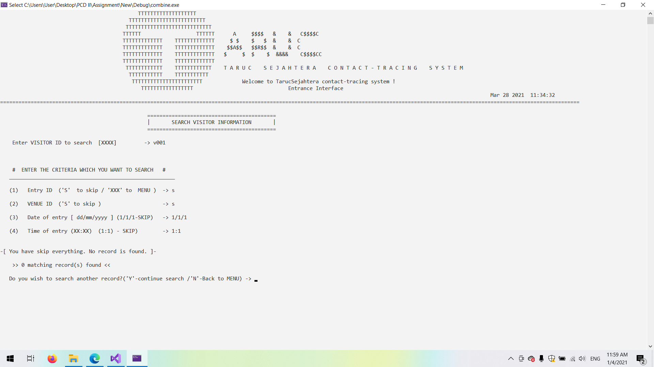

*Figure of 4.4.28 Screenshot of search visitor information (Skip all criteria)*

**vi) Search visitor information ( No visitor ID founded )**

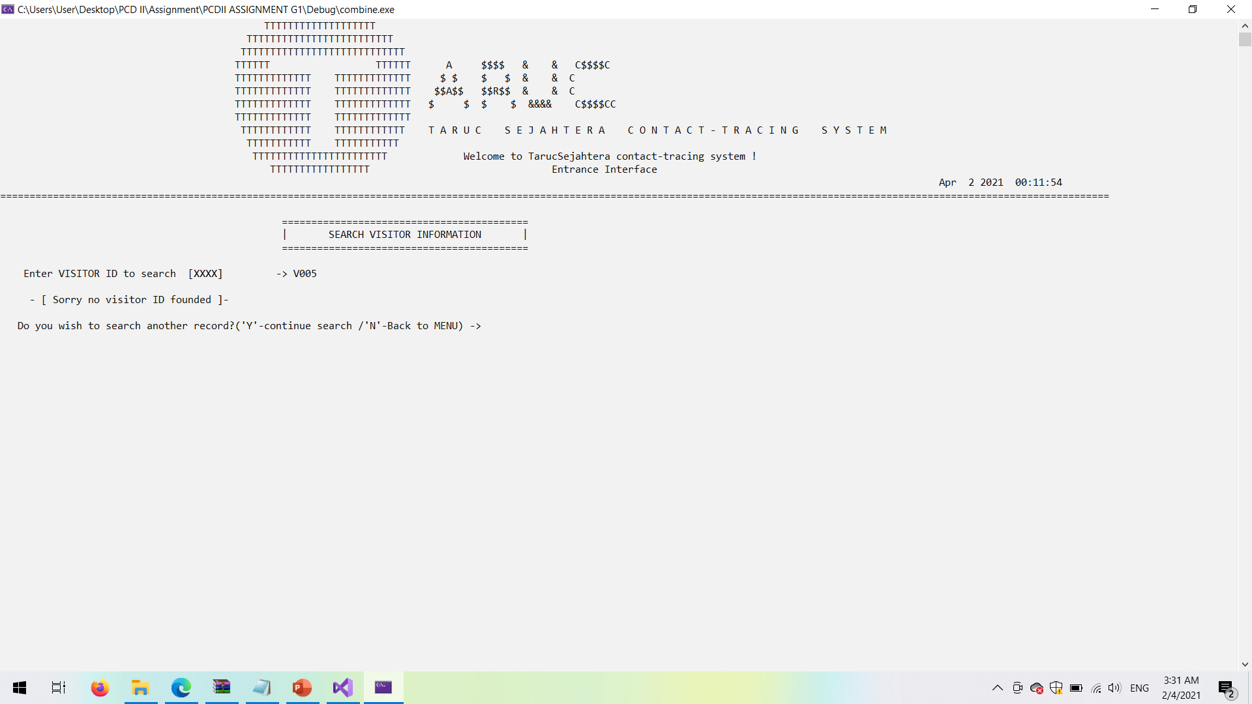

*Figure of 4.4.29 Screenshot of search visitor information (No visitor ID founded)*

1. **Modify visitor information**

* This system does not allow admin to change the current date and time ,entry ID, personal ID and venue ID because it will cause the inconsistency of data .Only certain data fields can make changes.

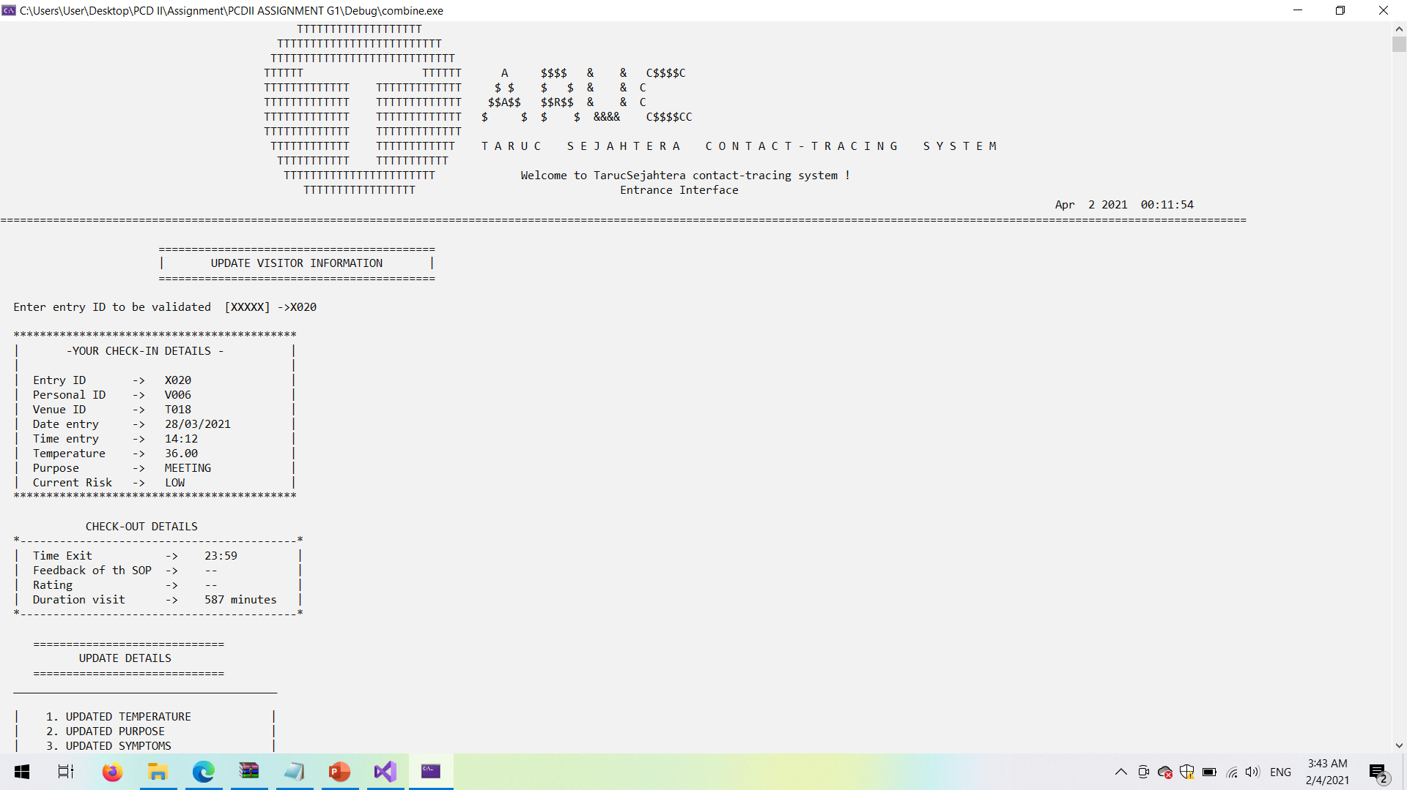

*Figure of 4.4.30 Screenshot of modify visitor information (Part 1)*

* Allow admin to choose which type of details want to modify

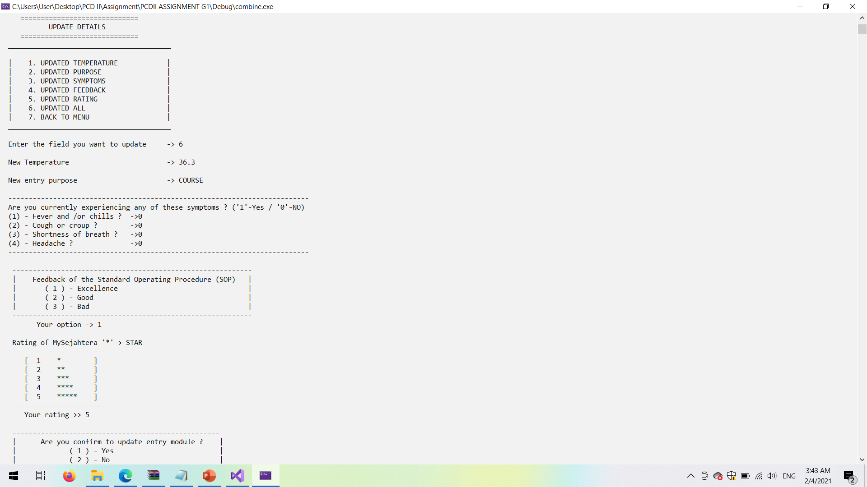

*Figure of 4.4.31 Screenshot of modify visitor information (Part 2)*

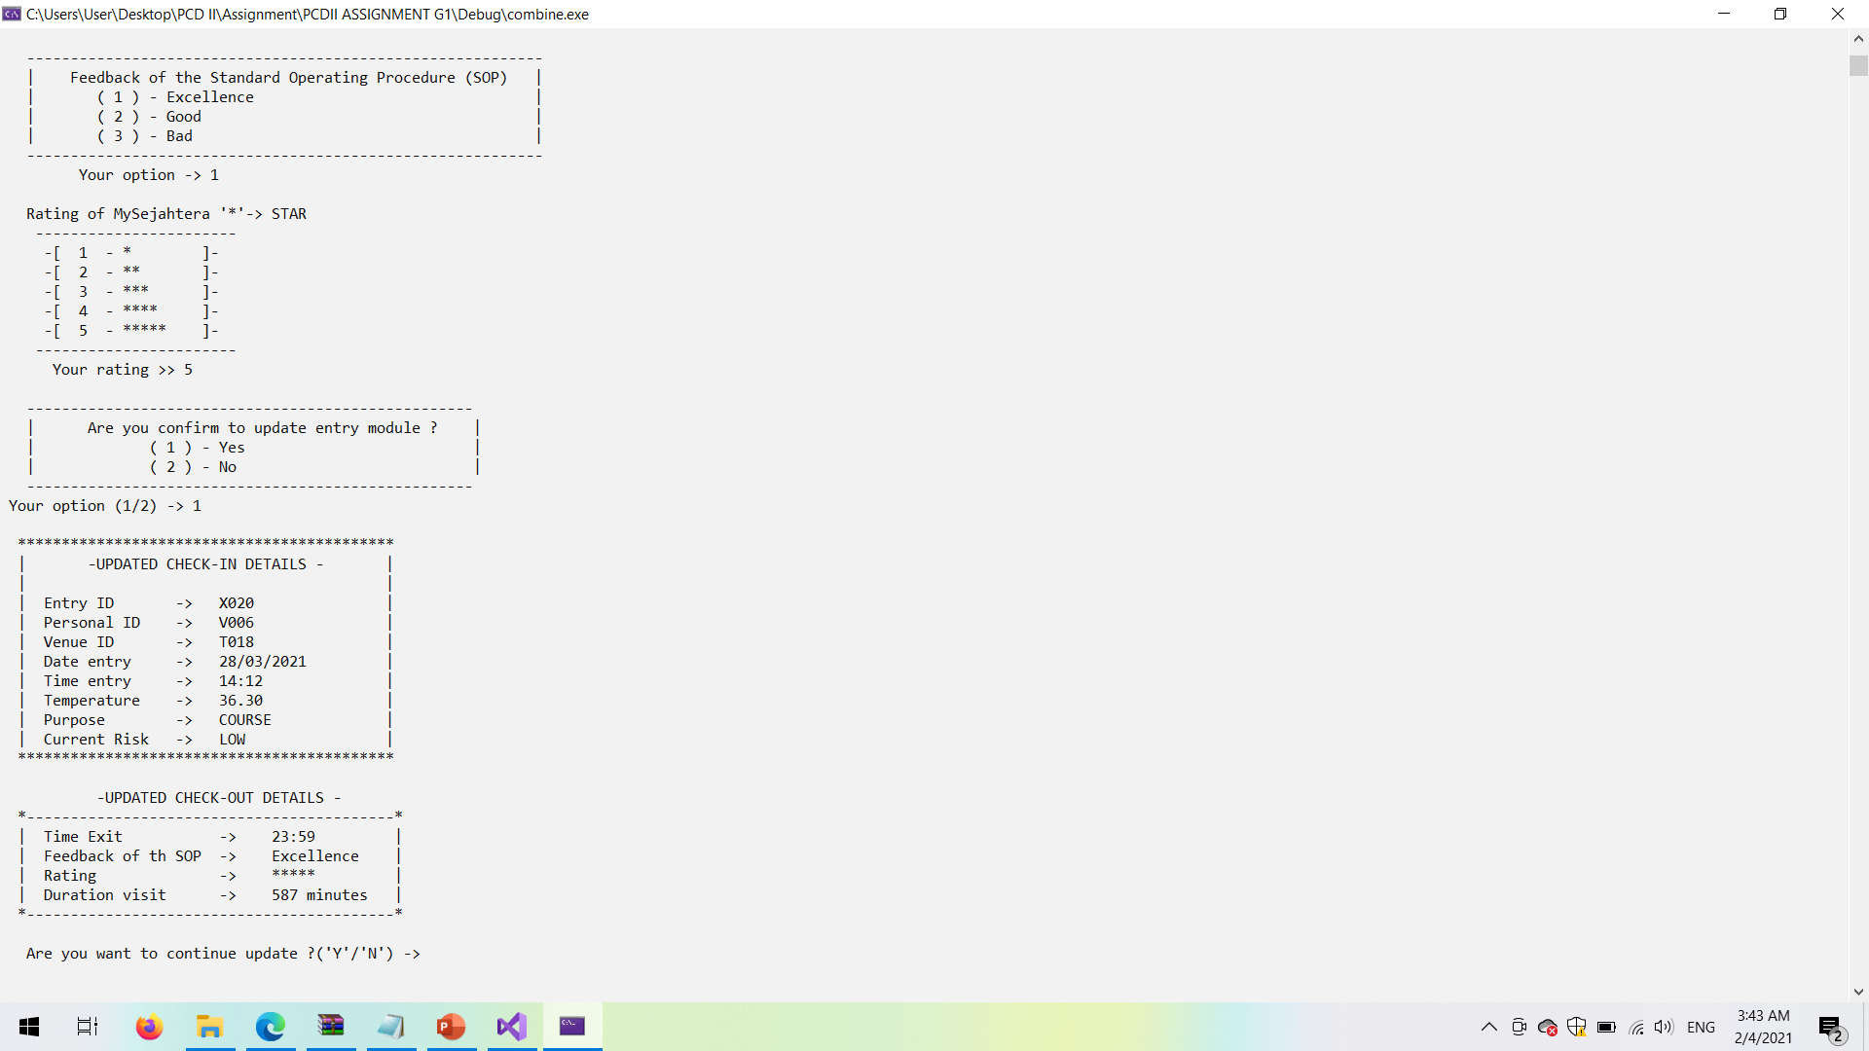

*Figure of 4.4.32 Screenshot of modify visitor information (Part 3)*

1. **Delete visitor entry history**

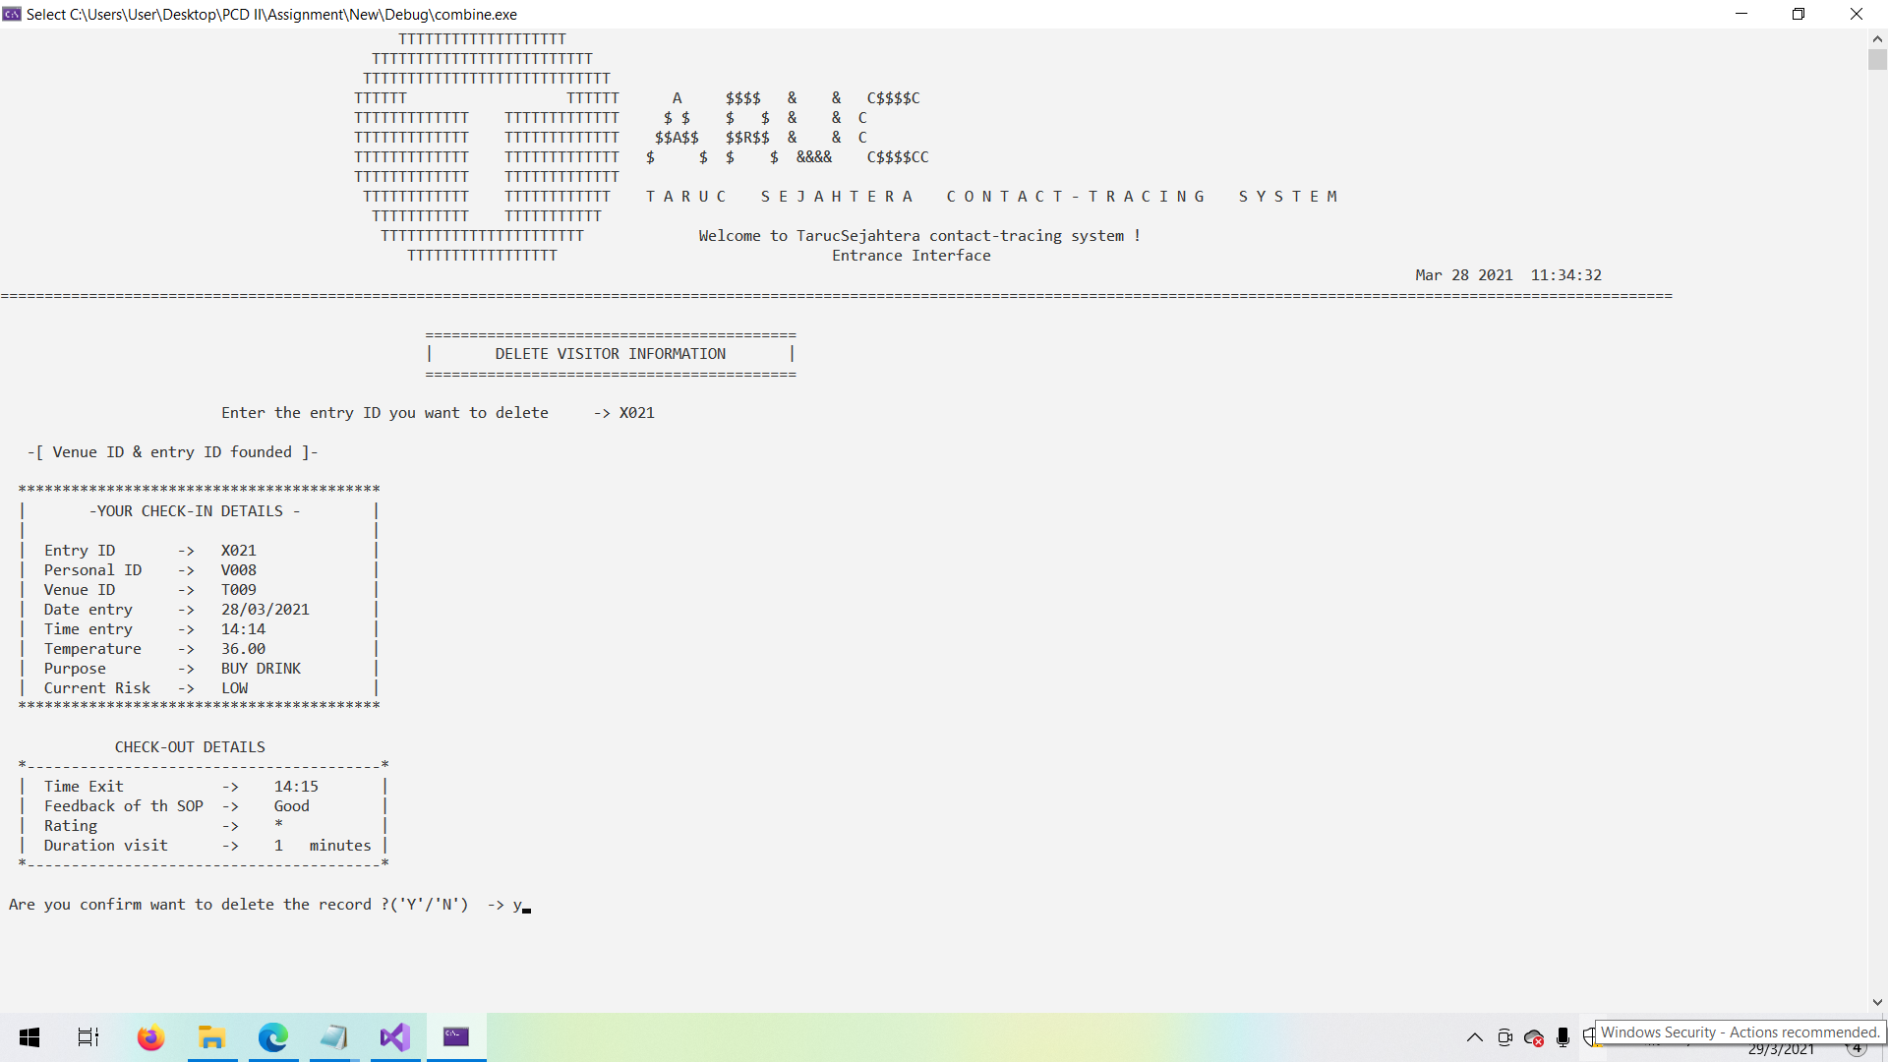

*Figure of 4.4.33 Screenshot of delete visitor entry history*

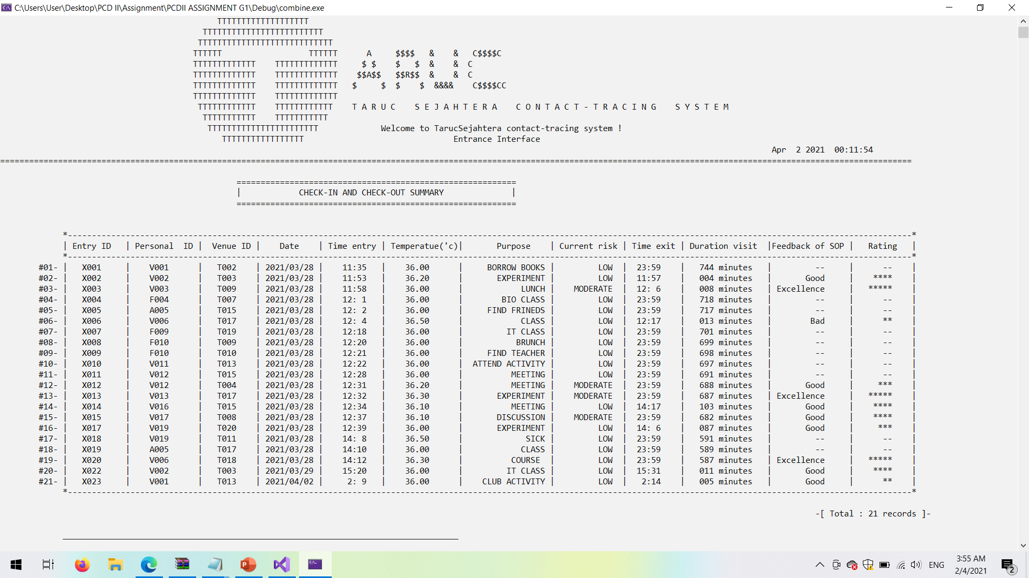

*Figure of 4.4.34 Screenshot of proving X021 has been deleted*

* X021 has been moved into the ‘backup’ text file . The purpose of backup is to let the top management to find back the old records of entry history in case of need.

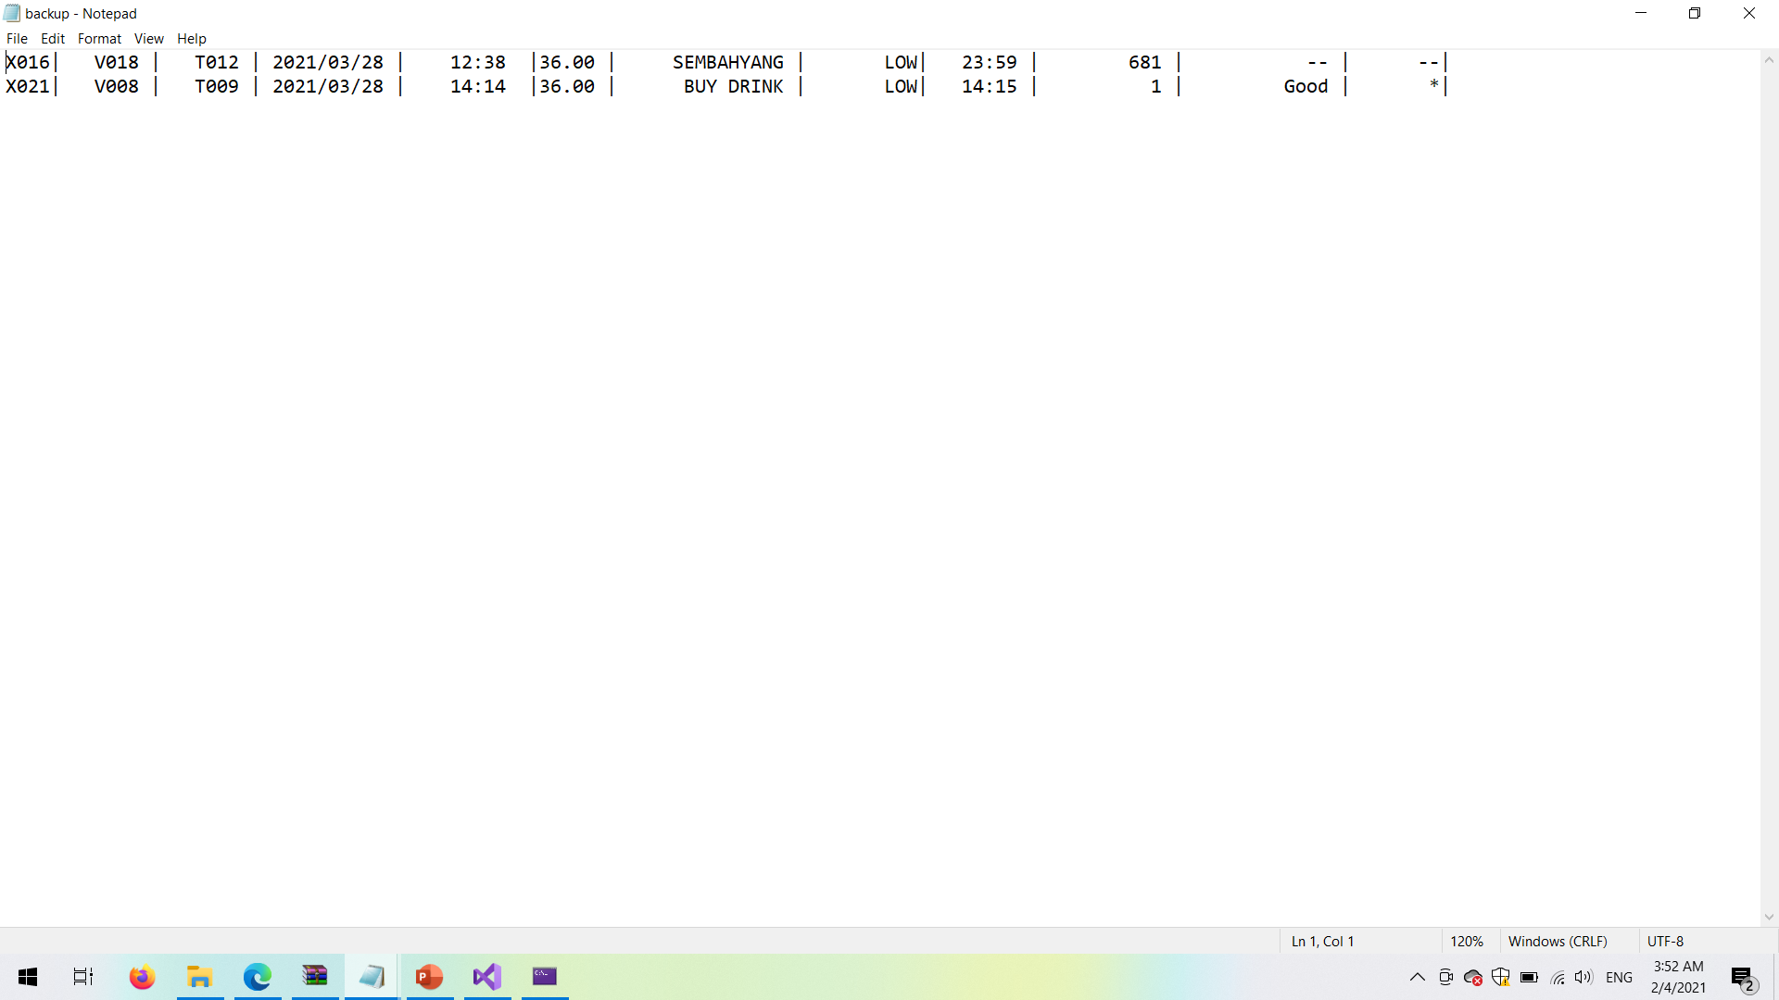

*Figure of 4.4.35 Screenshot of deleted data in the backup text file*

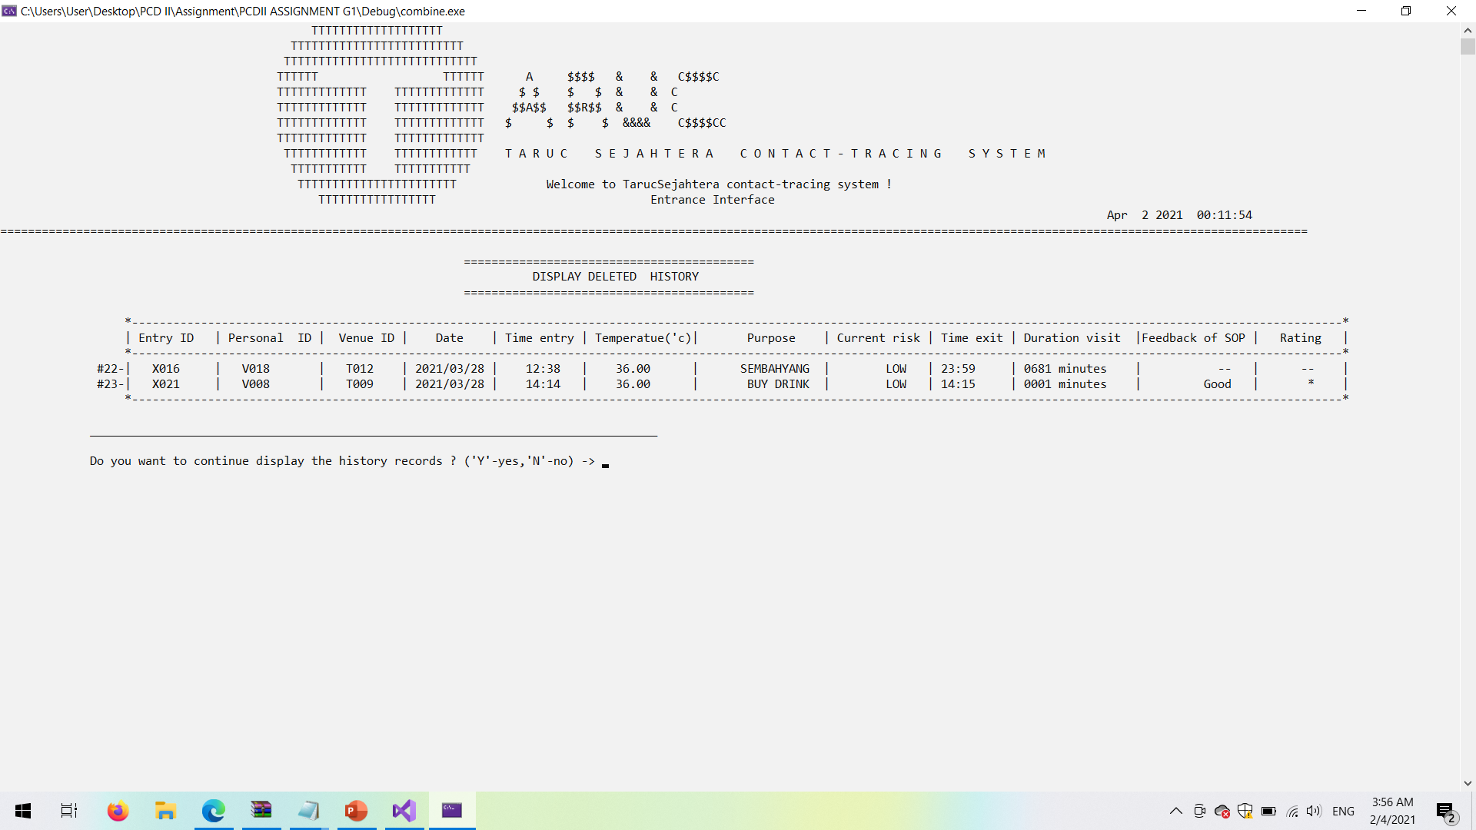

*Figure of 4.4.36 Screenshot of deleted data in the display module*

1. **Report of visit and exit**

* It allows admin to choose 3 type of report

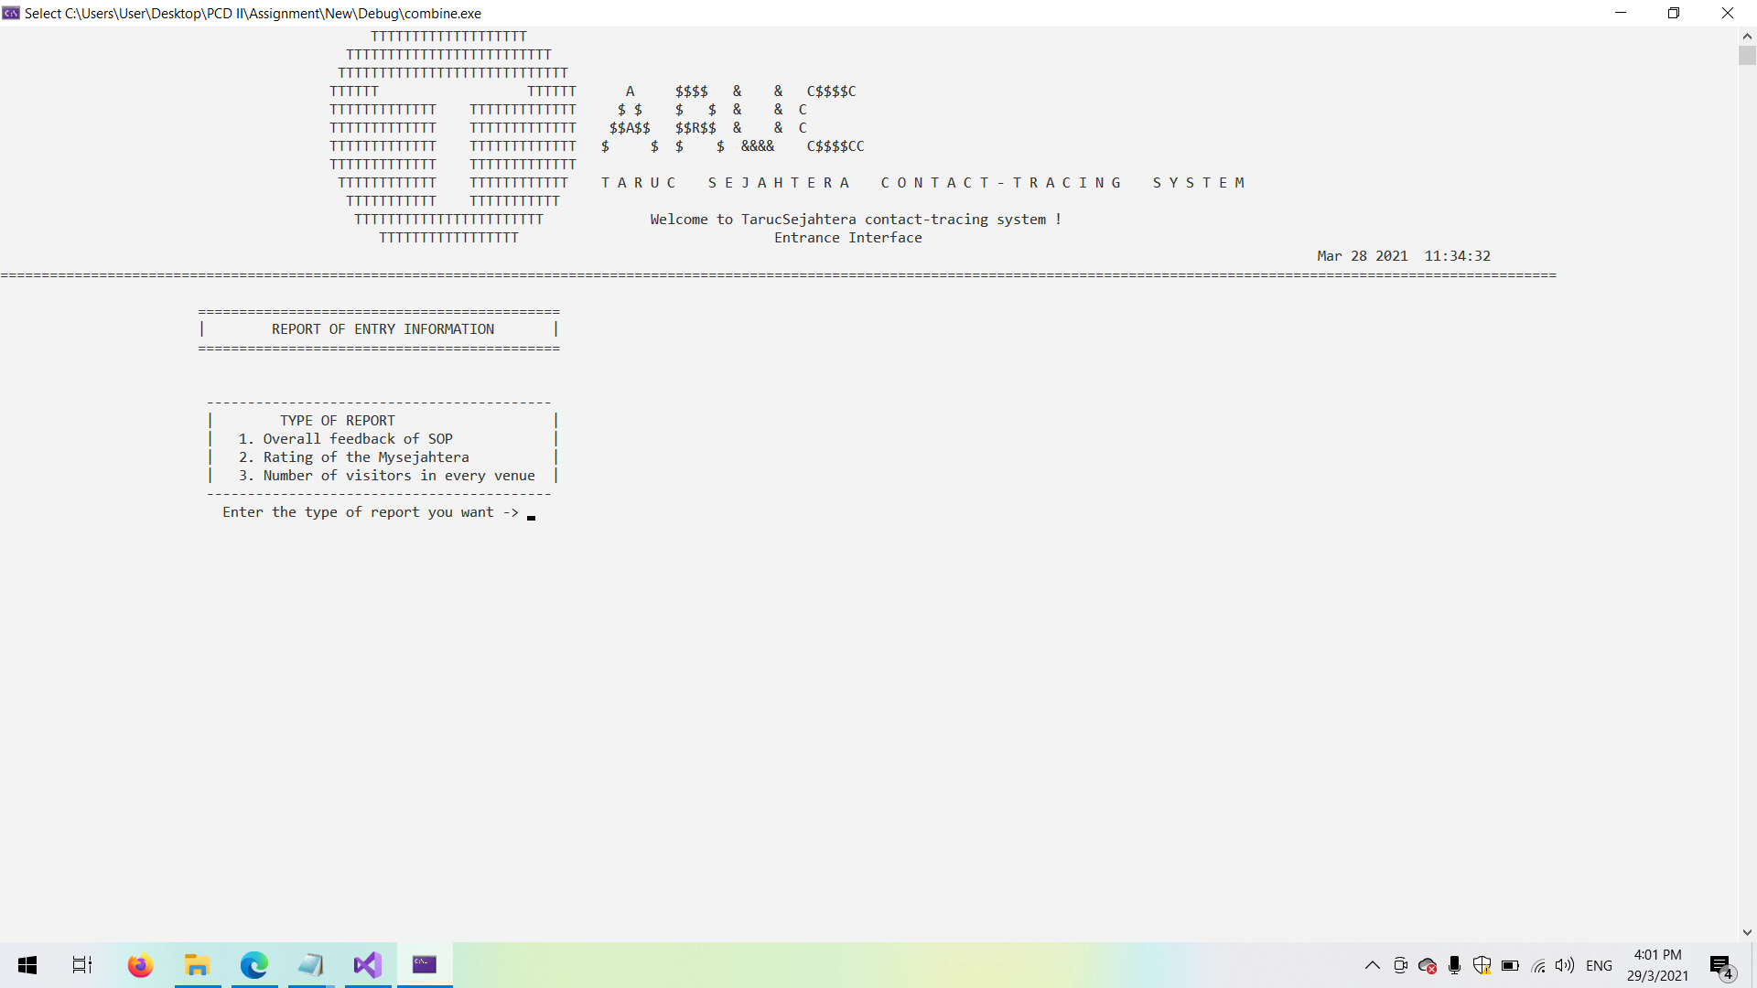

*Figure of 4.4.37 Screenshot of report menu*

**6.1 Feedback report**

* It will provide the conclusion based on the feedback given.

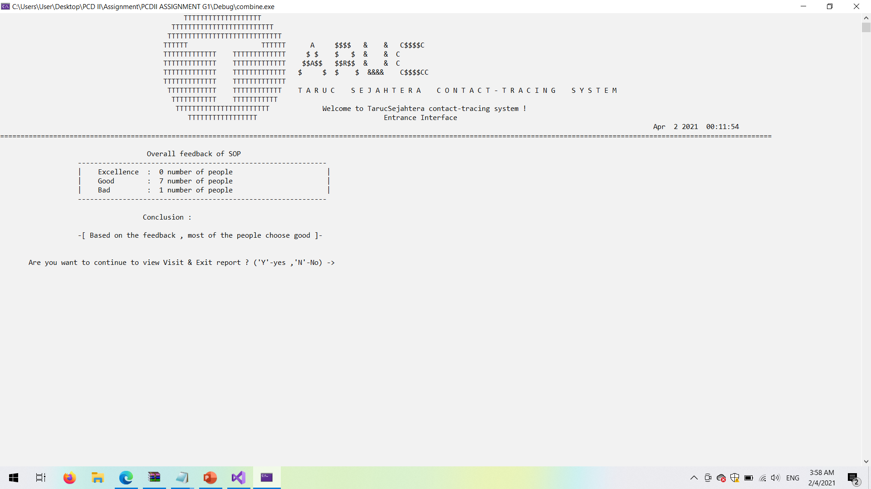

*Figure of 4.4.38 Screenshot of feedback report*

**6.2 Rating report**

* It will provide the conclusion based on the rating given.

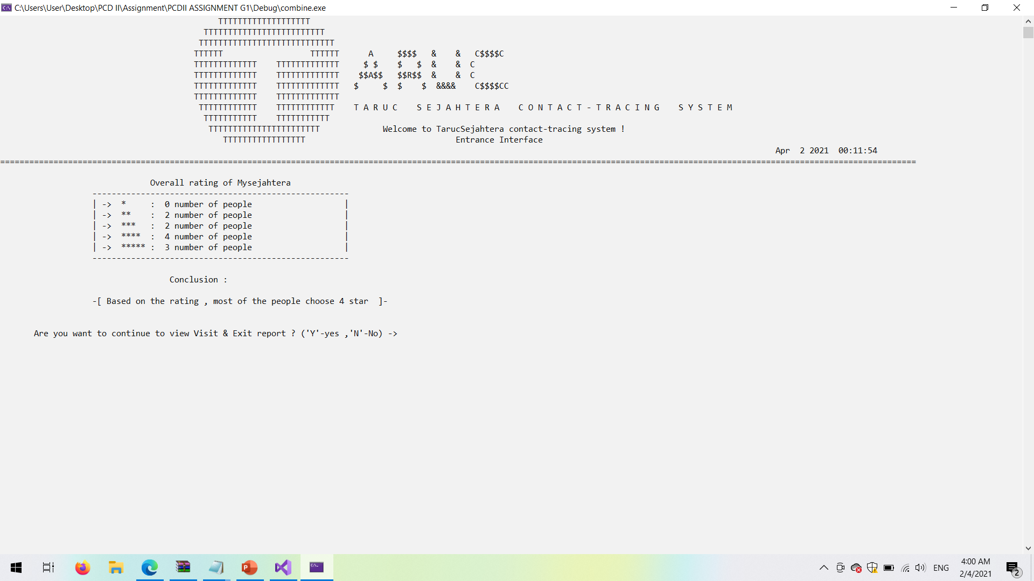

*Figure of 4.4.39 Screenshot of rating report*

**6.3 Monthly report of visitors in each venue**

* It will provide the number of visitors in each venue in each of the month.

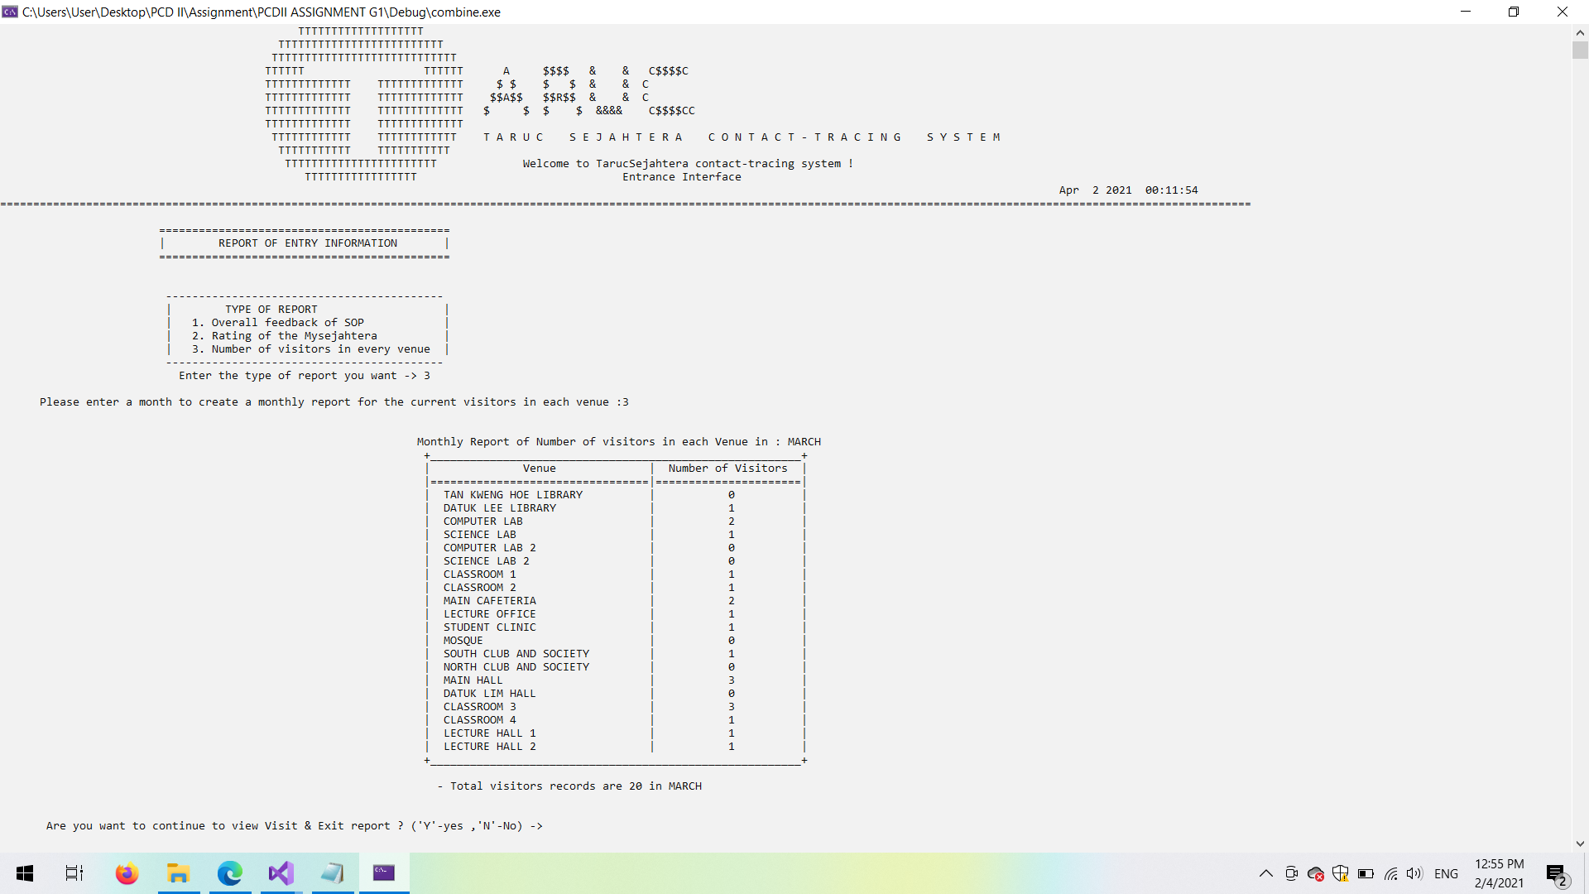

*Figure of 4.4.40 Screenshot of monthly report in each venue*

1. **Validation check**

* **Validation check ( 1 )**

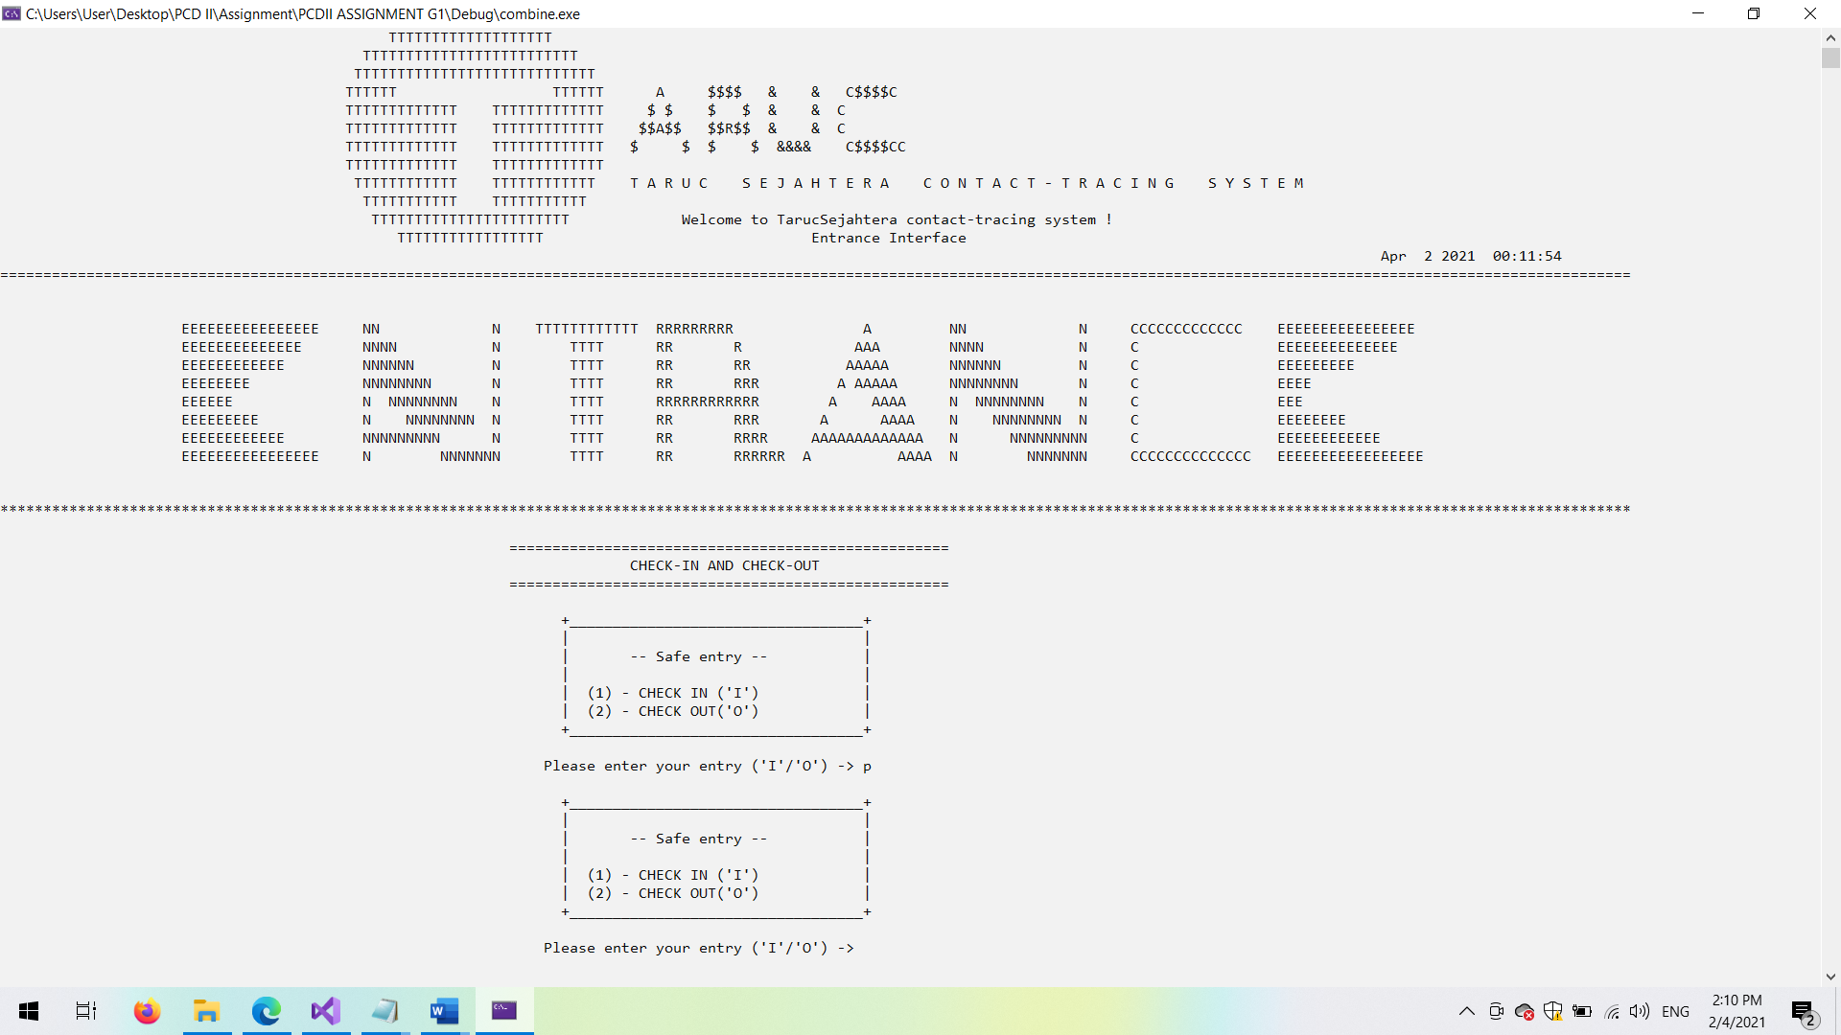

*Figure of 4.4.41 Screenshot of validation check in entry part*

* **Validation check ( 2 )**

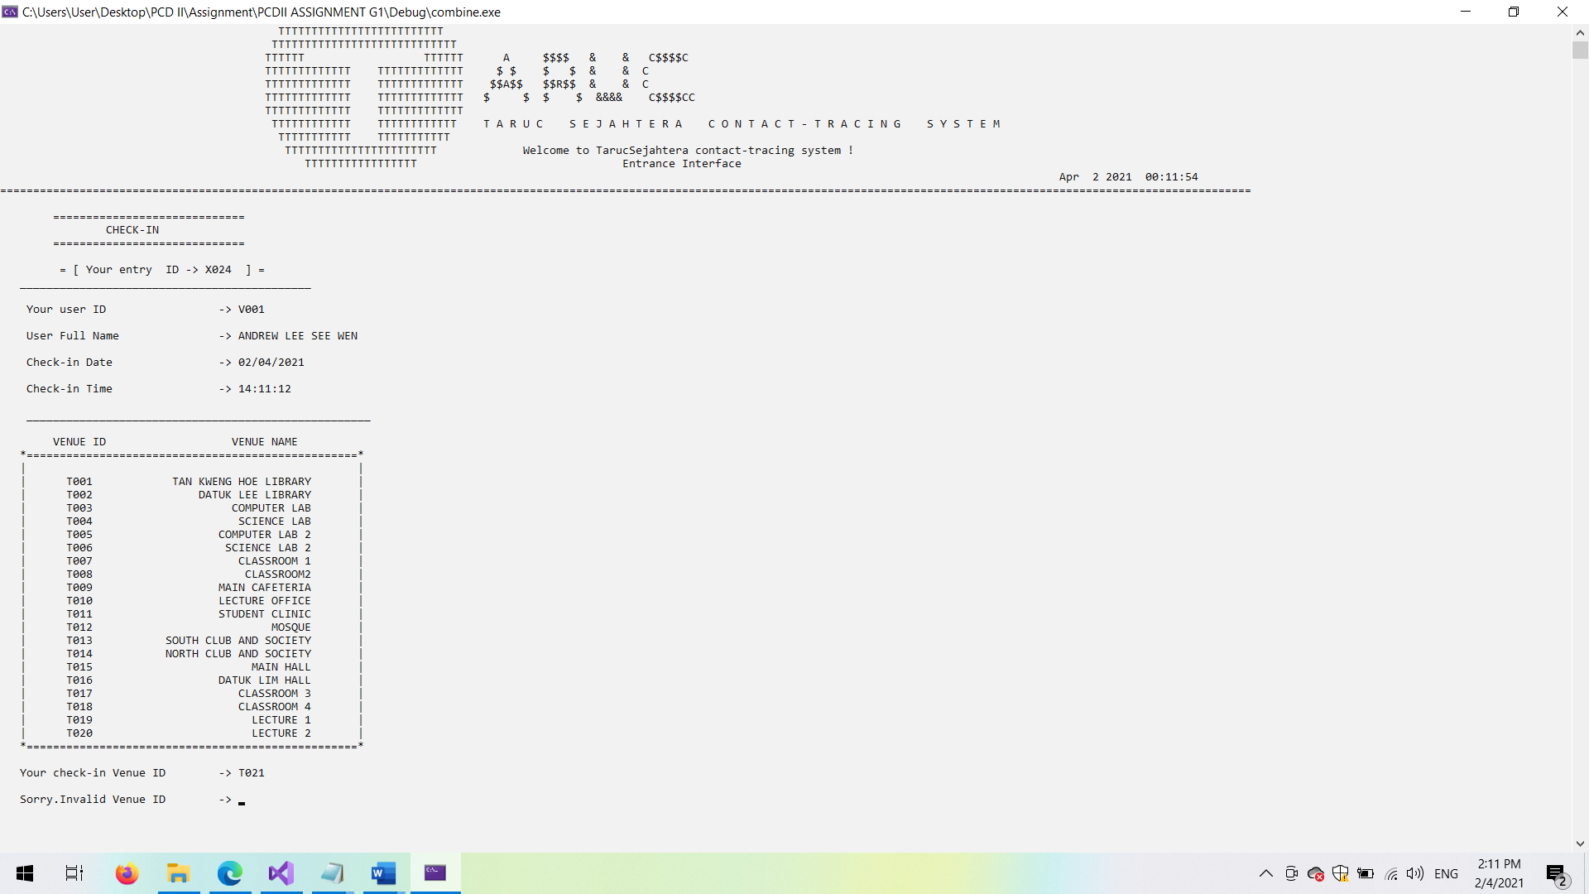

*Figure of 4.4.42 Screenshot of validation check in part(Invalid Venue ID)*

* **Validation check ( 3 )**



*Figure of 4.4.43 Screenshot of validation check in part(High temperature)*

* **Validation check ( 4 )**

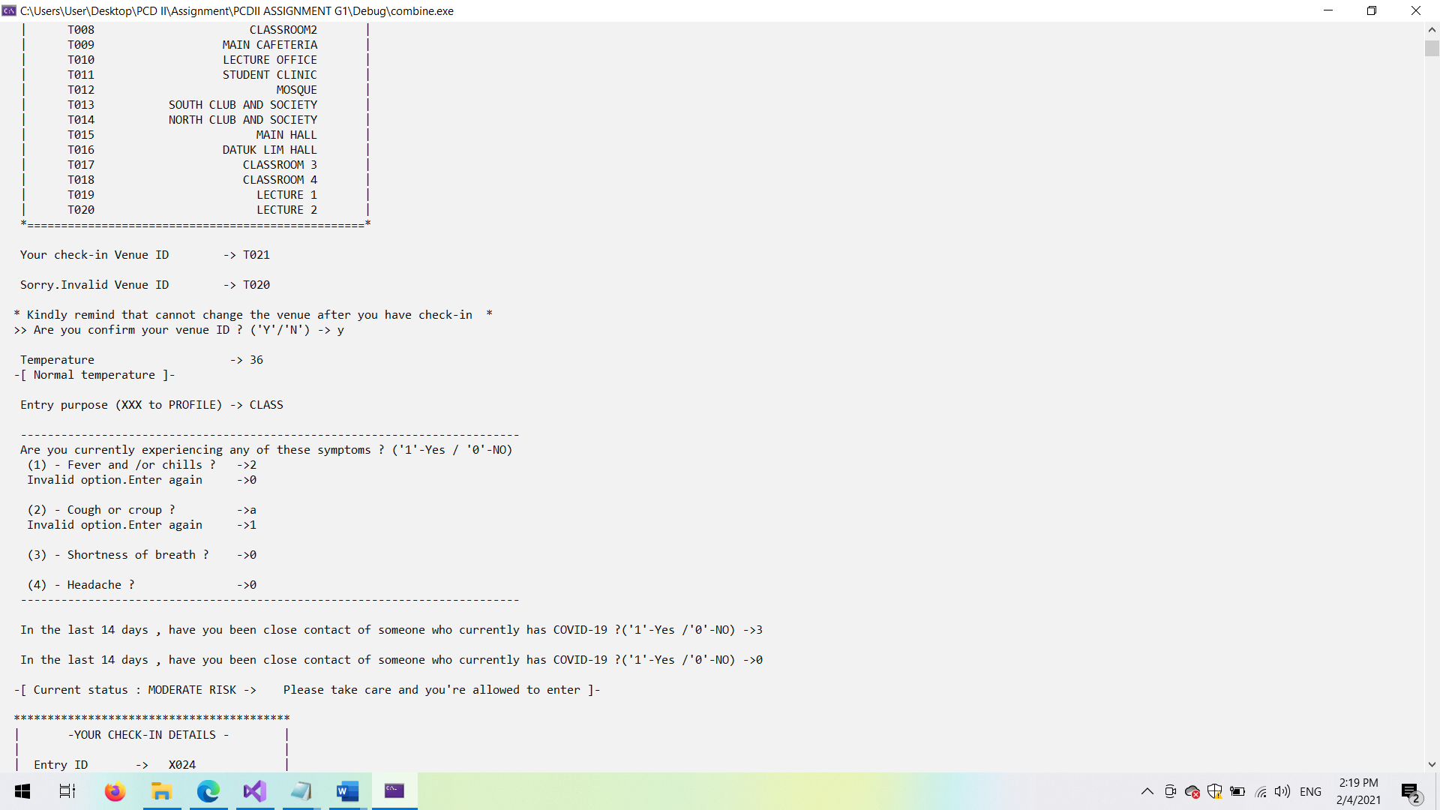

*Figure of 4.4.44 Screenshot of validation check in part(Experienced current symptoms)*

* **Validation check ( 5 )**

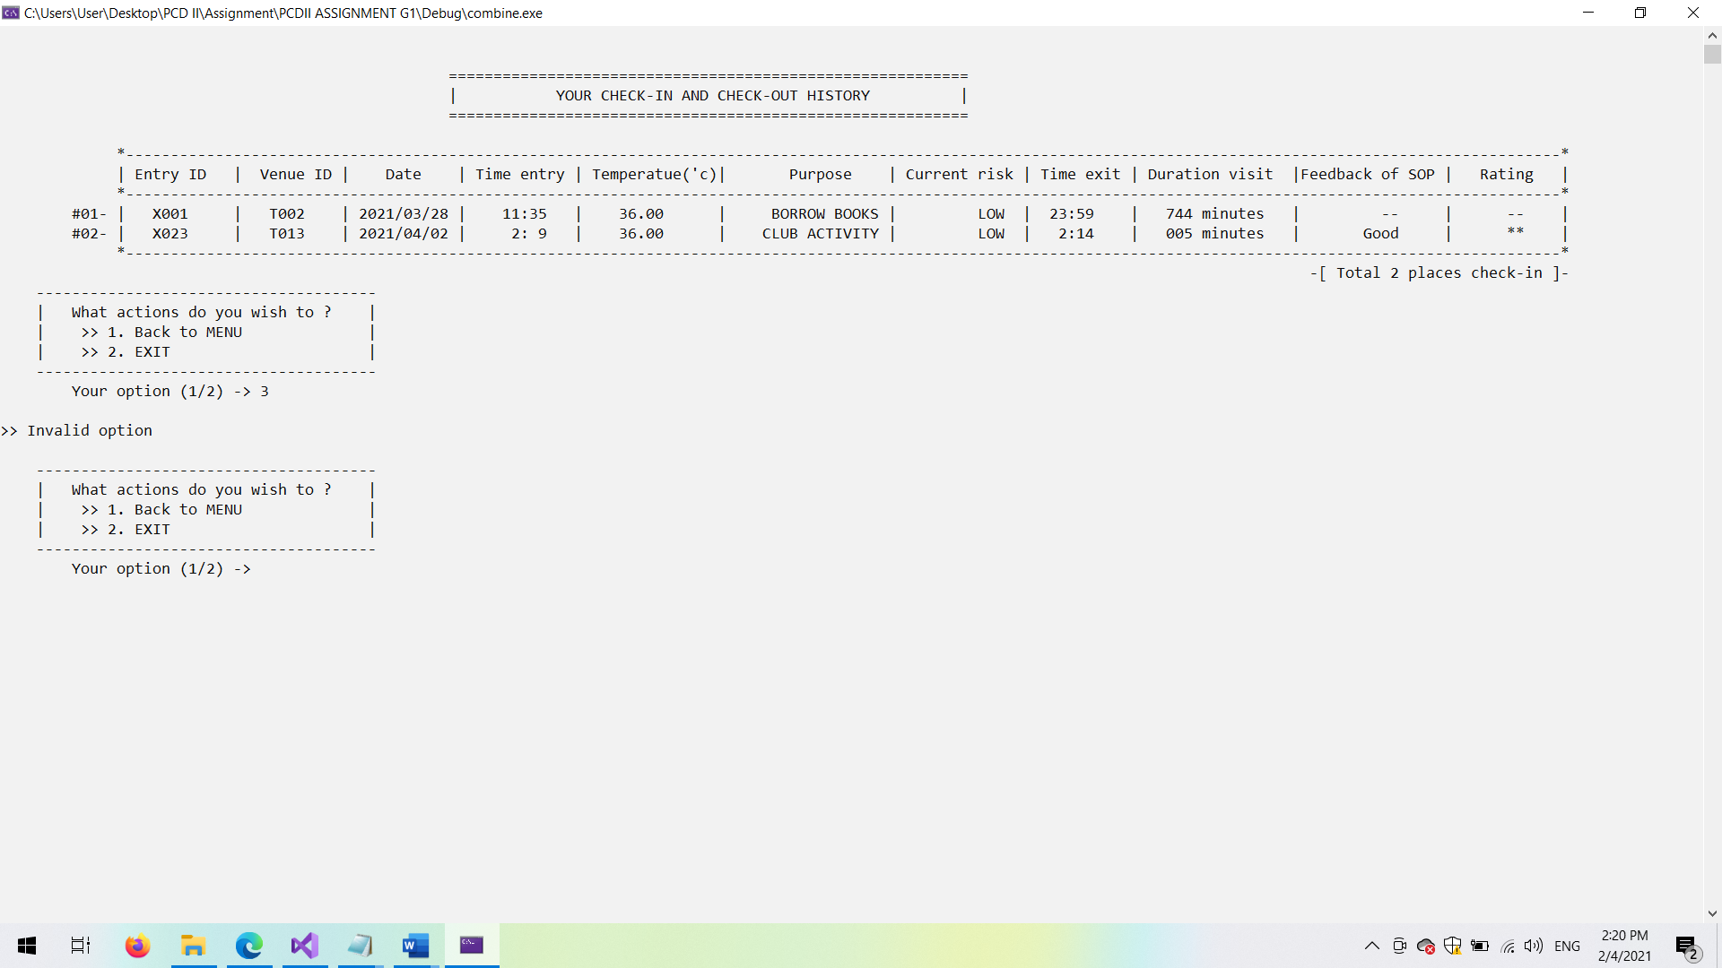

*Figure of 4.4.45 Screenshot of validation part(When back to menu)*

* **Validation check ( 6 )**

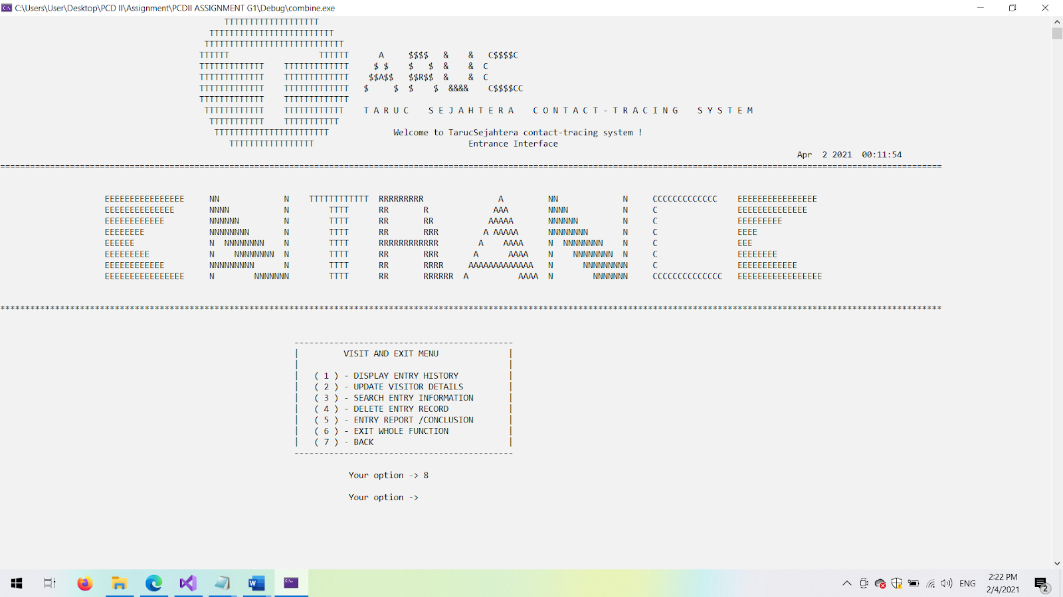

*Figure of 4.4.46 Screenshot of validation in admin menu of visit and exit*

* **Validation check ( 7 )**

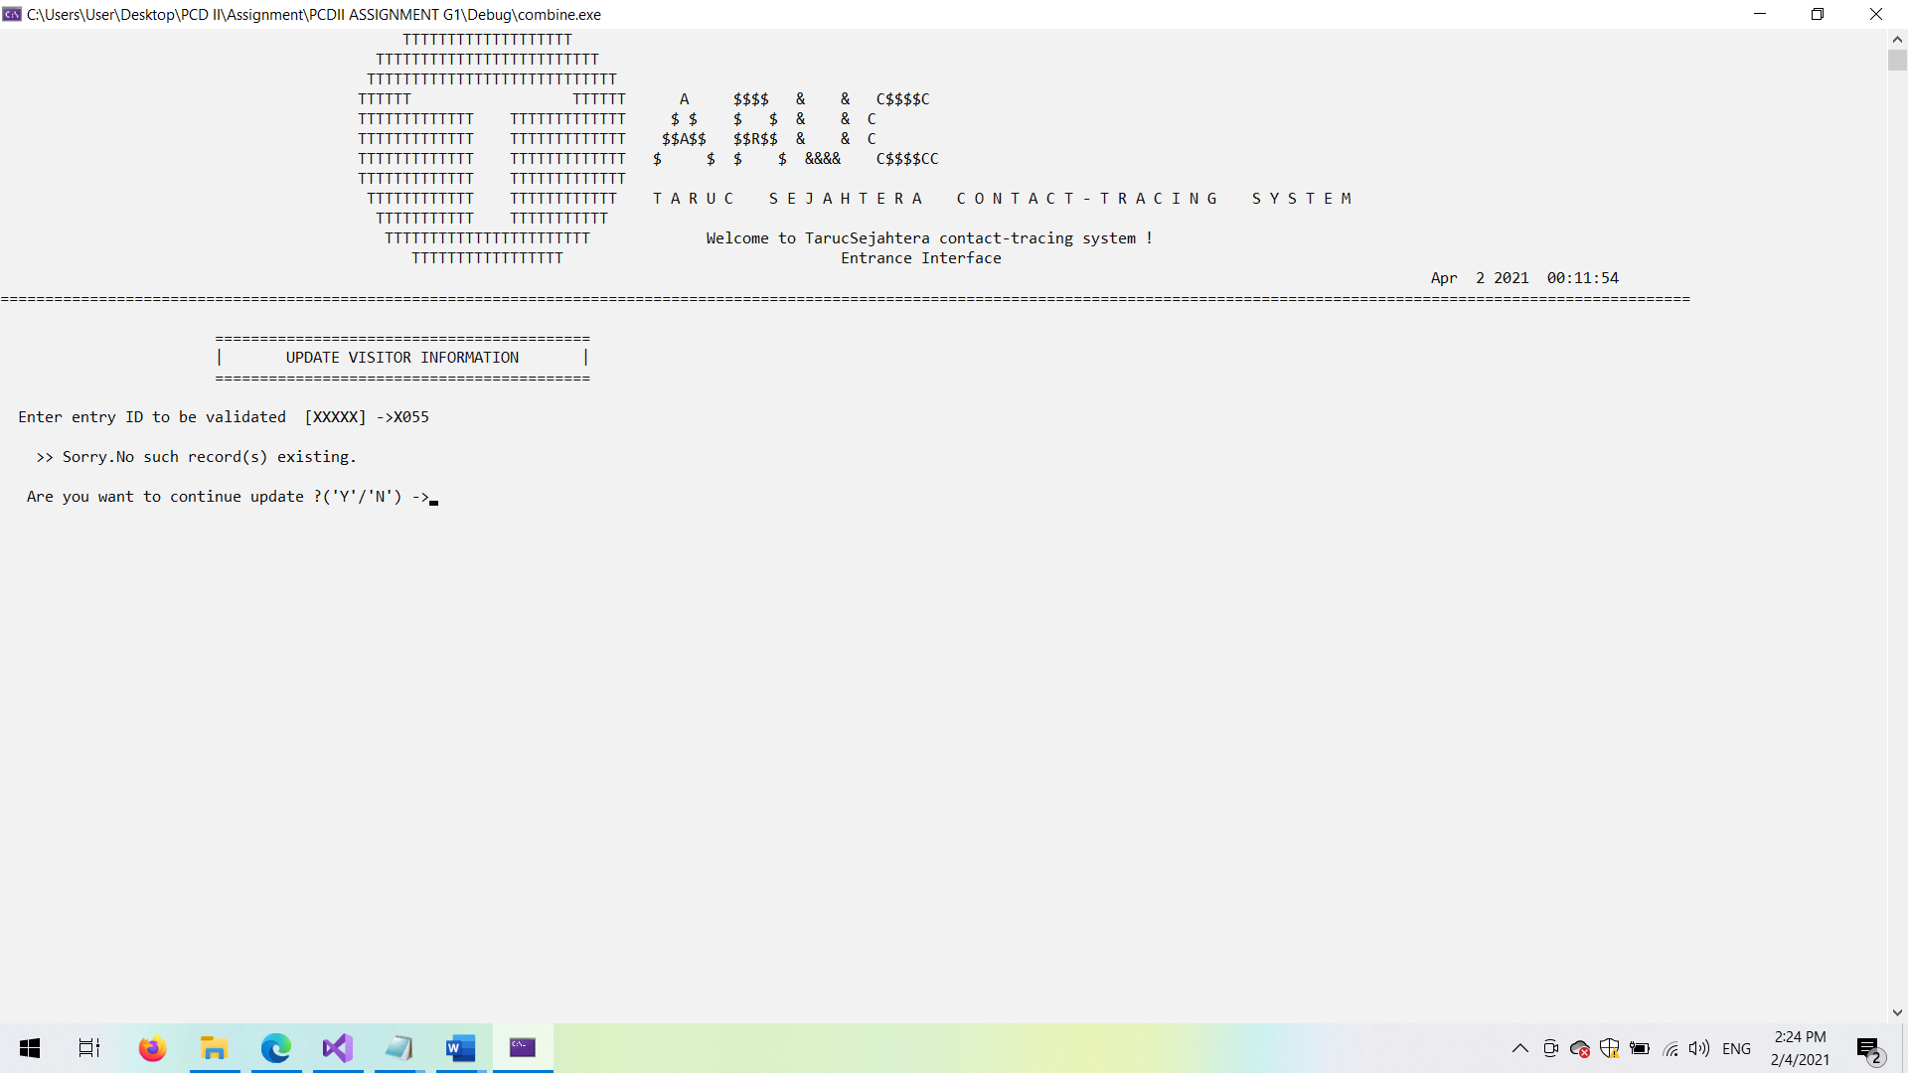

*Figure of 4.4.47 Screenshot of validation in modify of visit and exit(No such ID existing)*

* **Validation check ( 8 )**

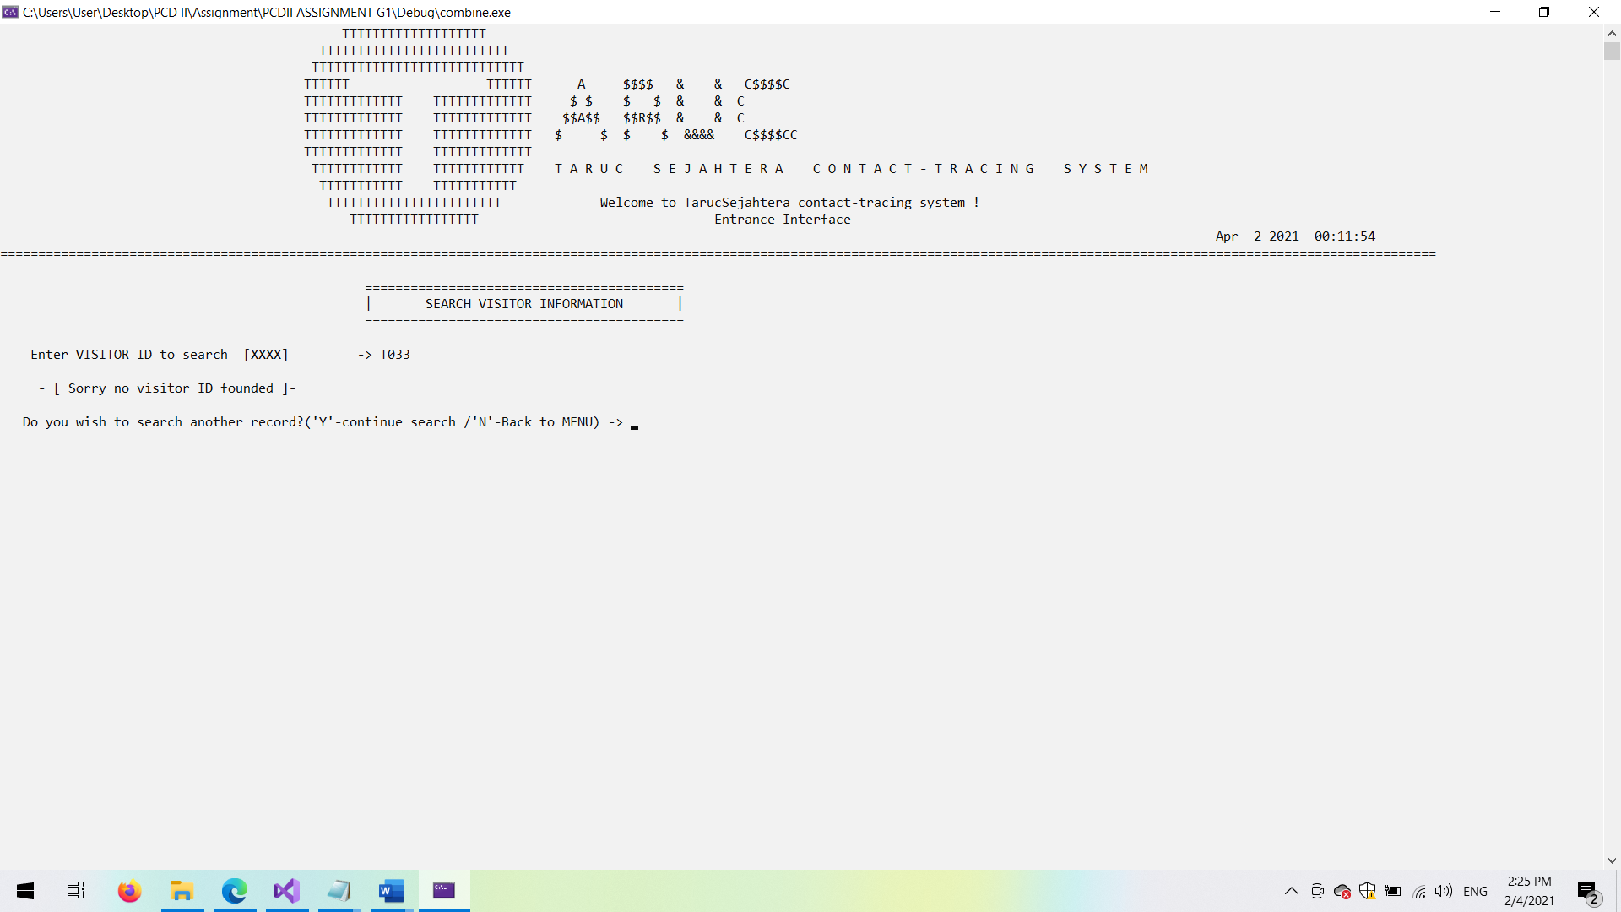

*Figure of 4.4.48 Screenshot of validation in search of visit and exit(No such ID existing)*

* **Validation check ( 9 )**

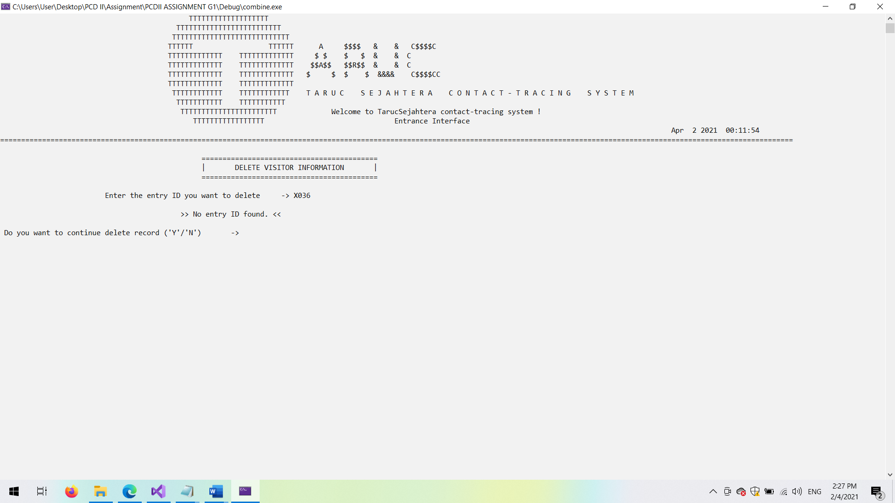

*Figure of 4.4.49 Screenshot of validation in delete of visit and exit(No such ID existing)*

# **4.5 Sanitization Module by < Cheng Cai Yuan >**

## 4.5.1 Brief Description

The main purpose of the sanitization module is to help record the reservation of sanitization that was made by the staff of TARUC with the sanitization company.When the staff have made a sanitization reservation to a venue,it will auto updated to the venue module to show to the visitor about that time of sanitization.This module will ensure that staff will not make double reservations for a venue at a same time because staffs can check the sanitization details they have made before through this module clearly.Besides,this module also helps to record the details of previous sanitizations such as payment details and service rating for the sanitization company.By having this record,the staff can look back to know that which company has a better service rate so that they can make reservations of sanitization with them.

## 4.5.2 Outputs and File Contents

* Sanitization menu interface

After the user login as admin and select to go into the sanitization records module,a sanitization main menu will be shown and the user can select what action they would like to perform.

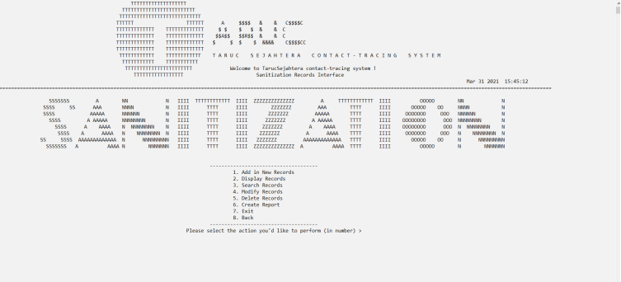

*Figure 4.5.1 shows the screenshot of main menu of sanitization*

**1.Add function**

When the user enters “1” in the menu,there will be two choice to let the user select whether they want to add a new reservation sanitization record or previous sanitization record.

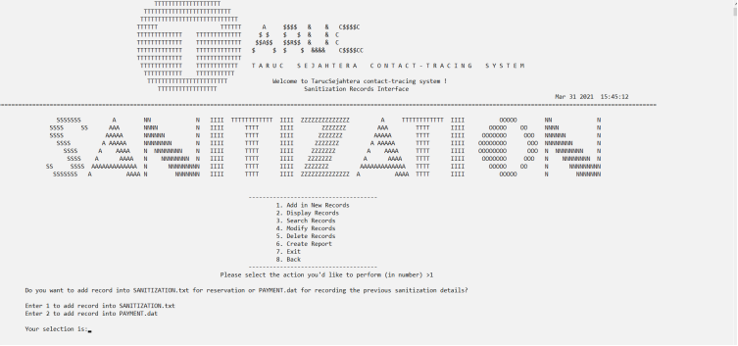

*Figure 4.5.2 shows the screenshot of add sanitization record*

When the user selects “1” to add a new reservation sanitization record into sanitization.txt,the system will automatically generate the latest sanitization ID so that the user no longer needs to key in the sanitization ID anymore.After that,the system will assign the user to key in the reservation date,reservation time,reservation venue and so on.After the user key in successfully,it will show that “Record successfully added” and ask the user whether he or she want to add in new record or not.If the user don’t want to add in anymore,then the user can select whether he or she want to back to sanitization main menu to perform another action or not.

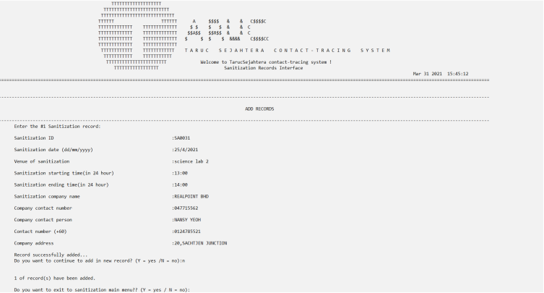

*Figure 4.5.3 shows the screenshot of add new reservation sanitization record*

**Validation check for add new reservation sanitization record**

* Validation check for date(User are not allow to key in the reservation date that are before the system date)



*Validation Figure 1*

* Validation check for venue(User are not allow to key in the venue name that are not match with the venue name that assign in the venue module)



*Validation Figure 2*

* Validation check for time(User are not allow to key in character or invalid time in this field)



*Validation Figure 3*

* Validation check for company contact number(User are not allow to key in the contact number which are less than or more than the length size of 9)



*Validation Figure 4*

* Validation check for company contact person(User are not allow to key in the number or symbol and only allow to key in character)



*Validation Figure 5*

* Validation check for the contact number(User are not allow to key in the contact number which are less than or more than the length size of 10 or 11)



*Validation Figure 6*

When the user selects “2” to add a new previous sanitization record into payment.dat,the system will automatically generate the latest payment ID so that the user no longer needs to key in the payment ID anymore.After that,the system will assign the user to key in the sanitization ID,payment method,payment merchant and so on.After the user key in successfully,it will show that “Record successfully added” and ask the user whether he or she want to add in new record or not.If the user don’t want to add in anymore,then the user can select whether he or she want to back to sanitization main menu to perform another action or not.

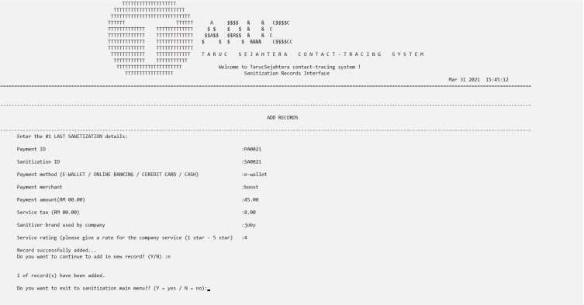

*Figure 4.5.4 shows the screenshot of add previous sanitization record*

**Validation check for add new previous sanitization record**

* Validation check for sanitization ID(User are not allow to key in the sanitization ID that cannot found in sanitization.txt)



*Validation Figure 7*

* Validation check for payment method(User are only allow to enter “E-Wallet” / “Online Banking” / “Credit Card” / “Cash”)



*Validation Figure 8*

* Validation check for payment amount and service tax(User are only allow to enter in numeric form)



*Validation Figure 9*



*Validation Figure 10*

* Validation check for service rating(User are only allow to enter the number between 1 to 5)



*Validation Figure 11*

1. **Display function**

When the user enters “2” in the menu,there will be two choice to let the user select whether they want to display the reservation sanitization record or previous sanitization record.

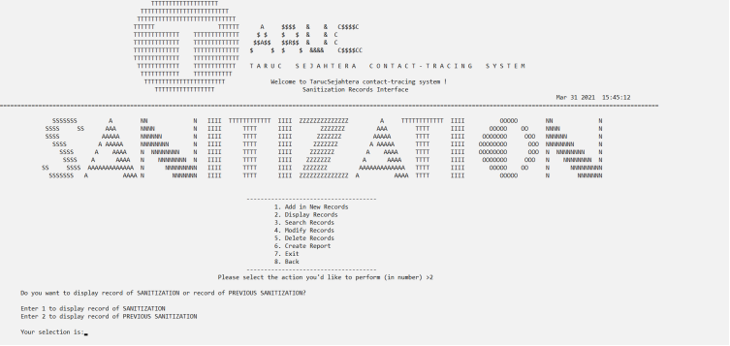

*Figure 4.5.5 shows the screenshot of display sanitization record*

When the user selects “1” to display the reservation sanitization record,the system will ask the user to select whether he or she want to display all records or certain records only.If the user selects “1”,then all the sanitization records in sanitization.txt will be display out.

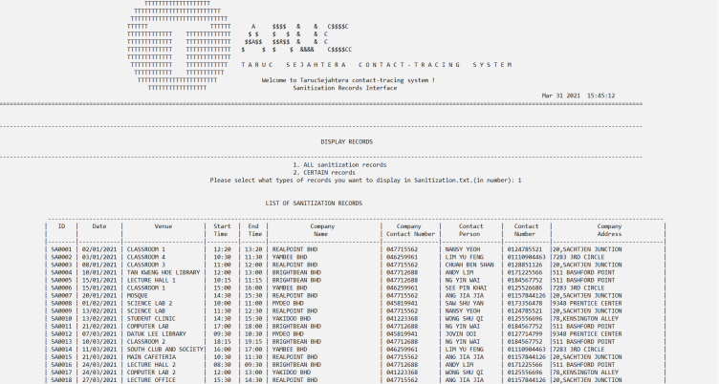

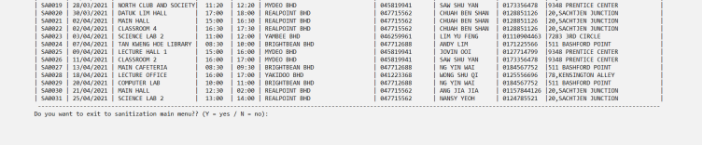

*Figure 4.5.6 shows the screenshot of display ALL the sanitization reservation record*

If the user selects “2”,then the system will ask the user to key in the range of sanitization ID that they would like to display.

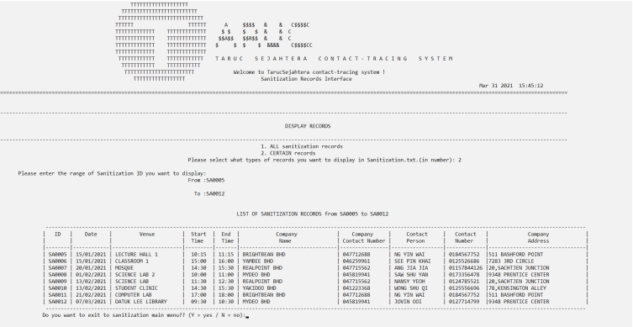

*Figure 4.5.7 shows the screenshot of display CERTAIN sanitization reservation record*

**Validation check for display certain reservation sanitization record**

* Validation check for sanitization ID(User are only allow to enter the sanitization ID which can found in sanitization.txt)

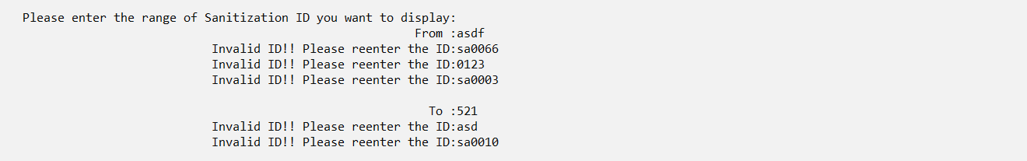

*Validation Figure 12*

When the user selects “2” to display the previous sanitization record,the system will ask the user to select whether he or she want to display all records or certain records only.If the user selects “1”,then all the previous sanitization records in payment.dat will be display out.

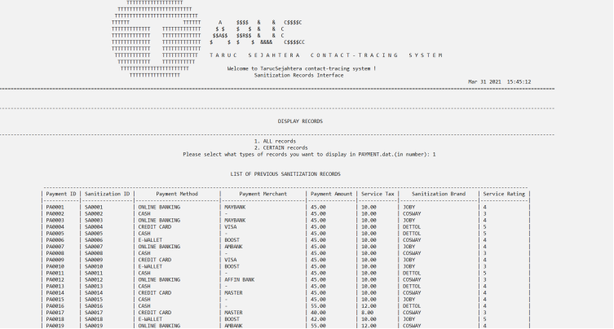



*Figure 4.5.8 shows the screenshot of display ALL the previous sanitization record*

If the user selects “2”,then the system will ask the user to key in the range of payment ID that they would like to display.

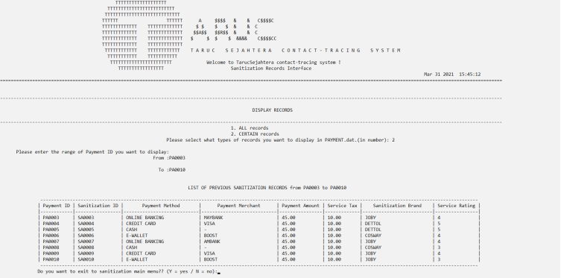

*Figure 4.5.9 shows the screenshot of display CERTAIN previous sanitization record*

**Validation check for display certain previous sanitization record**

* Validation check for payment ID(User are only allow to enter the payment ID which can found in payment.dat)

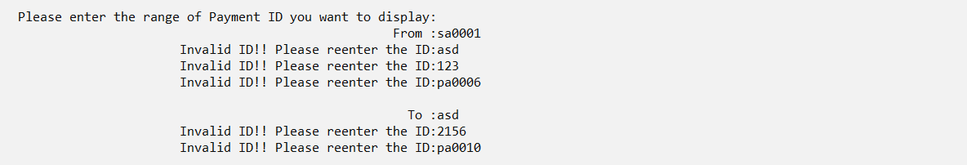

*Validation Figure 13*

1. **Search function**

When the user enters “3” in the menu,there will be two choice to let the user select whether they want to search for the reservation sanitization record or previous sanitization record.

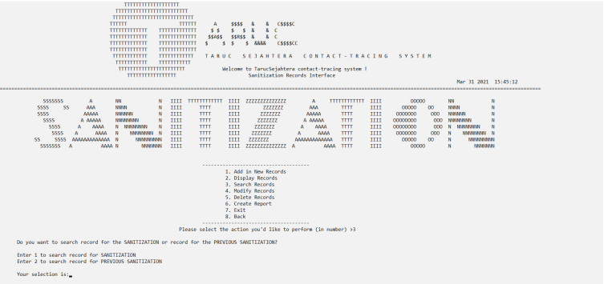

*Figure 4.5.10 shows the screenshot of search sanitization record*

When the user selects “1” to search for the reservation sanitization record,the system will display a search menu of the reservation sanitization record.There are 4 choices to let the user choose whether he or she wants to search the record based on how many criteria.

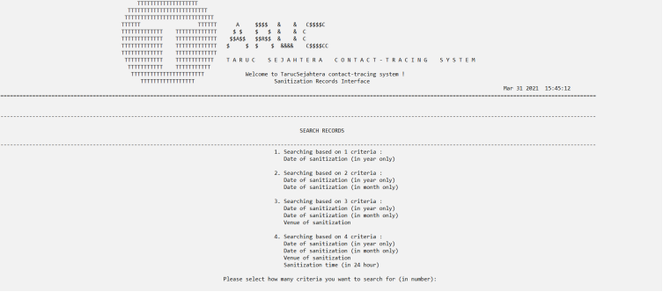

*Figure 4.5.11 shows the screenshot of search menu of the reservation sanitization record*

When the user selects “1”,it will go into the first one which is searching based on 1 criteria and only allow the user enter the year to search.

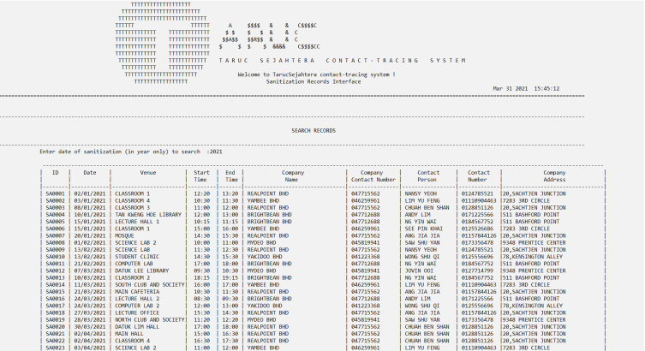

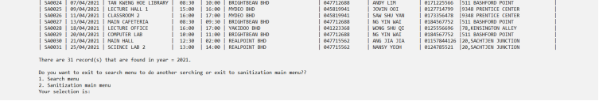

*Figure 4.5.12 shows the screenshot of searching based on 1 criteria*

When the user selects “2”,it will go into the second one which is searching based on 2 criteria and only allow the user enter the year and month to search.

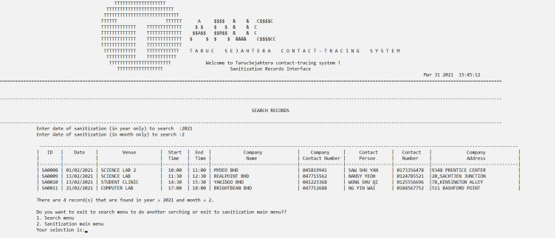

*Figure 4.5.13 shows the screenshot of searching based on 2 criteria*

When the user selects “3”,it will go into the third one which is searching based on 3 criteria and only allow the user enter the year,month and venue of sanitization to search.

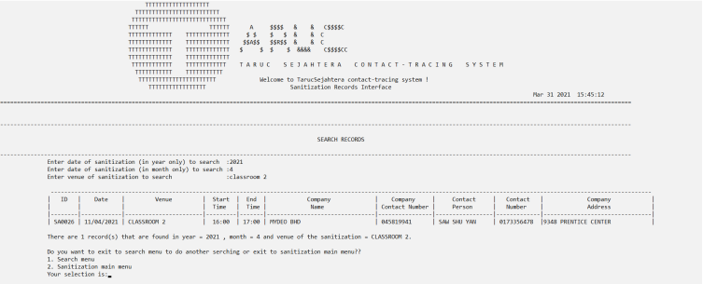

*Figure 4.5.14 shows the screenshot of searching based on 3 criteria*

When the user selects “4”,it will go into the fourth one which is searching based on 4 criteria and only allow the user enter the year,month,venue of sanitization and time to search.

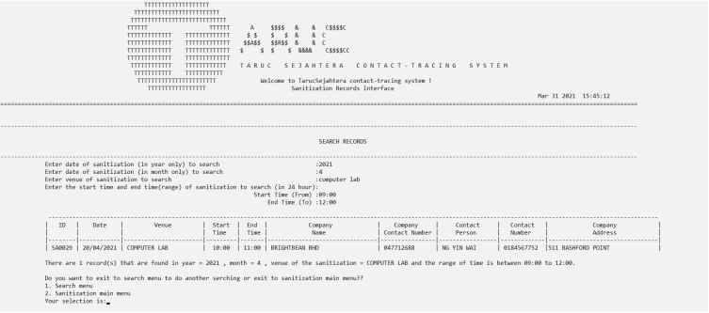

*Figure 4.5.15 shows the screenshot of searching based on 4 criteria*

When the user selects “2” to search for the previous sanitization record,the system will display a search menu of the previous sanitization record.There are 4 choices to let the user choose whether he or she wants to search the record based on which criteria.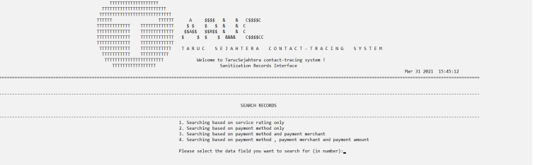

*Figure 4.5.16 shows the screenshot of search menu of the previous sanitization record*

When the user selects “1”,it will go into the first one which is searching based on 1 criteria and only allow the user enter the service rating to search.

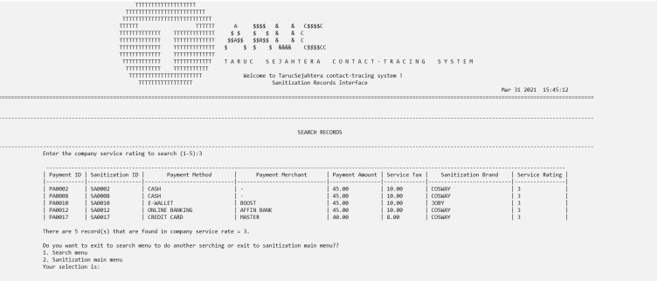

*Figure 4.5.17 shows the screenshot of searching based on service rate only*

When the user selects “2”,it will go into the second one which is searching based on 1 criteria and only allow the user enter the payment method to search.

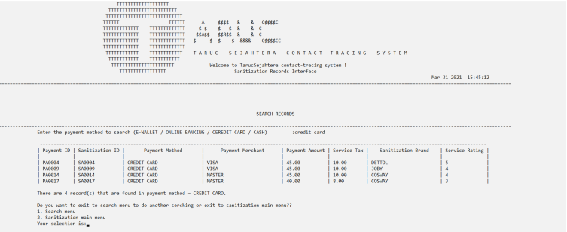

*Figure 4.5.18 shows the screenshot of searching based on payment method only*

When the user selects “3”,it will go into the third one which is searching based on 2 criteria and only allow the user enter the payment method and payment merchant to search.

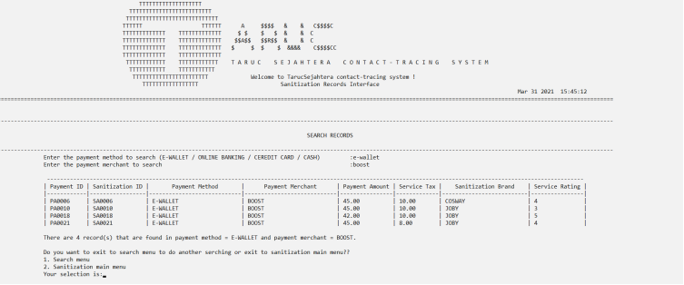

*Figure 4.5.19 shows the screenshot of searching based on payment method and payment merchant* *only*

When the user selects “4”,it will go into the fourth one which is searching based on 3 criteria and only allow the user enter the payment method, payment merchant and payment amount to search.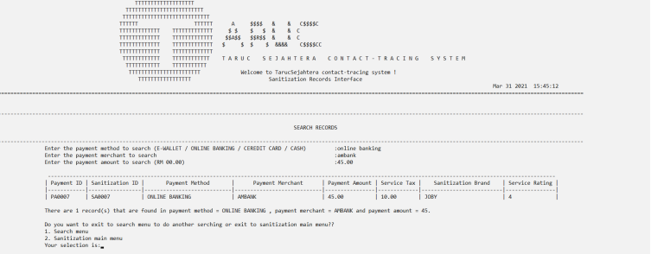

*Figure 4.5.20 shows the screenshot of searching based on payment method, payment merchant and payment amount only*

1. **Modify function**

When the user enters “4” in the menu,there will be two choice to let the user select whether they want to modify for the reservation sanitization record or previous sanitization record.

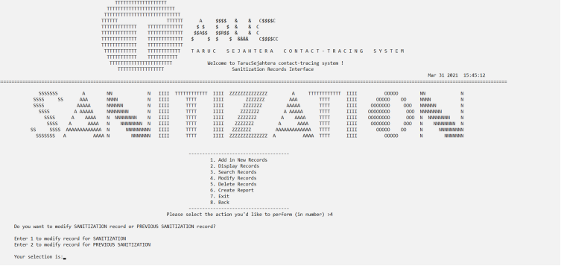

*Figure 4.5.21 shows the screenshot of modify sanitization record*

When the user selects “1” to modify the reservation sanitization record,the system will ask the user to key in the sanitization ID they want to modify first.After that display the details of the ID that the user key in.User then can key in all the details that they want to update except the sanitization ID.After the user key in all the details they want to updated,the system will ask the user whether he or she confirm to update this sanitization ID.If the answer from user is “Y”,then it will display out all the updated details for the ID.

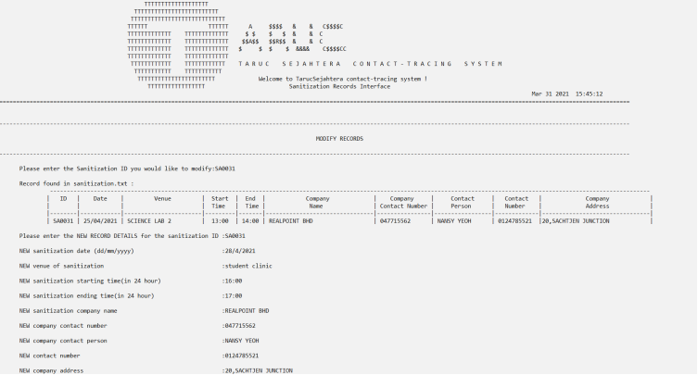

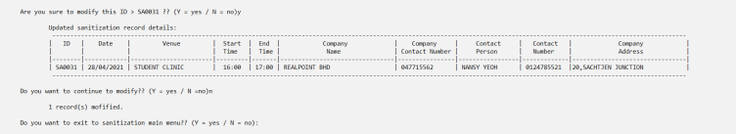

*Figure 4.5.22 shows the screenshot of modify reservation sanitization record*

When the user selects “2” to modify the previous sanitization record,the system will ask the user to key in the payment ID they want to modify first.After that display the details of the ID that the user key in.User then can key in all the details that they want to update except the payment ID.After the user key in all the details they want to updated,the system will ask the user whether he or she confirm to update this payment ID.If the answer from user is “Y”,then it will display out all the updated details for the ID.

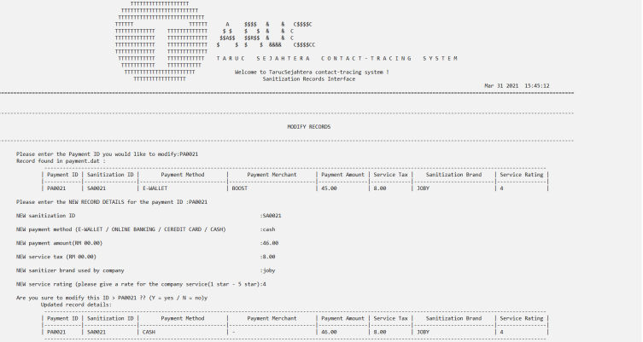



*Figure 4.5.23 shows the screenshot of modify previous sanitization record*

1. **Delete function**

When the user enters “5” in the menu,there will be two choice to let the user select whether they want to delete the reservation sanitization record or previous sanitization record.

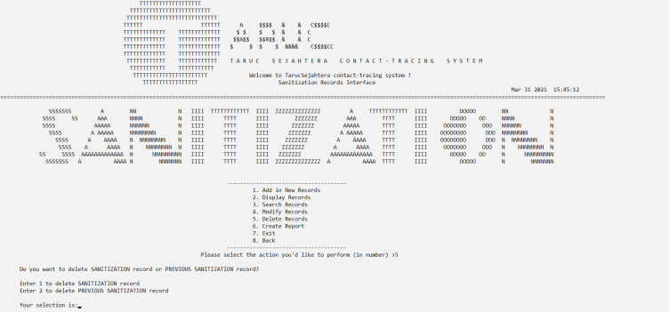

*Figure 4.5.24 shows the screenshot of delete sanitization record*

When the user selects “1” to delete the reservation sanitization record,the system will ask the user to key in the sanitization ID they want to delete first.After that display the details of the ID that the user key in.Then the system will ask the user whether he or she confirm to delete this record,if the answer form user is “Y”,then the record will successfully deleted.

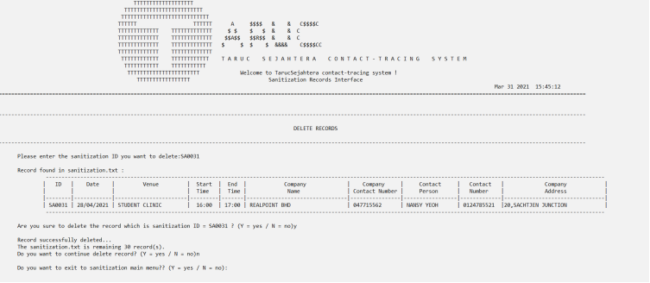

*Figure 4.5.25 shows the screenshot of delete the reservation sanitization record*

The deleted record will automatically save into the sanitization_backup.txt.



*Figure 4.5.26 shows the screenshot of deleted record in sanitization backup file*

When the user selects “2” to delete the previous sanitization record,the system will ask the user to key in the payment ID they want to delete first.After that display the details of the ID that the user key in.Then the system will ask the user whether he or she confirm to delete this record,if the answer form user is “Y”,then the record will successfully deleted.

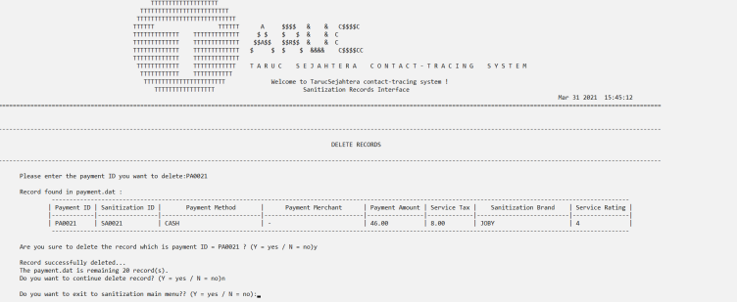

*Figure 4.5.27 shows the screenshot of delete the previous sanitization record*

The deleted record will automatically save into the payment_backup.dat.



*Figure 4.5.28 shows the screenshot of deleted record in payment backup file*

1. **Report function**

When the user enters “6” in the menu,it will go into the report function to generate a monthly report for the venue.The purpose of this report is to count the number of sanitization for each venue in a month.The system will ask the user to enter a month first then only generate the monthly report for the month.

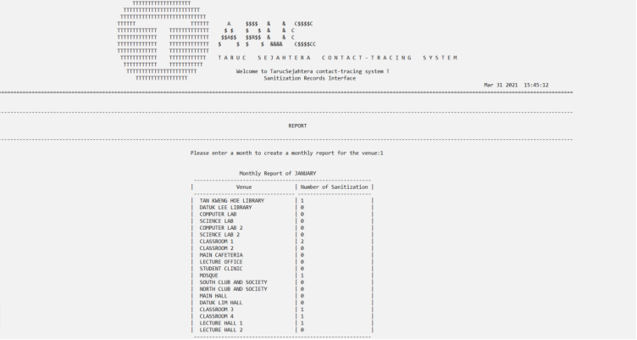



*Figure 4.5.29 shows the screenshot of monthly report for the venue*

**Validation check for create report**

* Validation check for month(User are only allow to key in the range of month between 1 to 12)

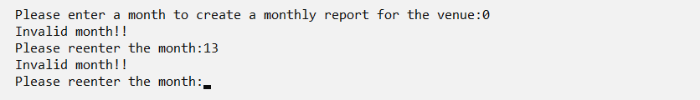

*Validation Figure14*

# **References**

George Watson, 1996, *ASCII Table*

Available at: <http://www.physics.udel.edu/~watson/scen103/ascii.html>

[Accessed march 2021].

Fresh2refresh, 2021, *Validation Check in c*

Available at: <https://fresh2refresh.com/c-programming/c-int-char-validation/>

[Accessed march 2021].

[Sandeepa Nadahalli](https://c-program-example.com/author/sandeepa-nadahalli), 2011*,* [*C Program to mask password text with asterisk(*)*](https://c-program-example.com/2011/09/c-program-to-mask-password-text-with-asterisk.html)

Available at: <https://c-program-example.com/2011/09/c-program-to-mask-password-text-with-asterisk.html>

[Accessed april 2021].

codingunit, n.d. *codingunit.* [Online]   
Available at: https://www.codingunit.com/c-tutorial-deleting-a-record-from-a-binary-file  
[Accessed april 2021].

LearningLad, 2016. *youtube.* [Online]   
Available at: https://www.bing.com/videos/search?q=password+in+c+programming&view=detail&mid=781EC1F33A1693BFBF48781EC1F33A1693BFBF48&FORM=VIRE  
[Accessed march 2021].

overflow, s., n.d. *stack overflow.* [Online]   
Available at: https://stackoverflow.com/questions/1442116/how-to-get-the-date-and-time-values-in-a-c-program  
[Accessed april 2021].

overflow, s., n.d. *stack overflow.* [Online]   
Available at: https://stackoverflow.com/questions/36533362/how-to-call-a-function-in-another-function-in-c-programming  
[Accessed march 2021].

point, t., n.d. *tutorial point.* [Online]   
Available at: https://www.tutorialspoint.com/cprogramming/c_functions.htm#:~:text=C%20-%20Functions%201%20Defining%20a%20Function.%20A,the%20function.%20...%204%20Calling%20a%20Function.%20  
[Accessed march 2021].

Sharma, n.d. *geekforgeek.* [Online]   
Available at: https://www.geeksforgeeks.org/check-if-given-email-address-is-valid-or-not-in-cpp/  
[Accessed march 2021].

Stromberg, J., n.d. *jack stromsberg.* [Online]   
Available at: https://jackstromberg.com/2013/02/how-to-validate-numeric-integer-input-in-c/  
[Accessed march 2021].

TARUC, n.d. chapter 1 structure. In: *PCD 2.* s.l.:TARUC, p. 26.

TARUC, n.d. chapter 4 function. In: *PCD 2.* s.l.:TARUC, p. 7.

TARUC, n.d. function. In: taruc, ed. *PCD 2.* s.l.:s.n.

techiedelight, n.d. *techiedelight.* [Online]   
Available at: https://www.techiedelight.com/return-multiple-values-function-c/  
[Accessed march 2021].

w3resource, n.d. *w3resource.* [Online]   
Available at: https://www.w3resource.com/c-programming-exercises/string/c-string-exercise-7.php  
[Accessed march 2021].